[page 1]

**The History of Korean Medicine.**

N. H. Bowman, M.D. [Newton H. Bowman]

Severance Union Medical College, Seoul, Korea.

The life story of Korean Medicine is based upon a traditional inheritance from the dim past, before the time when history began to be a matter of record, and the subject does not claim our attention today because it is a monument of ancient skill, for in fact it is not, but because it comes to us as a part of the traditions and history of the Korean people.

After careful study of the subject the following outline is suggested for consideration.

I. The Chinese origin (2838-2648 B.C.)

(a) Sil-long-se (신농씨 神農氏)

(b) The Pon-cho (본초 本草)

(c) The Pharmacy sign (신농유업 神農遺業)

II. The medical treatises and authors with a chronological outline of the Korean library of medicine arranged according to the dynasties and the date of their occurence.

III. The revision of the Pon-cho (본초 本草) 1393 A.D. and the bibliography.

IV. Emperor Sin-chong’s (신종 神宗) proclamation (1608 A.D.)

(a) You-han, (류한 劉漢) the royal household physician.

(b) The Pon-cho (본초 本草) becomes a book and the accepted standard for Chinese Medicine.

(c) The description of the Pon-cho (본초 本草)

V. The Moon-Chang (문쟝 門場) and the introduction of the Pon-cho (1628 A.D.)

VI. The Pang-yak-hap-pyun (방약합편 方藥合編) as a standard for Korean medicine. (1838 A.D.) [page 2]

VII. The description and translation of a part of the Pang-yak-hap-pyun (방약합편 方藥合編)

VIII. The origin of Acupuncture and its subsequent development.

IX. The organization of the Sil-long-se adherents, 1913 A.D. and the granting of the title of “Scholar of Medicine” by the Japanese authorities.

X. Conclusion.

---------------------------

I. In the traditions of China is to be found the first glimpse of what the Korean people believe to have been the origin of their medicine.

The legendary story begins with (*a*) Sil-long-se (신농씨 神農氏), the second of the five ancient rulers of China, who founded a dynasty, which lasted from 2838-2648 B.C. This personage has been honored with the title of “Father of Medicine” and he is reputed to have written an original manuscript on medicine, called the (*b*) Pon-cho (본초 本草) which analysed in its component parts signifies the first manuscript (“Pon”-1st, “Cho”-manuscript). (*c*) This tradition is commemorated in the form of a sign on all retail drug shops where native medicines are prepared and sold. The final syllable (honorific) is dropped and the word for inheritance, you-aup (유업 遺業) is added, thus the sign reads Sil-long-you-aup (신농유업 神農遺業) “inherited from Sil-long-se” or inherited medicine, which in point of significance corresponds to the English word pharmacy, except that it is never employed to indicate the science of pharmacy, because there is no such distinction in Korean medicine.

Wholesale drug shops of native medicines are called Yak-gai (약계 藥契) but they are purely commercial and have no part whatever in the subject under discussion. Thus the traditional story of Sil-long-se (신농씨 神農氏) ends and the Pon-cho is lost sight of for a period of about four thousand years when it reappears within the province of history to which [page 3] reference will be made later in the order as it appears in the synopsis.

II. The library of medical books is in possession of the practitioners of native medicine and the number and kind varies considerably. Some have at least one book on medicine and that book is in most instances the one of the six written by a Korean on the subject of medicine. Others possess more, but they are of Chinese origin and written in Classic Chinese. The greatest number of medical books found in the possession of any one practitioner of native medicine was seventy two, fifty two volumes of which were by one author and that set was an elaborate edition of the Pon-cho.

Referring to the chronological outline of the Korean Library appearing herein, there are two books derived from the Whang dynasty (황데헌원씨 黃帝軒轅氏), the founder of which was the 3rd of the five ancient rulers of China (2697-2597 B.C.). They are included because both of these books have until recent years been in the possession of many of the present day practitioners of native medicine, but at present both of the books are out of print, and it is not likely that another edition of them will ever be issued again in Korea.

The other books included in the outline are bonafide members of the present day Korean medical library, and are in actual use by the practitioners of native medicine. Some of the books have a supplementary sheet which mentions a large number of other books of Chinese authorship, that were never in use in Korea by the Korean people, therefore no mention will be made of them.

The next books in order of time do not appear until 56-59 A.D. after which time they occur in fairly regular order of one or two books for about every 250 years until the Mung (명 明) (Chinese “Ming”) dynasty (1368-1628) is reached.

During this time a greater number of books came into use, all of which may be noted by consulting the chronological outline herein attached and further delineation of the Korean Library of Medicine will be deferred except as it becomes [page 4] necessary to refer to it in treating with special topics of this discussion.

III. The revision of the Pon-cho (본초 本草) occurred in the Mung (명 明 (Ming) dynasty) (1368-1628 A.D.) during the reign of Mung-tai-cho (명태조 明太祖) 1393 A.D. The Pon-Cho was revised by one E-Se-Chin (리시진 李時珍) a Chinese doctor and scholar living at Ko-wol (고월 古越) China. In the revision of the Pon-Cho the author incorporated many new rules, which he took from contemporary sources or from his predecessors; however be this as it may, the bibliographic outline of the Pon-Cho herein given will show the sources drawn upon.

The rule of pulse science is strongly emphasized throughout the Pon-Cho and frequent references are made to one or other of the books or authors of the bibliography. Whether all are books to which reference is made is uncertain, as some were probably names of teachers, but this is a matter of conjecture. These references indicate much of interest as to the character of the teaching in Medicine in China at that time.

BIBLIOGRAPHY OF THE PON-CHO.

TITLE OF BOOK

|  |  |  |
| --- | --- | --- |
| KOREAN  맥결교증  맥결비숙화셔  맥학긔경팔맥  신농본경명례  력대졔가본초  도씨별록합약 | CHINESE  脉訣巧證  脉訣非叔和書  脉學奇經八脉  神農本經名例  歷代諸家本草  陶氏別錄合藥 | ENGLISH DEFINITION  A book of clever proof on the pulse.  Pi-sook-wha’s book on the pulse.  Eight beautiful rules of the canon of pulse science.  Rule of the original canon of Sil-long-se.  Catalogue of medicine of all the households of the preceding dynasties.  The rule of gathering and |

[page 5]

|  |  |  |
| --- | --- | --- |
| 분졔법측  의림즙약  본초화  셥성한람  사시용약례  숭강비요  긔약비고  약셩원해  긔미음양  숭강부침  표본음양  오미편승  복약금긔  임신금긔  오미의긔  십졔  칠졔  리동원수즘  용약례  진쟝긔졔허  용약례  쟝자화한  토하삼법 | 分劑法則  醫林輯略  本草話  攝生閒覽  四時用藥例  升降備要  奇藥備考  藥性原觧  氣味陰陽  升降浮沉  標本陰陽  五味偏勝  服藥禁忌  姙娠禁忌  五味宜忌  十劑  七劑  李東垣隨症  用藥例  陳藏器諸虛  用藥例  張子和汗  吐下三法 | dividing medicine according to the special records of Do-se.  A summary of brief extracts from various authors.  A catalogue of remarks on medicine.  Important decision on the preservation of health.  Rule of the use of medicine according to the four seasons.  Seung-Kang Pi Yo.  Wonderful remarks on medicine.  Original interpretation of the nature of medicine.  Original remarks on sex.  To float and sink alternately, as if to ascend and descend.  The primeval force developed from original remarks.  Five tastes contraindicating the use of medicine.  Medicines to be avoided.  How to avoid becoming pregnant.  Five tastes to be avoided.  A treatise of ten remedies.  Seven kinds of medicine.  Rule of treating disease according to Yi-Song.  Chin-chang-ke’s rule of the use of medicine in chronic diseases.  The rule of three; diaphoretic, emetic and purgative. |

[page 6]

|  |  |  |
| --- | --- | --- |
| 토 법  하 법  한 법 | 吐法  下法  汗法 | Rules for emetics.  Rules for purgatives.  Rules for diaphoretics. |

IV. In 1608 A.D. just 215 years after E-se-chin (리시진 李時珍) revised the Pon-cho the Emperor Sin-chong (신종 神宗) of the Mung (명 明) (Ming) dynasty issued a proclamation throughout his empire making diligent inquiry of every man for the best treatise on the subject of medicine known to the Chinese people. Whereupon an heir of E-se-chin (리시진 李時珍) took the revised Pon-cho to the royal court of his majesty. (*a*) The royal household physician, You-han (류한 劉漢) by virtue of his position became the head of the Royal Commission before whom came all replies and findings on the subject in question. After having examined the revised Pon-cho, the Royal Commission pronounced it most excellent, in testimony thereof the Emperor’s Seal was placed upon it. (*b*) The Emperor ordered it copied and made into a book which is the first mention of the Pon-cho being anything more in form than a manuscript, as the word signifies. From this time on the Pon-cho became the recognized standard for Chinese medicine. The Emperor also ordered that the book be taught to the “Clever sons” of the empire according to their selection by the doctors. (*c*) The Pon-cho is a book of varying proportions, but the subject matter is the same in all the editions. The smallest number of volumes found in any one edition was fifteen, and the greatest number was fifty two. The script is all in Classic Chinese (슌한문 純漢文). It contains many drawings of animals, snakes, birds, plants, flowers and vegetables, representing in all one thousand eight hundred and seventy one agents, described in 60 parts and having a diagnostic and a therapeutic index.

CLASSIFICATION OF MEDICINE ACCORDING TO THE PON-CHO.

KOREAN CHINESE ENGLISH

현슈류 天水類 13 Products of paddy fields watered by the rains.

[page 7]

디슈류 地水類 30 Products of paddy fields watered from the ground.

화 火 11 Fire, Atmospheres, Flame, Fever, etc.

토 土 61 Earth.

셕류금셕 石類金石 28 Gold stone.

석류옥셕 石類玉石 14 Precious stones.

셕류일 石類一 32 Stone (I).

셕류이 石類二 39 Stone (II).

셕류 石類 47 Stone.

산초샹 山草上 31 Mountain grass (I).

샹초하 山草下 40 Mountain grass (II).

방초 芳草 56 Green grass.

습초샹 濕草上 53 Damp grass (I).

습초하 濕草下 73 Damp grass (II).

독초 毒草 47 Poisonous grass.

지이 芝栭 15 Mushroom found growing on rocks and pine wood.

오과 五果 11 Five Fruits.

미과 味果 13 Appetizing fruit.

만초일 蔓草一 73 Vine grass (I).

만초이 蔓草二 19 Vine grass (II).

슈초 水草 23 Water grass.

셕초 石草 19 Stone grass.

태초 苔草 16 Vallisneria spiralis, a water-plant.

잡초 雜草 9 Various grasses

마맥도 麻麥稻 12 Hemp, Barley and Rice.

직속 稷粟 18 Panicled millet and millet.

숙두 菽豆 14 Beans.

조양 造釀 29 Brewing of alcoholic liquids.

군신채 葷莘菜 32 Peppery and acrid Vegetables.

유활채 柔滑菜 41 Soft vegetables.

[page 8]

파채 苽菜 11 Cucumbers, melons, and vegetables.

슈채 水菜 6 Water vegetables.

산과 山果 34 Mountain fruit.

리과 夷果 31 Miscellaneous fruits.

긔물 器物 54 Household goods.

파과 苽果 9 Cucumbers.

슈과 水果 6 Water fruit.

향목 香木 35 Fragrant wood.

교목 喬木 52 Old wide spreading trees such as Zelkova Keaki.

관목 灌木 51 Shrubs.

우목 寓木 12 Parasitic plants, like misletoe.

포목 苞木 4 Bamboo.

잡목 雜木 7 Miscellaneous trees.

부록졔목 附錄諸木 20 Index of the species of trees.

림금류 林禽類 17 Forest animals.

산금류 山禽類 14 Mountain animals.

축류 蓄類 28 Domestic animals.

슈류 獸類 38 Beasts.

셔류 鼠類 12 Rats.

인 人 37 Parts of human body.

유명미용 有名未用 153 Famous remedies.

란성일 卵生一 23 Egg embryo (I).

란성이 卵生二 22 Egg Embryo (II).

화성 化生 32 Transformed beings.

습성 濕生 23 Centipedes.

부록 附錄 7 Earth worms (?)

룡 龍 9 Dragon

사 蛇 17 Snakes.

어 魚 31 Fish.

무린어 無麟魚 28 Skin Fish (without scales).

부록 附錄 9 Allied species of skin fish (?)

[page 9]

구별 龜鼈 17 Tortoise and fresh water turtles.

방합류 蚌蛤類 19 Mussels, clams and bivalves.

슈금 水禽 23 Water fowls.

원금 原禽 23 Squab, fowls.

V. Twenty years after the Pon-cho received imperial recognition by the Emperor Sin-chong, (신종 神宗) the famous Chinese and Korean Market called Moon-chang (문쟝 門場) was established in N. E. China in the Laotung or Yo-tong (요동 遼東) province 700 li (333 ⅓ English Miles) from the nearest Korean prefect, Wiju (의쥬 義州) and 300 li (100 English miles) from the Eastern border of the Laotung or Yu-tong province which was the Yalu River, the N. W. Boundary of Korea. This market was established at the close of the Mung (Ming) (명 明) dynasty in the year 1628 A.D., and was continued for a period of 230 years during which time it was the greatest ginseng (인삼 人蔘) market in the world. The market was as the word signifies the “Door of trade” for Korea in China. It was the only point in Chinese territory at that time open to the Korean merchantmen. The Koreans took their merchandise there for disposal and the Chinese did likewise. The trade consisted chiefly of ginseng from Korea and silk from China; however there were other commodities bought and sold by both countrymen. The Pon-cho became the official catalogue of classification for all medicines of the two countries and any one not contained in the Pon cho was marketed under some disadvantage. In the meantime Korean Medicine of various kinds developed in point of importance both in practice in Korea and in commerce at the Moon Chang. The book of antiquity, the Pon-cho no longer covered the new field of medicine which had sprung up from Korea, therefore the necessity arose for either revising the Pon-cho again or of writing an entirely new book on medicine in order to conserve the trade interests of the Korean constituency. In the first instance a revision of the Pon-cho by a [page 10] Korean who most needed it, would have been a failure as a business proposition since the Chinese preferred the old to the new, and also, because Korea was to China only a child and surely what was not bred in the bone of a Chinaman could not come out in the flesh of a Korean.

VI. Therefore a new book called the Pang-yak-hap-pyun (방약합편 方藥合編) was written by one Whang-do-soon (황도슌 黃道淳) a Korean doctor and scholar of the Chinese classics living at Sauk-chung-dong (셕졍동 石井洞) Seoul, Korea. For all ethical intents and purposes, the author incorporated the fundamentals of the Pon-cho in his new book. In introducing the book the author used the name of the great teacher Confucius, whom he claimed to represent, admonishing all who should read the book to follow its precepts as the author had done, thereby dispelling all doubt as to authenticity in the minds of the Chinese to whom the drugs were to be sold and justifying the practice of Korean medicine in Korea. The book was written in mixed script (Chinese context with Korean connectives). The first edition was published in the 447th year (1839 A.D.) of the Yi (리 李) dynasty (Korea) seventy six years ago. Eleven years later the second edition appeared. The third and present edition appeared just sixteen years after the first, all of which were written by the same author. The first edition appeared just twenty years before the Moon-chang (문쟝 門場) the border market or the “door of trade” was discontinued. Following the third and last revision of the book the market continued for only four years.

VII. The Pang-yak-hap-pyun (방약합편 方藥合編) is a book of only 58 pages containing a diagnostic index of diseases and therapeutic indications for the use of 223 agents as medicine.

The book answers more nearly to the description of a catalogue of medicine and is practically so regarded, but it does not contain a price list of any description. It is in all essentials a tradesman’s commentary on medicine, embodying many prescriptions for as many ills. Many of these prescriptions are [page 11] popularly known to the laity who buy them from the drug shops, Sil-long-you-aup (신농유업 神農遺業) and take them home to use after the fashion of domestic medicine.

SA-AN-TONG’S EYE WASH.

MEDICINE NAME

KOREAN CHINESE ENGLISH

당귀 當歸 A drug supplied by several members of the Umbelliferae family.

황련 黃連 Rhizomes of the Coptis teeta.

젹작약 赤芍藥 The roots of Paeonia albiflora.

방풍 防風 Caraway seed.

행인 杏仁 Apricot seed.

성디황 生地黃 Rehmannia glutinosa.

Uses: ― A wash for sore eyes.

KOONG-RE-TANG’S GINSENG REMEDY.

MEDICINE NAME

KOREAN CHINESE ENGLISH

쳔궁 川芎 A kind of medicine used for head troubles and as a tonic.

당귀 當歸 A drug supplied by several members of the Umbelliferae family.

반하 半夏 Pinellia ternata, a bean-like medicinal plant.

봉출 蓬朮 Mugwort and Atractylis ovata.

목향 木香 Putchuck root.

사인 砂仁 Inferior cardamons.

오약 烏藥 Lindera strychnifolia.

감초 甘草 Licorice.

인삼 人蔘 Ginseng.

계피 桂皮 Cinnamon bark.

Uses: ― A remedy for dropsical conditions.

[page 12]

NUMBER II, STOMACH MEDICINE.

MEDICINE NAME

KOREAN CHINESE ENGLISH

창출 蒼朮 Atractylis ovata.

진피 陳皮 Dried orange-peel.

후박 厚朴 The Magnolia hypoleuca.

반하 半夏 Pinellia ternata, a bean like medicine plant.

젹복령 赤茯笭 Red China “root.”

곽향 藿香 Betony of bishopwort.

인삼 人蔘 Ginseng.

초과 草果 The ovada cardamon.

감초 甘草 Licorice.

Uses:― Summer dispepsia.

A DIARRHOEA REMEDY.

MEDICINE NAME

KOREAN CHINESE ENGLISH

당귀 當歸 A drug supplied by several members of the Umbelliferae family.

초룡담 草龍膽 Gentiana scabra.

쳔궁 川芎 A kind of medicine ― used for head troubles and as a tonic.

외자 桅子 The seed of a kind of aspen.

대황 大黃 Rhubarb.

강활 羌活 The Peucedanum decursivum.

방풍 防風 Caraway seed.

Uses: —A liver regulator.

THE FOUR MEDICINE REMEDY.

MEDICINE NAME

KOREAN CHINESE ENGLISH

숙디황 熟地黃 Cooked Rehmannia glutinosa.

백작약 白灼藥 White roots of Paeonia albiflora.

[page 13]

쳔궁 川芎 A kind of medicine ― used for head troubles and as a tonic.

당귀 當歸 A drug supplied by several members of the Umbelliferae family.

Uses:― Tonic expectorant for cough, spitting of blood, etc.

E-CHUNG TANG’S INTERNAL REMEDY.

MEDICINE NAME

KOREAN CHINESE ENGLISH

인삼 人蔘 Ginseng.

백출 白朮 A variety of Atractylis ovata.

전강 乾薑 Dried ginger.

감초 甘草 Licorice.

Uses:― For jaundice and vomiting.

SAM-SO-UM’S GINSENG AND PERILLA NANKMENSIS.

MEDICINE NAME

KOREAN CHINESE ENGLISH

인삼 人蔘 Ginseng.

소엽 蘇葉 Perilla nankmensis.

젼호 前胡 Angelica.

반하 半夏 Pinellia ternata, a bean-like medicine plant.

전갈 乾葛 Dried Pueraria Thunbegiana.

젹복령 赤茯苓 Red China “root”

진피 陳皮 Dried orange-peel.

길경 桔梗 The species of Campanula.

기각 枳殼 The bark of Citrus aurantium.

감초 甘草 Licorice root,

Uses: — For “colds” accompanied by fever.

PAL-MUL’S MEDICAL DECOCTION OF EIGHT INGREDIENTS.

MEDICINE NAME

KOREAN CHINESE ENGLISH

인삼 人蔘 Ginseng.

백출 白朮 A variety of Atractylis ovata.

[page 14]

백복령 白茯笭 White China “root.”

감초 甘草 Licorice.

숙디황 熟地黃 Cooked Rehmannia glutinosa.

백작약 白灼藥 White roots of Paeonia albiflora.

쳔궁 川芎 A kind of medicine ― used for head troubles and as a tonic.

당귀 當歸 A drug supplied by several members of the Umbelliferae family.

Uses: — For impoverished blood and general debility.

YONG SUK SAN’S CAMPHOR AND CALCAREOUS SPAR REMEDY.

MEDICINE NAME

KOREAN CHINESE ENGLISH

한슈셕 寒水石 A calcareous spar.

쥬사 朱砂 Cinnabar.

룡뇌 龍腦 Camphor.

Uses: — For croup in children.

CHUNG-WHA-PO-UN’S FEVER ERADICATOR AND NERVE TONIC.

MEDICINE NAME

KOREAN CHINESE ENGLISH

현삼 玄蔘 A kind of medicinal plant, Scrophularia Oldhami,

백작약 白灼藥 White roots of Paeonia albiflora.

숙디황 熟地黃 Cooked Rehmannia glutinosa.

당귀 當歸 A drug supplied by several members of the Umbelliferae family.

쳔궁 川芎 A kind of medicine ― used for head troubles and as a tonic.

황백 黃栢 The yellow bark of the Phellodendron amurense.

지모 知母 Anemarrhena asphodeloides.

현화분 天花衯 Starch obtained from the root of the Trichosanthes japonica.

감초 甘草 Licorice.

[page 15]

Uses:— For fever and to increase the negative principle in one’s nature.

PYENG WE SAN’S STOMACH REMEDY.

MEDICINE NAME

KOREAN CHINESE ENGLISH

창출 蒼朮 Atractylis ovata.

진피 陳皮 Dried orange-peel.

후박 厚朴 The Magnolia hypoleuca.

감초 甘草 Licorice.

Uses:—For cramps of the stomach following the ingestion of food.

The amount of each ingredient contained in the foregoing formulas averages from 25 to 75 grains, making a quart of finished decoction. The more progressive practitioners of native medicine regard the Pang-yak-hap-pyun with scorn, because they look upon any book of medicine that is not written in classic Chinese as being too inferior for their consideration. In fact for a practitioner of native medicine to depend upon a copy of the Pang-yak-hap-pyun only is considered prima facie evidence that he can not read classic Chinese, otherwise he would do so and avail himself of the store of knowledge contained therein. Therefore it is to be noted that there are two classes of these practitioners of native medicine, namely, those who read classic Chinese and those who can not, a distribution which is known and recognized by even the laity.

ACUPUNCTURE.

VIII. Acupuncture bears the same relation to native medicine as surgery does to modern day scientific medicine. The essentials of this art and practice are taken from the Whang-chai-yung-choo-kyung (황데령츄경 黃帝靈樞經), one of the two books originating in the Whang (황데 黃帝) dynasty (2697-2597 B.C.). The authorship of this book and its fellow is ascribed to the Emperor. Whether or not the ruler was the real author or whether the title was given honorificially, [page 16] and the real author remained unknown, is doubtful. It may be noted that such manuscripts as appeared in this dynasty and the one preceding are ascribed to the founder of the dynasty, but after this time a different order obtains ― (see chronological chart). Therefore Emperor Whang (황 黃) bears practically the same relation to acupuncture as Sil-long-se (신농씨 神農氏) does to native medicine.

Of the two books referred to as occurring in this dynasty, the one mentioned is the only one which deals with the art of acupuncture and for this reason the other book will not be considered further.

The fundamental principle underlying this practice is based on the assumption that the blood becomes stagnated and will not flow properly through the natural channels of the body. Acupuncture is also believed to hasten relief, over and above what might be expected from the use of drugs.

The Korean name for this art is “Ch’im” (침 針) which is a term applied to any kind of an instrument used in piercing the flesh of the body, however the term in its original use and the one adhered to in this discussion was applied to needles only. At some subsequent time however the word jim (찜 灸) came to be used, but to signify a different form of treatment by the application of heat with or without medicine. The jim is altered by modifiers to indicate what article is employed, for instance the mugwort (Artemesia) a weed growing in all parts of Korea, is used quite extensively for this purpose under the name of Sook jim (쑥찜 艾灸) which is employed in two forms, the poultice and the fire ball. The poultice is prepared by boiling a quantity of the leaves and the stalk, then placing it in a cloth and wringing until the water is expressed. The hot pulp remaining is then used as a poultice. The fire ball called 뜸 or 쑥뜸 is made by crushing a small quantity of the stalk and rolling it between the palms of the hands, after which the ball, varying in size from a pea to a walnut, is set on fire and placed over different portions of the body. The “Pillow jim” (목침찜 木枕灸) is made by heating the wooden block on [page 17] which the Koreans rest their heads while sleeping and applying it to different portions of the body for various ailments. With this explanation of the jim, (찜 灸) or the second term, the discussion of the ch’im, the first and original word will now be resumed.

In 59 A.D. during the reign of Choong Mung (중명 中明) appeared the Wee-hak-eep-moon (의학입문 醫學入門) a medical Primary in which is included a few more rules for the application of the ch’im and elaborating on the rules of the Whang-chai-yung-choo-kyung, (황데령츄경 黃帝靈樞經) the original source of the ch’im practice. After this there appeared a succession of books, but none of them were of any special significance until 420 A.D., when the Tong-een-kyung appeared, which was written by one Wang-you-il (왕유일 王維一). This author modeled a man out of copper, which is signified by the title of the book, meaning the Copper man book. He elaborated on all the previous teachings of his predecessors and constructed a chart illustrative of the Copper man’s anatomy, which is to this day the accepted standard of anatomy amongst the practitioners of native medicine. In connection with this anatomical scheme it was believed that there are (1) blood vessels (2) nerves and (3) channels.

There are five kinds of channels illustrated (*a*) The spleen and stomach (비위경 脾胃經) (*b*) the liver (간경 肝經) (*c*) the lung (폐경 肺經) (*d*) pericardium (심포경 心包經) and the (*e*) gall (담경 膽經).

(*a*) The channels given off from the spleen and stomach convey nutritious material for final distribution to the different parts of the body.

(*b*) This organ gives off channels for the distribution of gall and it is believed, now as it was then, that the eye is directly connected with the liver by means of a gall channel, which accounts for the yellowish discoloration of the eye in jaundice.

(*c*) The channels originating from this organ are supposed [page 18] to contain air during foetal life but after birth when respiration is established blood in supposed to enter, which continues through life.

(*d*) The oil channels are connected with an oil sac remotely situated in the region below the diaphragm. This probably corresponds to the omentum and possibly the base of the mesentery.

(*e*) These channels are confined to the upper half of the body and they have no connection with the liver. They are the receptacles for a complimentary fluid which is supposed to be the seat of courage.

All the above named channels are supposed to contain blood but in a modified form, due of course to the presence of the respective substances which they receive and convey.

The chart of anatomy consists of three parts, Sam Cho 삼초 三焦.

(1) Regional (2) Visceral (3) Surgical.

The Regional consists of three divisions:

(a) Upper third of the trunk—thorax, Sang Cho 샹초 上焦

(b) Middle third of the trunk—abdomen, Chung Cho 즁초 中焦

(c) Lower third of the trunk—lower abdomen, Ha Cho 하초 下焦

(2) The Visceral—In this chart there are 32 anatomical structures named, which may be noted by referring to the chart. See chart number I.

(3) The Surgical—The blood vessels, nerves and channels represent the chief items of consideration. These structures are described as large and small, with erroneous origins and distributions, except for the fact that some of the blood vessels are shown to originate in the heart. The nerves are supposed to originate independent of the brain and cord and have abrupt endings. Along the supposed courses of these blood vessels, nerves and channels, certain points for the application of the chim are described in great detail. Each point is described as a [page 19] separate operation for a different group of symptoms all of which are based on the pulse law, but there is no definite principle taught in any of the pulse laws and the observer is left to exercise his own judgment and to formulate his own interpretation of the symptoms. These points, described as sites for the application of the ch’im, are determined by surface measurements from a given point in the respective region. See charts II and III.

For example ― *on the face*, these points are determined by measurement in a given direction from the corner of the eye.

*On the forehead* ― from a point midway between the eye brows.

*Shoulder region* ― from the center of the axilla and the point of the shoulder; *the chest*-from the center of the mammary gland and from the cardinal point at the end of the sternum where the aorta is supposed to end.

*The abdomen* ― from the umbilicus. *The Pelvis* ― from the center of the pubic arch in front and the center of the sacrum behind.

*On the limbs* ― from points before, behind and from either side.

*The extremities ―* from the ball of the foot and great toe.

*The toes* ― from the 1st and 2nd joints of each. The same rule applies to the hands fingers. Special stress is laid on the significance of all promontories of the body as suitable points for the application of the ch’im.

The total number of operations described and the corresponding number of groups of symptoms indicating the operation are one hundred and sixty, but for the sake of brevity only a few are herein given. The majority of the names of the operations have no special significance or corresponding meaning in English, therefore it would be of no special value to burden these pages with all their names. Example:-

Operation No. 2. “Cloudy gate” (운문 雲門) or Axilla. Cauterize five times 3/10 of an inch deep for the relief [page 20] of stomach sickness, painful arms and back, stopping of chest, cough and indigestion.

No. 15 ― “Gathering Valley” (합곡 合谷). Cauterize three times 2/10 of an inch deep between the thumb and forefinger for headache, foul sores, painful eyes, ringing of ears, sore mouth and throat, toothache, fever and malaria.

No. 24 ― “Five Li” (오리 五里). Three inches up the arm from the elbow. Use no needle but cauterize ten times for spitting of blood, painful arm and shoulder, weak arms and legs, fever, enlarged glands of the neck, cough and malaria.

No. 27 ― “Big Barn” (거골 巨骨). Cauterize 15/100 of an inch deep three times between the shoulder and neck for blood poison of chest, aches of the shoulder, arm and back.

No. 28 ― “Heaven pot” (현졍 天鼎) cauterize one inch after the Poo-tol (부둘 扶突) 4/10 of an inch deep, 3 times for the dumps, sore throat and hard breathing.

Other ambiguous names given to these operations are— “four white”—”earth barn”—”welcome”—”man welcome”—”house itch”— “milk center”—”milk root”—”water root”— “return”— “calf nose”— “three li”— “young sea”—”small sea”—”bent wall”— “heaven window”—”hearing hole”—”through sky”—”germ pillow”— “heaven post”— “three focus”—”white ring,” etc.

The next book in order is the Chun Kum Pang (쳔금방 千金方), “a thousand gold,” written in 632 A.D. which is practically a repetition of the foregoing with individual interpretations by the author. The Ch’in-Koo-Tai-Sung (침구대셩 針灸大成) 1682 A.D. is a book devoted exclusively to the use of the ch’im and is the first instance of any book being devoted to this subject alone. It delineates the virtues of the ch’im and describes the successes obtained by this method of treatment, which is also the first attempt to give anything like a clinical account of results. It introduces a new ch’im which the author calls a Yak jim (약찜 藥灸) or “medicine jim.” This jim has been described in the foregoing pages.

This chronology of medical books brings the subject down [page 21] to the Yi (리 李) dynasty (Korea). There is one book, Tong-wee-paw-kam (동의보감 東醫寶鑑) of Korean origin written by one Haw-Choon (허준 許浚) and entitled “A valuable treatise on Oriental Medicine,” that is much employed by practitioners of native medicine who regard it is a reliable source of information for both medicine and acupuncture. Of late years the book has been revised and the old copper man’s anatomy has been replaced with modern cuts taken from European anatomical books. However the old sect of practitioners of native medicine do not accept these innovations and they continue to believe in the old copper man anatomy.

The other books originating in Korea and included in the chronological outline do not treat of the subject of acupuncture.

The following is a list of books taken from the Chronological Outline of the Korean Library of Medicine already given to show which ones are concerned with the subject of acupuncture.

KOREAN CHINESE ENGLISH

황데령추경 黃帝靈樞經 Wang-chai.

의학입문 醫學入門 Wee-hak-eep-moon.

동원십셔 東垣十書 Tong-won-sip-saw.

란 경 難 經 Nan-kyung.

동 인 경 銅 人 經 Tong-een-kyung.

쳔 금 방 千 金 方 Chun-kum-pang.

침구대셩 針灸大成 Ch’im-koo-tai-sung.

동의보감 東醫寶鑑 Tong-wee-pow-kam.

IX. In 1913 all the practitioners of native medicine in Seoul, Korea, were requested by the Japanese authorities to assemble for the purpose of effecting an organization, which was done. A chairman and secretary were elected and a membership of one hundred and fifteen was recorded in this organization. Each member of the organization who presented a membership certificate signed by the chairman and secretary of the organization, accompanied with a registration fee, to the police department, was granted an article of writing (March 1914) conferring upon the applicant the title of “Scholar of [page 22] Medicine” 의성 醫生 which in effect is a license to practice native medicine in Korea for a period of five years. Later this was extended to cover the life time of the doctor so licensed.

This unique regulation has served the purpose of incorporating this class of practitioners under government supervision and preventing the perpetuation of the practice of native medicine in Korea.

X. In the preceding paragraphs the evolution of medicine from prehistoric times has been outlined ― its appearance upon the far horizon of history in China and its introduction into Korea has been set forth. The old manuscripts of Chinese origin buried from the English-speaking world in a mass of strange and scattered hieroglyphics have been brought to light for our perusal. The knowledge gained by this study will not, of necessity, give to us in this 20th century of intellectual environment greater energy of thought, but it will give us a better understanding of the life-story of Oriental medicine and its history in Korea.

CHRONOLOGICAL OUTLINE OF THE KOREAN LIBRARY OF MEDICINE

CHINA

|  |  |  |  |  |  |  |
| --- | --- | --- | --- | --- | --- | --- |
| DYNASTY | DATE | BOOK | NAME | DEFINITION | AUTHOR | DEGREE |
| 신농씨  神農氏 | 2383-2648B.C. | Korean  Chinese  English | 본초  本草  Pon-cho | An original manuscript | 신농씨  神農氏  Sil-long-se | 염매  炎帝  Emperor |
| 헌원씨  軒轅氏 | 2697-2597B.C. | Korean  Chinese  English  Korean  Chinese  English | 황매소문  黃帝素問  Whang-chai-so moon  황매령츄경  黃帝靈樞經  Whang-chai-yung-choo kyung | A treatise on medicine  A treatise on medicine | 헌원씨  軒轅氏  Whang chai-hon-one-se  헌원씨  軒轅氏  Whang-chai hon-one-se | 황매  黃帝  Emperor  황매  黃帝  Emperor |
| 즁명  中明 | 76-59A.D. | Korean  Chinese  English | 경약젼셔  景岳全書  Kyung ak-chun-saw | A treatise on medicine | 쟝개빈  張介賓  Chang-gai-peen | 의원  醫員  Physician |
|  | 59A.D. | Korean  Chinese  English | 의학입문  醫學入門  Wee-hak-eep-moon | A medical primary | 리졍  李楨  E-Chung | 의원  醫員  Physician |

|  |  |  |  |  |  |  |
| --- | --- | --- | --- | --- | --- | --- |
| DYNASTY | DATE | BOOK | NAME | DEFINITION | AUTHOR | DEGREE |
| 후한  後漢 | 223-221A.D. | Korean  Chinese  English | 금궤옥함경  金櫃玉函經  Kum gay-ok-ham-hyung | A treatise on medicine | 쟝긔  張機  Chang-ke | 의원  醫員  Physician |
| 원  元 | 260-227A.D  260A.D. | Korean  Chinese  English  Korean  Chinese  English | 동원십셔  東垣十書  Tong-won-sip-saw  하간륙셔  河間六書  Ha-kan-yuke-saw | A library of ten volumes on medicine  A library of six volumes on medicine | 리고  李杲  E-ko  류완소  劉完素  You-wan-so | 의원  醫員  Physician  의원  醫員  Physician |
| 진  晉 | 284-286A.D | Korean  Chinese  English | 난경  難經  Nan-kyung | A list of diseases not hard to control | 편작  扁鵲  Pyun-chak | 의원  醫員  Physician |
| 송  宋 | 420A.D. | Korean  Chinese  English | 동인경  銅人經  Tong-een-kyung | A treatise on medicine and anatomy | 왕유일  王維一  Wang-you-il | 의원  醫員  Physician |
| 당  唐 | 610-632A.D. | Korean  Chinese  English | 쳔금방  千金方  Chun-kum-pang | A treatise on medicine | 손사막  遜思邈  Son-sa-mo | 의원  醫員  Physician |
| 명  明 | 1375A.D.0 | Korean  Chinese  English | 의학정전  醫學正傳  Wee-hak-chung-chun | A treatise on medicine | 우박  愚博  Oo-pak | 의원  醫員  Physician |
| DYNASTY | DATE | BOOK | NAME | DEFINITION | AUTHOR | DEGREE |
|  | 1375A.D. | Korean  Chinese  English | 만병회츈  萬病回春  Man-pyung-whay-choon | A remedy for every ill. | 공신  龔信  Kong-sin | 의원  醫員  Physician |
|  | 1375A.D. | Korean  Chinese  English | 증치준승  証治準繩  Choong-che-choo-sung | A rule of control in disease | 왕우태  王于泰  Wang-oo-tai | 의원  醫員  Physician |
|  | 1375A.D. | Korean  Chinese  English | 본초강목  本草綱目  Pon-cho-kang-mok | A revision including the general features of the original Pon-cho | 리시진  李時珍  E-se-chin | 의원  醫員  Physician |
|  | 1375A.D. | Korean  Chinese  English | 쟝씨튜경  張氏類經  Chang-se-you-kyung | A treatise on medicine | 쟝개진  張介賓  Chang-gai-peen | 의원  醫員  Physician |
| 슌치  順治 | 1650-1660A.D. | Korean  Chinese  English | 의문법률  醫門法律  Wee-moon-paup-yule | A law of medicine | 유챵  喩昌  You-chang | 의원  醫員  Physician |
| 강희  康熙 | 1657-1688A.D. | Korean  Chinese  English | 의종금감  醫宗金鑑  Wee-chong-kum-kan | Instructions for first aid | 오젼겸  吳錢兼  O-chun-kum | 의원  醫員  Physician |
| 광셔  光曙 | 1896-1910A.D. | Korean  Chinese  English | 침구대셩  針灸大成  Chim-koo-tai-syung | A treatise on acupuncture by needle and cautery | 양게쥬  楊機洲  Yang-kai-choo | 의원  醫員  Physician |
| DYNASTY | DATE | BOOK | NAME | DEFINITION | AUTHOR | DEGREE |
| 리  李 | 1392-1909 |  |  |  |  |  |
|  | 1526A.D. | Korean  Chinese  English | 위성의방션요  衛生醫方選要  Way-saing-wee-pang-syenyo |  | 셰종  世宗  Say-chong | 의원  醫員  Physician |
|  | 1777A.D. | Korean  Chinese  English | 동의보감  東醫寶鑑  Tong-we-po-kam | A valuable treatise on Oriental medicine | 허준  許浚  Haw-choon | 의원  醫員  Physician |
|  | 1801A.D. | Korean  Chinese  English | 졔즁신편  濟衆新編  Chai-choong-sin-pyun |  | 강명길  康命吉  Kang-myung-keel | 의원  醫員  Physician |
|  | 1839A.D. | Korean  Chinese  English | 방약합편  方藥合編  Pang-yak-hap-pyun | A treatise of medicine containing prescriptions | 황도슌  黃道淳  Wang-tow-soon | 의원  醫員  Physician |
|  | 1350A.D. | Korean  Chinese  English | 〃  〃  〃 | Revision | 황도슌  黃道淳  Wang-tow-soon | 의원  醫員  Physician |
|  | 1855A.D. | Korean  Chinese  English | 〃  〃  〃 | Revision | 황도슌  黃道淳  Wang-tow-soon | 의원  醫員  Physician |

**ANATOMICAL CHARTS**

EXPLANATION OF ANATOMICAL CHART. No. I

1. Brain.

2. Throat.

3. Lungs.

4. Pericardium.

5. Heart.

6. Spleen.

7. Diaphragm.

8. “Oil Sac,” omentum ?

9. Stomach.

1o. Neck of spleen, ligament ?

11. Neck of stomach, cardia ?

12. Neck of liver. Inf. vena cava ?

13. Internal Anus, pylorus ?

14. Liver.

15. Small intestines.

16. Inside of large intestines.

17. Large intestines.

18. Gall Bladder.

19. Kidney.

20. Original source of urine. Renal vessels ?

21. Urethral sphincter.

22. Bladder

23. Straight intestines.

24. Center of breast.

25. Navel.

26. Inside face of navel.

27. Urinary meatus.

28. Sphincter.

29. End of large intestine.

30. Anus.

31. Seven parts of heart.

32. Three parts of spinal column.

I. Thoracic Portion.

II. Abdominal ,,

III. Pelvic ,,

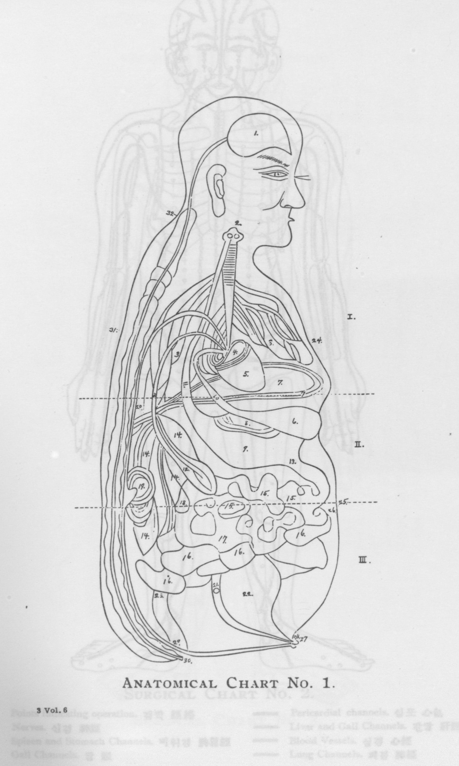

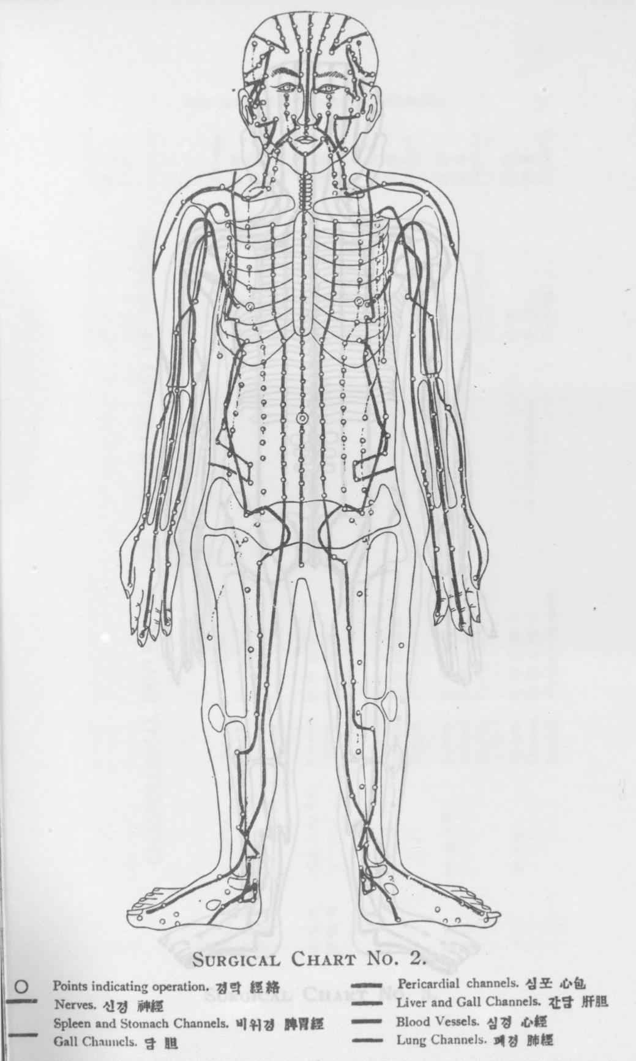

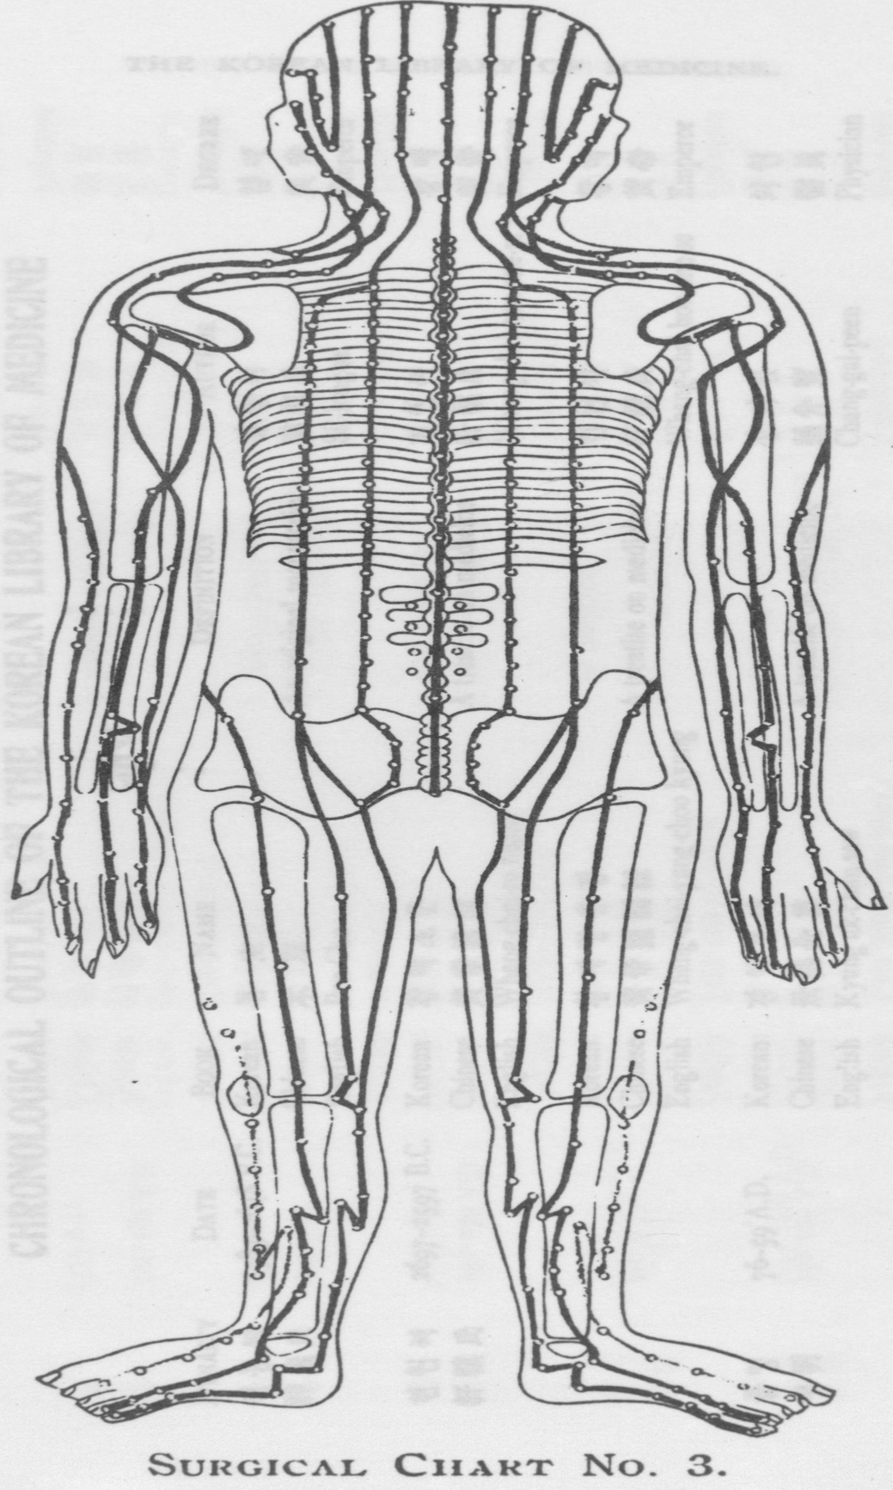

[page 31]

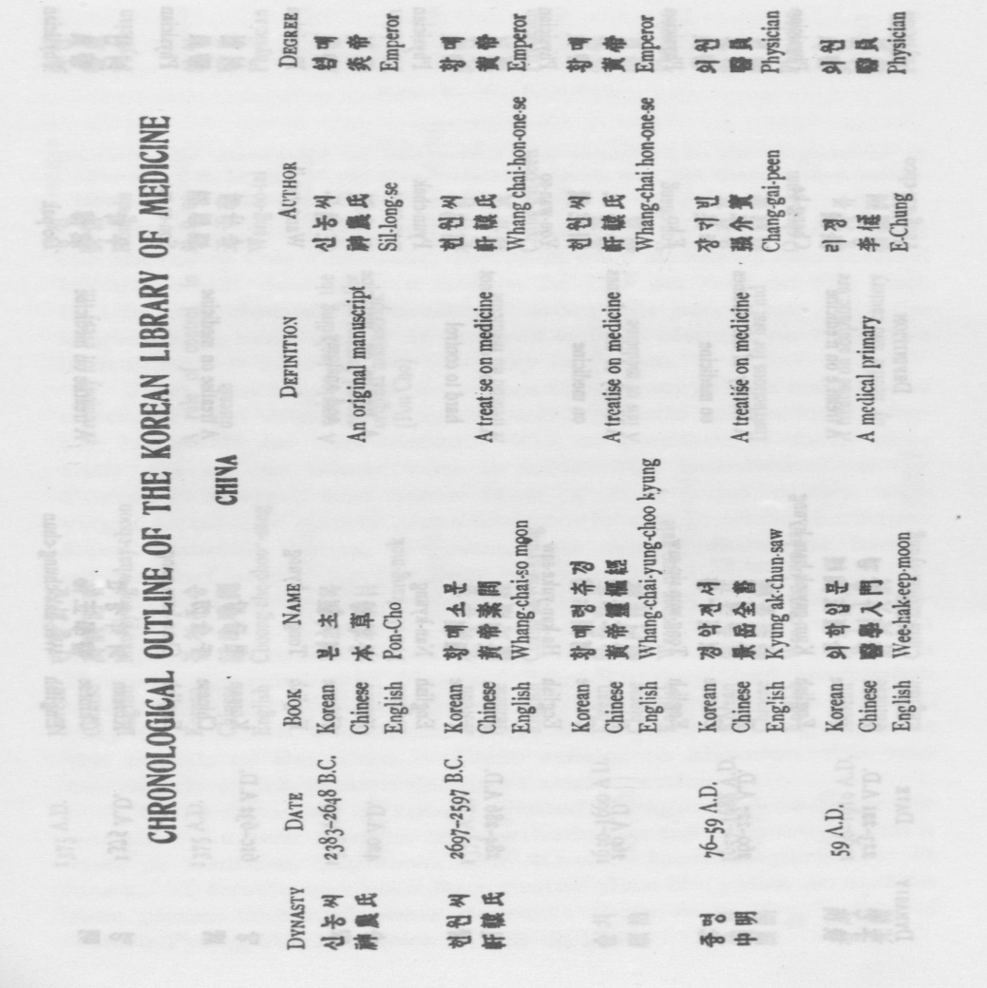

[page 32]

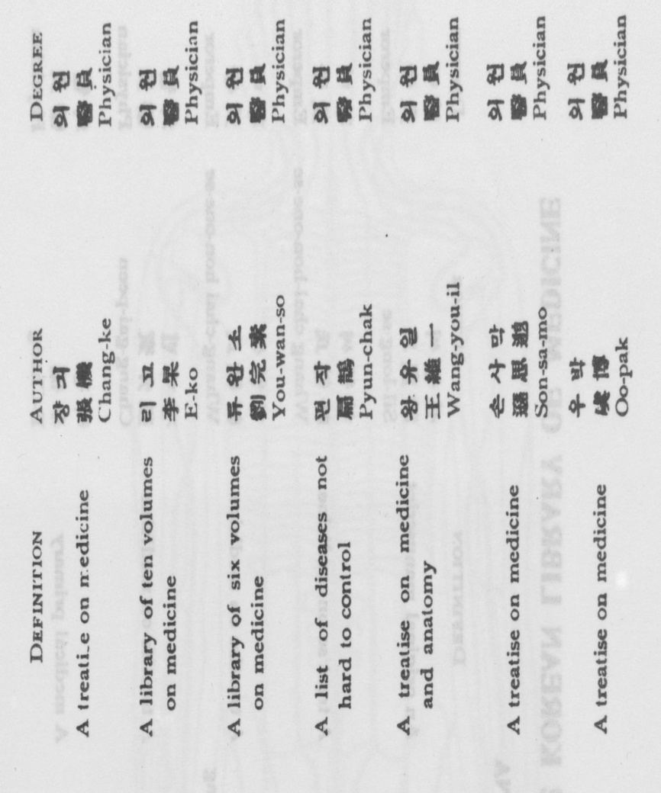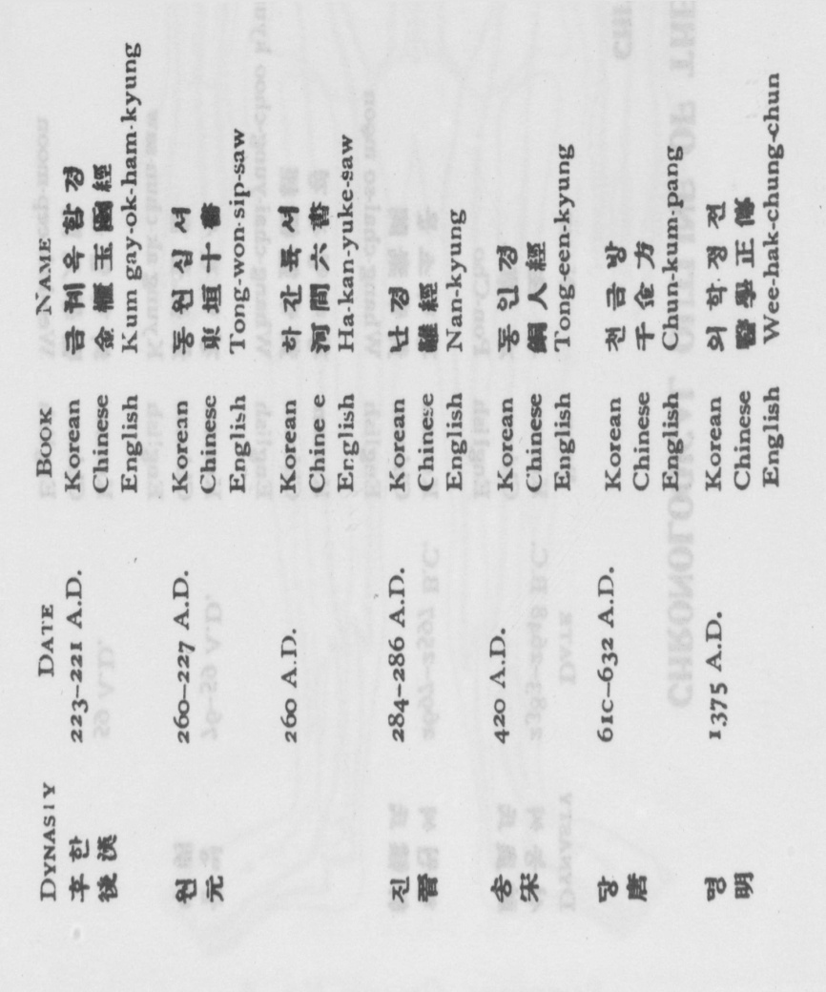

[page 33]

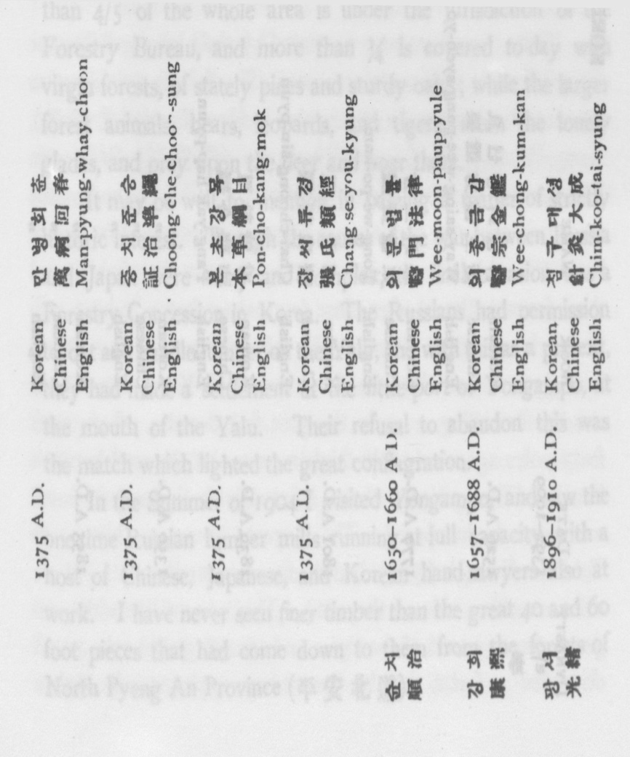

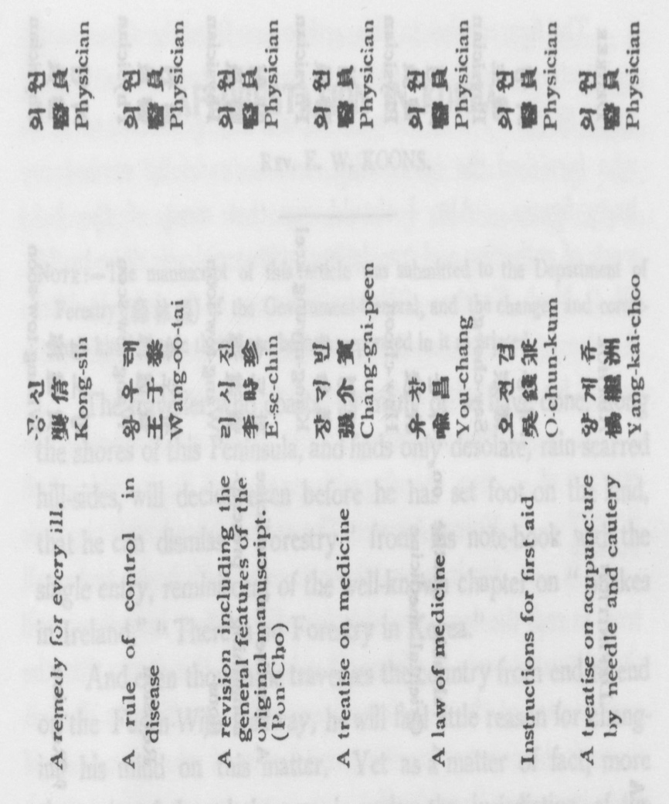

[page 34]

