TRANSACTIONS OF THE KOREA BRANCH OF THE ROYAL ASIATIC SOCIETY

VOL. VI

1915

CONTENTS.

PAGE .

The History of Korean Medicine 1

Afforestation in Korea .......................................................... 35

Minutes of Annual Meeting ......................... 43

Report of the Council ............................................................ 43

Appendix :

Officers ............................................................. 45

List of Members 46

Catalogue of Publications .......................... 49

[page 1]

**The History of Korean Medicine.**

N. H. Bowman, M.D. [Newton H. Bowman]

Severance Union Medical College, Seoul, Korea.

The life story of Korean Medicine is based upon a traditional inheritance from the dim past, before the time when history began to be a matter of record, and the subject does not claim our attention today because it is a monument of ancient skill, for in fact it is not, but because it comes to us as a part of the traditions and history of the Korean people.

After careful study of the subject the following outline is suggested for consideration.

I. The Chinese origin (2838-2648 B.C.)

(a) Sil-long-se (신농씨 神農氏)

(b) The Pon-cho (본초 本草)

(c) The Pharmacy sign (신농유업 神農遺業)

II. The medical treatises and authors with a chronological outline of the Korean library of medicine arranged according to the dynasties and the date of their occurence.

III. The revision of the Pon-cho (본초 本草) 1393 A.D. and the bibliography.

IV. Emperor Sin-chong’s (신종 神宗) proclamation (1608 A.D.)

(a) You-han, (류한 劉漢) the royal household physician.

(b) The Pon-cho (본초 本草) becomes a book and the accepted standard for Chinese Medicine.

(c) The description of the Pon-cho (본초 本草)

V. The Moon-Chang (문쟝 門場) and the introduction of the Pon-cho (1628 A.D.)

VI. The Pang-yak-hap-pyun (방약합편 方藥合編) as a standard for Korean medicine. (1838 A.D.) [page 2]

VII. The description and translation of a part of the Pang-yak-hap-pyun (방약합편 方藥合編)

VIII. The origin of Acupuncture and its subsequent development.

IX. The organization of the Sil-long-se adherents, 1913 A.D. and the granting of the title of “Scholar of Medicine” by the Japanese authorities.

X. Conclusion.

---------------------------

I. In the traditions of China is to be found the first glimpse of what the Korean people believe to have been the origin of their medicine.

The legendary story begins with (*a*) Sil-long-se (신농씨 神農氏), the second of the five ancient rulers of China, who founded a dynasty, which lasted from 2838-2648 B.C. This personage has been honored with the title of “Father of Medicine” and he is reputed to have written an original manuscript on medicine, called the (*b*) Pon-cho (본초 本草) which analysed in its component parts signifies the first manuscript (“Pon”-1st, “Cho”-manuscript). (*c*) This tradition is commemorated in the form of a sign on all retail drug shops where native medicines are prepared and sold. The final syllable (honorific) is dropped and the word for inheritance, you-aup (유업 遺業) is added, thus the sign reads Sil-long-you-aup (신농유업 神農遺業) “inherited from Sil-long-se” or inherited medicine, which in point of significance corresponds to the English word pharmacy, except that it is never employed to indicate the science of pharmacy, because there is no such distinction in Korean medicine.

Wholesale drug shops of native medicines are called Yak-gai (약계 藥契) but they are purely commercial and have no part whatever in the subject under discussion. Thus the traditional story of Sil-long-se (신농씨 神農氏) ends and the Pon-cho is lost sight of for a period of about four thousand years when it reappears within the province of history to which [page 3] reference will be made later in the order as it appears in the synopsis.

II. The library of medical books is in possession of the practitioners of native medicine and the number and kind varies considerably. Some have at least one book on medicine and that book is in most instances the one of the six written by a Korean on the subject of medicine. Others possess more, but they are of Chinese origin and written in Classic Chinese. The greatest number of medical books found in the possession of any one practitioner of native medicine was seventy two, fifty two volumes of which were by one author and that set was an elaborate edition of the Pon-cho.

Referring to the chronological outline of the Korean Library appearing herein, there are two books derived from the Whang dynasty (황데헌원씨 黃帝軒轅氏), the founder of which was the 3rd of the five ancient rulers of China (2697-2597 B.C.). They are included because both of these books have until recent years been in the possession of many of the present day practitioners of native medicine, but at present both of the books are out of print, and it is not likely that another edition of them will ever be issued again in Korea.

The other books included in the outline are bonafide members of the present day Korean medical library, and are in actual use by the practitioners of native medicine. Some of the books have a supplementary sheet which mentions a large number of other books of Chinese authorship, that were never in use in Korea by the Korean people, therefore no mention will be made of them.

The next books in order of time do not appear until 56-59 A.D. after which time they occur in fairly regular order of one or two books for about every 250 years until the Mung (명 明) (Chinese “Ming”) dynasty (1368-1628) is reached.

During this time a greater number of books came into use, all of which may be noted by consulting the chronological outline herein attached and further delineation of the Korean Library of Medicine will be deferred except as it becomes [page 4] necessary to refer to it in treating with special topics of this discussion.

III. The revision of the Pon-cho (본초 本草) occurred in the Mung (명 明 (Ming) dynasty) (1368-1628 A.D.) during the reign of Mung-tai-cho (명태조 明太祖) 1393 A.D. The Pon-Cho was revised by one E-Se-Chin (리시진 李時珍) a Chinese doctor and scholar living at Ko-wol (고월 古越) China. In the revision of the Pon-Cho the author incorporated many new rules, which he took from contemporary sources or from his predecessors; however be this as it may, the bibliographic outline of the Pon-Cho herein given will show the sources drawn upon.

The rule of pulse science is strongly emphasized throughout the Pon-Cho and frequent references are made to one or other of the books or authors of the bibliography. Whether all are books to which reference is made is uncertain, as some were probably names of teachers, but this is a matter of conjecture. These references indicate much of interest as to the character of the teaching in Medicine in China at that time.

BIBLIOGRAPHY OF THE PON-CHO.

TITLE OF BOOK

|  |  |  |
| --- | --- | --- |
| KOREAN  맥결교증  맥결비숙화셔  맥학긔경팔맥  신농본경명례  력대졔가본초  도씨별록합약 | CHINESE  脉訣巧證  脉訣非叔和書  脉學奇經八脉  神農本經名例  歷代諸家本草  陶氏別錄合藥 | ENGLISH DEFINITION  A book of clever proof on the pulse.  Pi-sook-wha’s book on the pulse.  Eight beautiful rules of the canon of pulse science.  Rule of the original canon of Sil-long-se.  Catalogue of medicine of all the households of the preceding dynasties.  The rule of gathering and |

[page 5]

|  |  |  |
| --- | --- | --- |
| 분졔법측  의림즙약  본초화  셥성한람  사시용약례  숭강비요  긔약비고  약셩원해  긔미음양  숭강부침  표본음양  오미편승  복약금긔  임신금긔  오미의긔  십졔  칠졔  리동원수즘  용약례  진쟝긔졔허  용약례  쟝자화한  토하삼법 | 分劑法則  醫林輯略  本草話  攝生閒覽  四時用藥例  升降備要  奇藥備考  藥性原觧  氣味陰陽  升降浮沉  標本陰陽  五味偏勝  服藥禁忌  姙娠禁忌  五味宜忌  十劑  七劑  李東垣隨症  用藥例  陳藏器諸虛  用藥例  張子和汗  吐下三法 | dividing medicine according to the special records of Do-se.  A summary of brief extracts from various authors.  A catalogue of remarks on medicine.  Important decision on the preservation of health.  Rule of the use of medicine according to the four seasons.  Seung-Kang Pi Yo.  Wonderful remarks on medicine.  Original interpretation of the nature of medicine.  Original remarks on sex.  To float and sink alternately, as if to ascend and descend.  The primeval force developed from original remarks.  Five tastes contraindicating the use of medicine.  Medicines to be avoided.  How to avoid becoming pregnant.  Five tastes to be avoided.  A treatise of ten remedies.  Seven kinds of medicine.  Rule of treating disease according to Yi-Song.  Chin-chang-ke’s rule of the use of medicine in chronic diseases.  The rule of three; diaphoretic, emetic and purgative. |

[page 6]

|  |  |  |
| --- | --- | --- |
| 토 법  하 법  한 법 | 吐法  下法  汗法 | Rules for emetics.  Rules for purgatives.  Rules for diaphoretics. |

IV. In 1608 A.D. just 215 years after E-se-chin (리시진 李時珍) revised the Pon-cho the Emperor Sin-chong (신종 神宗) of the Mung (명 明) (Ming) dynasty issued a proclamation throughout his empire making diligent inquiry of every man for the best treatise on the subject of medicine known to the Chinese people. Whereupon an heir of E-se-chin (리시진 李時珍) took the revised Pon-cho to the royal court of his majesty. (*a*) The royal household physician, You-han (류한 劉漢) by virtue of his position became the head of the Royal Commission before whom came all replies and findings on the subject in question. After having examined the revised Pon-cho, the Royal Commission pronounced it most excellent, in testimony thereof the Emperor’s Seal was placed upon it. (*b*) The Emperor ordered it copied and made into a book which is the first mention of the Pon-cho being anything more in form than a manuscript, as the word signifies. From this time on the Pon-cho became the recognized standard for Chinese medicine. The Emperor also ordered that the book be taught to the “Clever sons” of the empire according to their selection by the doctors. (*c*) The Pon-cho is a book of varying proportions, but the subject matter is the same in all the editions. The smallest number of volumes found in any one edition was fifteen, and the greatest number was fifty two. The script is all in Classic Chinese (슌한문 純漢文). It contains many drawings of animals, snakes, birds, plants, flowers and vegetables, representing in all one thousand eight hundred and seventy one agents, described in 60 parts and having a diagnostic and a therapeutic index.

CLASSIFICATION OF MEDICINE ACCORDING TO THE PON-CHO.

KOREAN CHINESE ENGLISH

현슈류 天水類 13 Products of paddy fields watered by the rains.

[page 7]

디슈류 地水類 30 Products of paddy fields watered from the ground.

화 火 11 Fire, Atmospheres, Flame, Fever, etc.

토 土 61 Earth.

셕류금셕 石類金石 28 Gold stone.

석류옥셕 石類玉石 14 Precious stones.

셕류일 石類一 32 Stone (I).

셕류이 石類二 39 Stone (II).

셕류 石類 47 Stone.

산초샹 山草上 31 Mountain grass (I).

샹초하 山草下 40 Mountain grass (II).

방초 芳草 56 Green grass.

습초샹 濕草上 53 Damp grass (I).

습초하 濕草下 73 Damp grass (II).

독초 毒草 47 Poisonous grass.

지이 芝栭 15 Mushroom found growing on rocks and pine wood.

오과 五果 11 Five Fruits.

미과 味果 13 Appetizing fruit.

만초일 蔓草一 73 Vine grass (I).

만초이 蔓草二 19 Vine grass (II).

슈초 水草 23 Water grass.

셕초 石草 19 Stone grass.

태초 苔草 16 Vallisneria spiralis, a water-plant.

잡초 雜草 9 Various grasses

마맥도 麻麥稻 12 Hemp, Barley and Rice.

직속 稷粟 18 Panicled millet and millet.

숙두 菽豆 14 Beans.

조양 造釀 29 Brewing of alcoholic liquids.

군신채 葷莘菜 32 Peppery and acrid Vegetables.

유활채 柔滑菜 41 Soft vegetables.

[page 8]

파채 苽菜 11 Cucumbers, melons, and vegetables.

슈채 水菜 6 Water vegetables.

산과 山果 34 Mountain fruit.

리과 夷果 31 Miscellaneous fruits.

긔물 器物 54 Household goods.

파과 苽果 9 Cucumbers.

슈과 水果 6 Water fruit.

향목 香木 35 Fragrant wood.

교목 喬木 52 Old wide spreading trees such as Zelkova Keaki.

관목 灌木 51 Shrubs.

우목 寓木 12 Parasitic plants, like misletoe.

포목 苞木 4 Bamboo.

잡목 雜木 7 Miscellaneous trees.

부록졔목 附錄諸木 20 Index of the species of trees.

림금류 林禽類 17 Forest animals.

산금류 山禽類 14 Mountain animals.

축류 蓄類 28 Domestic animals.

슈류 獸類 38 Beasts.

셔류 鼠類 12 Rats.

인 人 37 Parts of human body.

유명미용 有名未用 153 Famous remedies.

란성일 卵生一 23 Egg embryo (I).

란성이 卵生二 22 Egg Embryo (II).

화성 化生 32 Transformed beings.

습성 濕生 23 Centipedes.

부록 附錄 7 Earth worms (?)

룡 龍 9 Dragon

사 蛇 17 Snakes.

어 魚 31 Fish.

무린어 無麟魚 28 Skin Fish (without scales).

부록 附錄 9 Allied species of skin fish (?)

[page 9]

구별 龜鼈 17 Tortoise and fresh water turtles.

방합류 蚌蛤類 19 Mussels, clams and bivalves.

슈금 水禽 23 Water fowls.

원금 原禽 23 Squab, fowls.

V. Twenty years after the Pon-cho received imperial recognition by the Emperor Sin-chong, (신종 神宗) the famous Chinese and Korean Market called Moon-chang (문쟝 門場) was established in N. E. China in the Laotung or Yo-tong (요동 遼東) province 700 li (333 ⅓ English Miles) from the nearest Korean prefect, Wiju (의쥬 義州) and 300 li (100 English miles) from the Eastern border of the Laotung or Yu-tong province which was the Yalu River, the N. W. Boundary of Korea. This market was established at the close of the Mung (Ming) (명 明) dynasty in the year 1628 A.D., and was continued for a period of 230 years during which time it was the greatest ginseng (인삼 人蔘) market in the world. The market was as the word signifies the “Door of trade” for Korea in China. It was the only point in Chinese territory at that time open to the Korean merchantmen. The Koreans took their merchandise there for disposal and the Chinese did likewise. The trade consisted chiefly of ginseng from Korea and silk from China; however there were other commodities bought and sold by both countrymen. The Pon-cho became the official catalogue of classification for all medicines of the two countries and any one not contained in the Pon cho was marketed under some disadvantage. In the meantime Korean Medicine of various kinds developed in point of importance both in practice in Korea and in commerce at the Moon Chang. The book of antiquity, the Pon-cho no longer covered the new field of medicine which had sprung up from Korea, therefore the necessity arose for either revising the Pon-cho again or of writing an entirely new book on medicine in order to conserve the trade interests of the Korean constituency. In the first instance a revision of the Pon-cho by a [page 10] Korean who most needed it, would have been a failure as a business proposition since the Chinese preferred the old to the new, and also, because Korea was to China only a child and surely what was not bred in the bone of a Chinaman could not come out in the flesh of a Korean.

VI. Therefore a new book called the Pang-yak-hap-pyun (방약합편 方藥合編) was written by one Whang-do-soon (황도슌 黃道淳) a Korean doctor and scholar of the Chinese classics living at Sauk-chung-dong (셕졍동 石井洞) Seoul, Korea. For all ethical intents and purposes, the author incorporated the fundamentals of the Pon-cho in his new book. In introducing the book the author used the name of the great teacher Confucius, whom he claimed to represent, admonishing all who should read the book to follow its precepts as the author had done, thereby dispelling all doubt as to authenticity in the minds of the Chinese to whom the drugs were to be sold and justifying the practice of Korean medicine in Korea. The book was written in mixed script (Chinese context with Korean connectives). The first edition was published in the 447th year (1839 A.D.) of the Yi (리 李) dynasty (Korea) seventy six years ago. Eleven years later the second edition appeared. The third and present edition appeared just sixteen years after the first, all of which were written by the same author. The first edition appeared just twenty years before the Moon-chang (문쟝 門場) the border market or the “door of trade” was discontinued. Following the third and last revision of the book the market continued for only four years.

VII. The Pang-yak-hap-pyun (방약합편 方藥合編) is a book of only 58 pages containing a diagnostic index of diseases and therapeutic indications for the use of 223 agents as medicine.

The book answers more nearly to the description of a catalogue of medicine and is practically so regarded, but it does not contain a price list of any description. It is in all essentials a tradesman’s commentary on medicine, embodying many prescriptions for as many ills. Many of these prescriptions are [page 11] popularly known to the laity who buy them from the drug shops, Sil-long-you-aup (신농유업 神農遺業) and take them home to use after the fashion of domestic medicine.

SA-AN-TONG’S EYE WASH.

MEDICINE NAME

KOREAN CHINESE ENGLISH

당귀 當歸 A drug supplied by several members of the Umbelliferae family.

황련 黃連 Rhizomes of the Coptis teeta.

젹작약 赤芍藥 The roots of Paeonia albiflora.

방풍 防風 Caraway seed.

행인 杏仁 Apricot seed.

성디황 生地黃 Rehmannia glutinosa.

Uses: ― A wash for sore eyes.

KOONG-RE-TANG’S GINSENG REMEDY.

MEDICINE NAME

KOREAN CHINESE ENGLISH

쳔궁 川芎 A kind of medicine used for head troubles and as a tonic.

당귀 當歸 A drug supplied by several members of the Umbelliferae family.

반하 半夏 Pinellia ternata, a bean-like medicinal plant.

봉출 蓬朮 Mugwort and Atractylis ovata.

목향 木香 Putchuck root.

사인 砂仁 Inferior cardamons.

오약 烏藥 Lindera strychnifolia.

감초 甘草 Licorice.

인삼 人蔘 Ginseng.

계피 桂皮 Cinnamon bark.

Uses: ― A remedy for dropsical conditions.

[page 12]

NUMBER II, STOMACH MEDICINE.

MEDICINE NAME

KOREAN CHINESE ENGLISH

창출 蒼朮 Atractylis ovata.

진피 陳皮 Dried orange-peel.

후박 厚朴 The Magnolia hypoleuca.

반하 半夏 Pinellia ternata, a bean like medicine plant.

젹복령 赤茯笭 Red China “root.”

곽향 藿香 Betony of bishopwort.

인삼 人蔘 Ginseng.

초과 草果 The ovada cardamon.

감초 甘草 Licorice.

Uses:― Summer dispepsia.

A DIARRHOEA REMEDY.

MEDICINE NAME

KOREAN CHINESE ENGLISH

당귀 當歸 A drug supplied by several members of the Umbelliferae family.

초룡담 草龍膽 Gentiana scabra.

쳔궁 川芎 A kind of medicine ― used for head troubles and as a tonic.

외자 桅子 The seed of a kind of aspen.

대황 大黃 Rhubarb.

강활 羌活 The Peucedanum decursivum.

방풍 防風 Caraway seed.

Uses: —A liver regulator.

THE FOUR MEDICINE REMEDY.

MEDICINE NAME

KOREAN CHINESE ENGLISH

숙디황 熟地黃 Cooked Rehmannia glutinosa.

백작약 白灼藥 White roots of Paeonia albiflora.

[page 13]

쳔궁 川芎 A kind of medicine ― used for head troubles and as a tonic.

당귀 當歸 A drug supplied by several members of the Umbelliferae family.

Uses:― Tonic expectorant for cough, spitting of blood, etc.

E-CHUNG TANG’S INTERNAL REMEDY.

MEDICINE NAME

KOREAN CHINESE ENGLISH

인삼 人蔘 Ginseng.

백출 白朮 A variety of Atractylis ovata.

전강 乾薑 Dried ginger.

감초 甘草 Licorice.

Uses:― For jaundice and vomiting.

SAM-SO-UM’S GINSENG AND PERILLA NANKMENSIS.

MEDICINE NAME

KOREAN CHINESE ENGLISH

인삼 人蔘 Ginseng.

소엽 蘇葉 Perilla nankmensis.

젼호 前胡 Angelica.

반하 半夏 Pinellia ternata, a bean-like medicine plant.

전갈 乾葛 Dried Pueraria Thunbegiana.

젹복령 赤茯苓 Red China “root”

진피 陳皮 Dried orange-peel.

길경 桔梗 The species of Campanula.

기각 枳殼 The bark of Citrus aurantium.

감초 甘草 Licorice root,

Uses: — For “colds” accompanied by fever.

PAL-MUL’S MEDICAL DECOCTION OF EIGHT INGREDIENTS.

MEDICINE NAME

KOREAN CHINESE ENGLISH

인삼 人蔘 Ginseng.

백출 白朮 A variety of Atractylis ovata.

[page 14]

백복령 白茯笭 White China “root.”

감초 甘草 Licorice.

숙디황 熟地黃 Cooked Rehmannia glutinosa.

백작약 白灼藥 White roots of Paeonia albiflora.

쳔궁 川芎 A kind of medicine ― used for head troubles and as a tonic.

당귀 當歸 A drug supplied by several members of the Umbelliferae family.

Uses: — For impoverished blood and general debility.

YONG SUK SAN’S CAMPHOR AND CALCAREOUS SPAR REMEDY.

MEDICINE NAME

KOREAN CHINESE ENGLISH

한슈셕 寒水石 A calcareous spar.

쥬사 朱砂 Cinnabar.

룡뇌 龍腦 Camphor.

Uses: — For croup in children.

CHUNG-WHA-PO-UN’S FEVER ERADICATOR AND NERVE TONIC.

MEDICINE NAME

KOREAN CHINESE ENGLISH

현삼 玄蔘 A kind of medicinal plant, Scrophularia Oldhami,

백작약 白灼藥 White roots of Paeonia albiflora.

숙디황 熟地黃 Cooked Rehmannia glutinosa.

당귀 當歸 A drug supplied by several members of the Umbelliferae family.

쳔궁 川芎 A kind of medicine ― used for head troubles and as a tonic.

황백 黃栢 The yellow bark of the Phellodendron amurense.

지모 知母 Anemarrhena asphodeloides.

현화분 天花衯 Starch obtained from the root of the Trichosanthes japonica.

감초 甘草 Licorice.

[page 15]

Uses:— For fever and to increase the negative principle in one’s nature.

PYENG WE SAN’S STOMACH REMEDY.

MEDICINE NAME

KOREAN CHINESE ENGLISH

창출 蒼朮 Atractylis ovata.

진피 陳皮 Dried orange-peel.

후박 厚朴 The Magnolia hypoleuca.

감초 甘草 Licorice.

Uses:—For cramps of the stomach following the ingestion of food.

The amount of each ingredient contained in the foregoing formulas averages from 25 to 75 grains, making a quart of finished decoction. The more progressive practitioners of native medicine regard the Pang-yak-hap-pyun with scorn, because they look upon any book of medicine that is not written in classic Chinese as being too inferior for their consideration. In fact for a practitioner of native medicine to depend upon a copy of the Pang-yak-hap-pyun only is considered prima facie evidence that he can not read classic Chinese, otherwise he would do so and avail himself of the store of knowledge contained therein. Therefore it is to be noted that there are two classes of these practitioners of native medicine, namely, those who read classic Chinese and those who can not, a distribution which is known and recognized by even the laity.

ACUPUNCTURE.

VIII. Acupuncture bears the same relation to native medicine as surgery does to modern day scientific medicine. The essentials of this art and practice are taken from the Whang-chai-yung-choo-kyung (황데령츄경 黃帝靈樞經), one of the two books originating in the Whang (황데 黃帝) dynasty (2697-2597 B.C.). The authorship of this book and its fellow is ascribed to the Emperor. Whether or not the ruler was the real author or whether the title was given honorificially, [page 16] and the real author remained unknown, is doubtful. It may be noted that such manuscripts as appeared in this dynasty and the one preceding are ascribed to the founder of the dynasty, but after this time a different order obtains ― (see chronological chart). Therefore Emperor Whang (황 黃) bears practically the same relation to acupuncture as Sil-long-se (신농씨 神農氏) does to native medicine.

Of the two books referred to as occurring in this dynasty, the one mentioned is the only one which deals with the art of acupuncture and for this reason the other book will not be considered further.

The fundamental principle underlying this practice is based on the assumption that the blood becomes stagnated and will not flow properly through the natural channels of the body. Acupuncture is also believed to hasten relief, over and above what might be expected from the use of drugs.

The Korean name for this art is “Ch’im” (침 針) which is a term applied to any kind of an instrument used in piercing the flesh of the body, however the term in its original use and the one adhered to in this discussion was applied to needles only. At some subsequent time however the word jim (찜 灸) came to be used, but to signify a different form of treatment by the application of heat with or without medicine. The jim is altered by modifiers to indicate what article is employed, for instance the mugwort (Artemesia) a weed growing in all parts of Korea, is used quite extensively for this purpose under the name of Sook jim (쑥찜 艾灸) which is employed in two forms, the poultice and the fire ball. The poultice is prepared by boiling a quantity of the leaves and the stalk, then placing it in a cloth and wringing until the water is expressed. The hot pulp remaining is then used as a poultice. The fire ball called 뜸 or 쑥뜸 is made by crushing a small quantity of the stalk and rolling it between the palms of the hands, after which the ball, varying in size from a pea to a walnut, is set on fire and placed over different portions of the body. The “Pillow jim” (목침찜 木枕灸) is made by heating the wooden block on [page 17] which the Koreans rest their heads while sleeping and applying it to different portions of the body for various ailments. With this explanation of the jim, (찜 灸) or the second term, the discussion of the ch’im, the first and original word will now be resumed.

In 59 A.D. during the reign of Choong Mung (중명 中明) appeared the Wee-hak-eep-moon (의학입문 醫學入門) a medical Primary in which is included a few more rules for the application of the ch’im and elaborating on the rules of the Whang-chai-yung-choo-kyung, (황데령츄경 黃帝靈樞經) the original source of the ch’im practice. After this there appeared a succession of books, but none of them were of any special significance until 420 A.D., when the Tong-een-kyung appeared, which was written by one Wang-you-il (왕유일 王維一). This author modeled a man out of copper, which is signified by the title of the book, meaning the Copper man book. He elaborated on all the previous teachings of his predecessors and constructed a chart illustrative of the Copper man’s anatomy, which is to this day the accepted standard of anatomy amongst the practitioners of native medicine. In connection with this anatomical scheme it was believed that there are (1) blood vessels (2) nerves and (3) channels.

There are five kinds of channels illustrated (*a*) The spleen and stomach (비위경 脾胃經) (*b*) the liver (간경 肝經) (*c*) the lung (폐경 肺經) (*d*) pericardium (심포경 心包經) and the (*e*) gall (담경 膽經).

(*a*) The channels given off from the spleen and stomach convey nutritious material for final distribution to the different parts of the body.

(*b*) This organ gives off channels for the distribution of gall and it is believed, now as it was then, that the eye is directly connected with the liver by means of a gall channel, which accounts for the yellowish discoloration of the eye in jaundice.

(*c*) The channels originating from this organ are supposed [page 18] to contain air during foetal life but after birth when respiration is established blood in supposed to enter, which continues through life.

(*d*) The oil channels are connected with an oil sac remotely situated in the region below the diaphragm. This probably corresponds to the omentum and possibly the base of the mesentery.

(*e*) These channels are confined to the upper half of the body and they have no connection with the liver. They are the receptacles for a complimentary fluid which is supposed to be the seat of courage.

All the above named channels are supposed to contain blood but in a modified form, due of course to the presence of the respective substances which they receive and convey.

The chart of anatomy consists of three parts, Sam Cho 삼초 三焦.

(1) Regional (2) Visceral (3) Surgical.

The Regional consists of three divisions:

(a) Upper third of the trunk—thorax, Sang Cho 샹초 上焦

(b) Middle third of the trunk—abdomen, Chung Cho 즁초 中焦

(c) Lower third of the trunk—lower abdomen, Ha Cho 하초 下焦

(2) The Visceral—In this chart there are 32 anatomical structures named, which may be noted by referring to the chart. See chart number I.

(3) The Surgical—The blood vessels, nerves and channels represent the chief items of consideration. These structures are described as large and small, with erroneous origins and distributions, except for the fact that some of the blood vessels are shown to originate in the heart. The nerves are supposed to originate independent of the brain and cord and have abrupt endings. Along the supposed courses of these blood vessels, nerves and channels, certain points for the application of the chim are described in great detail. Each point is described as a [page 19] separate operation for a different group of symptoms all of which are based on the pulse law, but there is no definite principle taught in any of the pulse laws and the observer is left to exercise his own judgment and to formulate his own interpretation of the symptoms. These points, described as sites for the application of the ch’im, are determined by surface measurements from a given point in the respective region. See charts II and III.

For example ― *on the face*, these points are determined by measurement in a given direction from the corner of the eye.

*On the forehead* ― from a point midway between the eye brows.

*Shoulder region* ― from the center of the axilla and the point of the shoulder; *the chest*-from the center of the mammary gland and from the cardinal point at the end of the sternum where the aorta is supposed to end.

*The abdomen* ― from the umbilicus. *The Pelvis* ― from the center of the pubic arch in front and the center of the sacrum behind.

*On the limbs* ― from points before, behind and from either side.

*The extremities ―* from the ball of the foot and great toe.

*The toes* ― from the 1st and 2nd joints of each. The same rule applies to the hands fingers. Special stress is laid on the significance of all promontories of the body as suitable points for the application of the ch’im.

The total number of operations described and the corresponding number of groups of symptoms indicating the operation are one hundred and sixty, but for the sake of brevity only a few are herein given. The majority of the names of the operations have no special significance or corresponding meaning in English, therefore it would be of no special value to burden these pages with all their names. Example:-

Operation No. 2. “Cloudy gate” (운문 雲門) or Axilla. Cauterize five times 3/10 of an inch deep for the relief [page 20] of stomach sickness, painful arms and back, stopping of chest, cough and indigestion.

No. 15 ― “Gathering Valley” (합곡 合谷). Cauterize three times 2/10 of an inch deep between the thumb and forefinger for headache, foul sores, painful eyes, ringing of ears, sore mouth and throat, toothache, fever and malaria.

No. 24 ― “Five Li” (오리 五里). Three inches up the arm from the elbow. Use no needle but cauterize ten times for spitting of blood, painful arm and shoulder, weak arms and legs, fever, enlarged glands of the neck, cough and malaria.

No. 27 ― “Big Barn” (거골 巨骨). Cauterize 15/100 of an inch deep three times between the shoulder and neck for blood poison of chest, aches of the shoulder, arm and back.

No. 28 ― “Heaven pot” (현졍 天鼎) cauterize one inch after the Poo-tol (부둘 扶突) 4/10 of an inch deep, 3 times for the dumps, sore throat and hard breathing.

Other ambiguous names given to these operations are— “four white”—”earth barn”—”welcome”—”man welcome”—”house itch”— “milk center”—”milk root”—”water root”— “return”— “calf nose”— “three li”— “young sea”—”small sea”—”bent wall”— “heaven window”—”hearing hole”—”through sky”—”germ pillow”— “heaven post”— “three focus”—”white ring,” etc.

The next book in order is the Chun Kum Pang (쳔금방 千金方), “a thousand gold,” written in 632 A.D. which is practically a repetition of the foregoing with individual interpretations by the author. The Ch’in-Koo-Tai-Sung (침구대셩 針灸大成) 1682 A.D. is a book devoted exclusively to the use of the ch’im and is the first instance of any book being devoted to this subject alone. It delineates the virtues of the ch’im and describes the successes obtained by this method of treatment, which is also the first attempt to give anything like a clinical account of results. It introduces a new ch’im which the author calls a Yak jim (약찜 藥灸) or “medicine jim.” This jim has been described in the foregoing pages.

This chronology of medical books brings the subject down [page 21] to the Yi (리 李) dynasty (Korea). There is one book, Tong-wee-paw-kam (동의보감 東醫寶鑑) of Korean origin written by one Haw-Choon (허준 許浚) and entitled “A valuable treatise on Oriental Medicine,” that is much employed by practitioners of native medicine who regard it is a reliable source of information for both medicine and acupuncture. Of late years the book has been revised and the old copper man’s anatomy has been replaced with modern cuts taken from European anatomical books. However the old sect of practitioners of native medicine do not accept these innovations and they continue to believe in the old copper man anatomy.

The other books originating in Korea and included in the chronological outline do not treat of the subject of acupuncture.

The following is a list of books taken from the Chronological Outline of the Korean Library of Medicine already given to show which ones are concerned with the subject of acupuncture.

KOREAN CHINESE ENGLISH

황데령추경 黃帝靈樞經 Wang-chai.

의학입문 醫學入門 Wee-hak-eep-moon.

동원십셔 東垣十書 Tong-won-sip-saw.

란 경 難 經 Nan-kyung.

동 인 경 銅 人 經 Tong-een-kyung.

쳔 금 방 千 金 方 Chun-kum-pang.

침구대셩 針灸大成 Ch’im-koo-tai-sung.

동의보감 東醫寶鑑 Tong-wee-pow-kam.

IX. In 1913 all the practitioners of native medicine in Seoul, Korea, were requested by the Japanese authorities to assemble for the purpose of effecting an organization, which was done. A chairman and secretary were elected and a membership of one hundred and fifteen was recorded in this organization. Each member of the organization who presented a membership certificate signed by the chairman and secretary of the organization, accompanied with a registration fee, to the police department, was granted an article of writing (March 1914) conferring upon the applicant the title of “Scholar of [page 22] Medicine” 의성 醫生 which in effect is a license to practice native medicine in Korea for a period of five years. Later this was extended to cover the life time of the doctor so licensed.

This unique regulation has served the purpose of incorporating this class of practitioners under government supervision and preventing the perpetuation of the practice of native medicine in Korea.

X. In the preceding paragraphs the evolution of medicine from prehistoric times has been outlined ― its appearance upon the far horizon of history in China and its introduction into Korea has been set forth. The old manuscripts of Chinese origin buried from the English-speaking world in a mass of strange and scattered hieroglyphics have been brought to light for our perusal. The knowledge gained by this study will not, of necessity, give to us in this 20th century of intellectual environment greater energy of thought, but it will give us a better understanding of the life-story of Oriental medicine and its history in Korea.

CHRONOLOGICAL OUTLINE OF THE KOREAN LIBRARY OF MEDICINE

CHINA

|  |  |  |  |  |  |  |
| --- | --- | --- | --- | --- | --- | --- |
| DYNASTY | DATE | BOOK | NAME | DEFINITION | AUTHOR | DEGREE |
| 신농씨  神農氏 | 2383-2648B.C. | Korean  Chinese  English | 본초  本草  Pon-cho | An original manuscript | 신농씨  神農氏  Sil-long-se | 염매  炎帝  Emperor |
| 헌원씨  軒轅氏 | 2697-2597B.C. | Korean  Chinese  English  Korean  Chinese  English | 황매소문  黃帝素問  Whang-chai-so moon  황매령츄경  黃帝靈樞經  Whang-chai-yung-choo kyung | A treatise on medicine  A treatise on medicine | 헌원씨  軒轅氏  Whang chai-hon-one-se  헌원씨  軒轅氏  Whang-chai hon-one-se | 황매  黃帝  Emperor  황매  黃帝  Emperor |
| 즁명  中明 | 76-59A.D. | Korean  Chinese  English | 경약젼셔  景岳全書  Kyung ak-chun-saw | A treatise on medicine | 쟝개빈  張介賓  Chang-gai-peen | 의원  醫員  Physician |
|  | 59A.D. | Korean  Chinese  English | 의학입문  醫學入門  Wee-hak-eep-moon | A medical primary | 리졍  李楨  E-Chung | 의원  醫員  Physician |

|  |  |  |  |  |  |  |
| --- | --- | --- | --- | --- | --- | --- |
| DYNASTY | DATE | BOOK | NAME | DEFINITION | AUTHOR | DEGREE |
| 후한  後漢 | 223-221A.D. | Korean  Chinese  English | 금궤옥함경  金櫃玉函經  Kum gay-ok-ham-hyung | A treatise on medicine | 쟝긔  張機  Chang-ke | 의원  醫員  Physician |
| 원  元 | 260-227A.D  260A.D. | Korean  Chinese  English  Korean  Chinese  English | 동원십셔  東垣十書  Tong-won-sip-saw  하간륙셔  河間六書  Ha-kan-yuke-saw | A library of ten volumes on medicine  A library of six volumes on medicine | 리고  李杲  E-ko  류완소  劉完素  You-wan-so | 의원  醫員  Physician  의원  醫員  Physician |
| 진  晉 | 284-286A.D | Korean  Chinese  English | 난경  難經  Nan-kyung | A list of diseases not hard to control | 편작  扁鵲  Pyun-chak | 의원  醫員  Physician |
| 송  宋 | 420A.D. | Korean  Chinese  English | 동인경  銅人經  Tong-een-kyung | A treatise on medicine and anatomy | 왕유일  王維一  Wang-you-il | 의원  醫員  Physician |
| 당  唐 | 610-632A.D. | Korean  Chinese  English | 쳔금방  千金方  Chun-kum-pang | A treatise on medicine | 손사막  遜思邈  Son-sa-mo | 의원  醫員  Physician |
| 명  明 | 1375A.D.0 | Korean  Chinese  English | 의학정전  醫學正傳  Wee-hak-chung-chun | A treatise on medicine | 우박  愚博  Oo-pak | 의원  醫員  Physician |
| DYNASTY | DATE | BOOK | NAME | DEFINITION | AUTHOR | DEGREE |
|  | 1375A.D. | Korean  Chinese  English | 만병회츈  萬病回春  Man-pyung-whay-choon | A remedy for every ill. | 공신  龔信  Kong-sin | 의원  醫員  Physician |
|  | 1375A.D. | Korean  Chinese  English | 증치준승  証治準繩  Choong-che-choo-sung | A rule of control in disease | 왕우태  王于泰  Wang-oo-tai | 의원  醫員  Physician |
|  | 1375A.D. | Korean  Chinese  English | 본초강목  本草綱目  Pon-cho-kang-mok | A revision including the general features of the original Pon-cho | 리시진  李時珍  E-se-chin | 의원  醫員  Physician |
|  | 1375A.D. | Korean  Chinese  English | 쟝씨튜경  張氏類經  Chang-se-you-kyung | A treatise on medicine | 쟝개진  張介賓  Chang-gai-peen | 의원  醫員  Physician |
| 슌치  順治 | 1650-1660A.D. | Korean  Chinese  English | 의문법률  醫門法律  Wee-moon-paup-yule | A law of medicine | 유챵  喩昌  You-chang | 의원  醫員  Physician |
| 강희  康熙 | 1657-1688A.D. | Korean  Chinese  English | 의종금감  醫宗金鑑  Wee-chong-kum-kan | Instructions for first aid | 오젼겸  吳錢兼  O-chun-kum | 의원  醫員  Physician |
| 광셔  光曙 | 1896-1910A.D. | Korean  Chinese  English | 침구대셩  針灸大成  Chim-koo-tai-syung | A treatise on acupuncture by needle and cautery | 양게쥬  楊機洲  Yang-kai-choo | 의원  醫員  Physician |
| DYNASTY | DATE | BOOK | NAME | DEFINITION | AUTHOR | DEGREE |
| 리  李 | 1392-1909 |  |  |  |  |  |
|  | 1526A.D. | Korean  Chinese  English | 위성의방션요  衛生醫方選要  Way-saing-wee-pang-syenyo |  | 셰종  世宗  Say-chong | 의원  醫員  Physician |
|  | 1777A.D. | Korean  Chinese  English | 동의보감  東醫寶鑑  Tong-we-po-kam | A valuable treatise on Oriental medicine | 허준  許浚  Haw-choon | 의원  醫員  Physician |
|  | 1801A.D. | Korean  Chinese  English | 졔즁신편  濟衆新編  Chai-choong-sin-pyun |  | 강명길  康命吉  Kang-myung-keel | 의원  醫員  Physician |
|  | 1839A.D. | Korean  Chinese  English | 방약합편  方藥合編  Pang-yak-hap-pyun | A treatise of medicine containing prescriptions | 황도슌  黃道淳  Wang-tow-soon | 의원  醫員  Physician |
|  | 1350A.D. | Korean  Chinese  English | 〃  〃  〃 | Revision | 황도슌  黃道淳  Wang-tow-soon | 의원  醫員  Physician |
|  | 1855A.D. | Korean  Chinese  English | 〃  〃  〃 | Revision | 황도슌  黃道淳  Wang-tow-soon | 의원  醫員  Physician |

**ANATOMICAL CHARTS**

EXPLANATION OF ANATOMICAL CHART. No. I

1. Brain.

2. Throat.

3. Lungs.

4. Pericardium.

5. Heart.

6. Spleen.

7. Diaphragm.

8. “Oil Sac,” omentum ?

9. Stomach.

1o. Neck of spleen, ligament ?

11. Neck of stomach, cardia ?

12. Neck of liver. Inf. vena cava ?

13. Internal Anus, pylorus ?

14. Liver.

15. Small intestines.

16. Inside of large intestines.

17. Large intestines.

18. Gall Bladder.

19. Kidney.

20. Original source of urine. Renal vessels ?

21. Urethral sphincter.

22. Bladder

23. Straight intestines.

24. Center of breast.

25. Navel.

26. Inside face of navel.

27. Urinary meatus.

28. Sphincter.

29. End of large intestine.

30. Anus.

31. Seven parts of heart.

32. Three parts of spinal column.

I. Thoracic Portion.

II. Abdominal ,,

III. Pelvic ,,

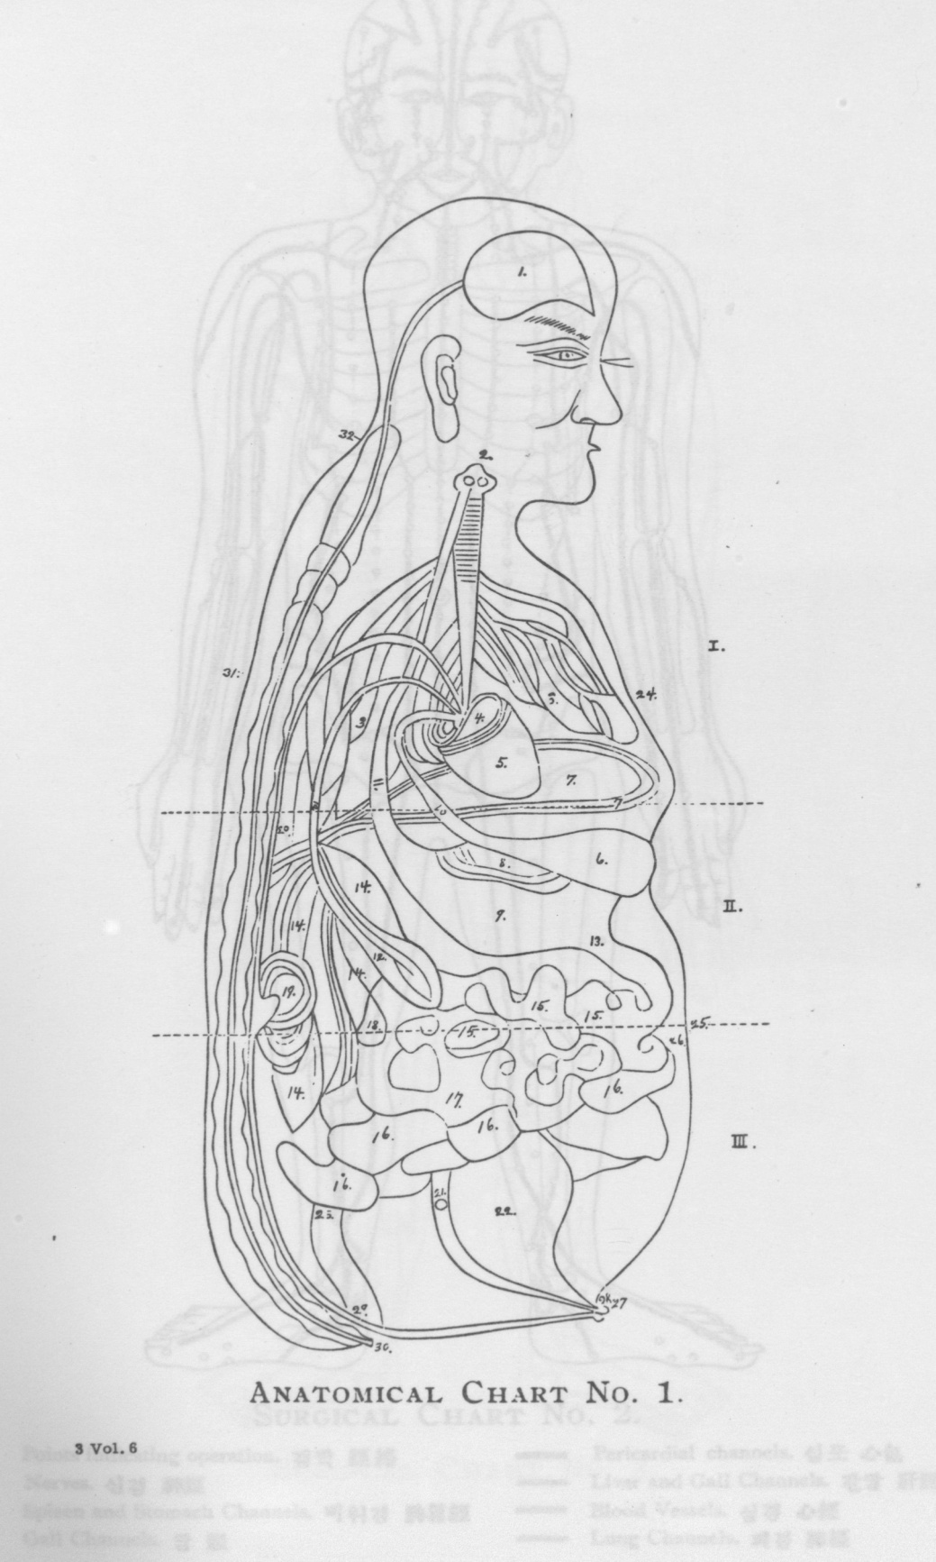

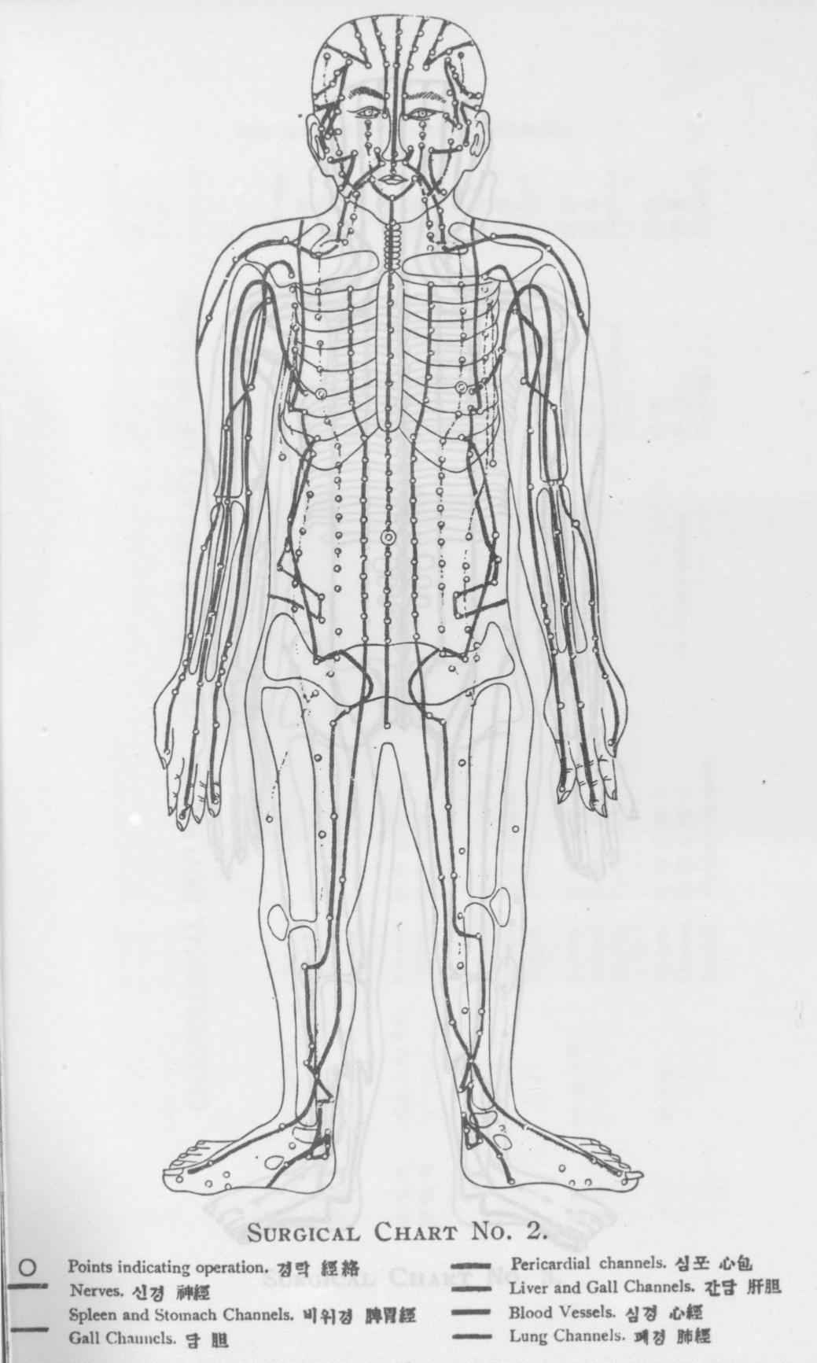

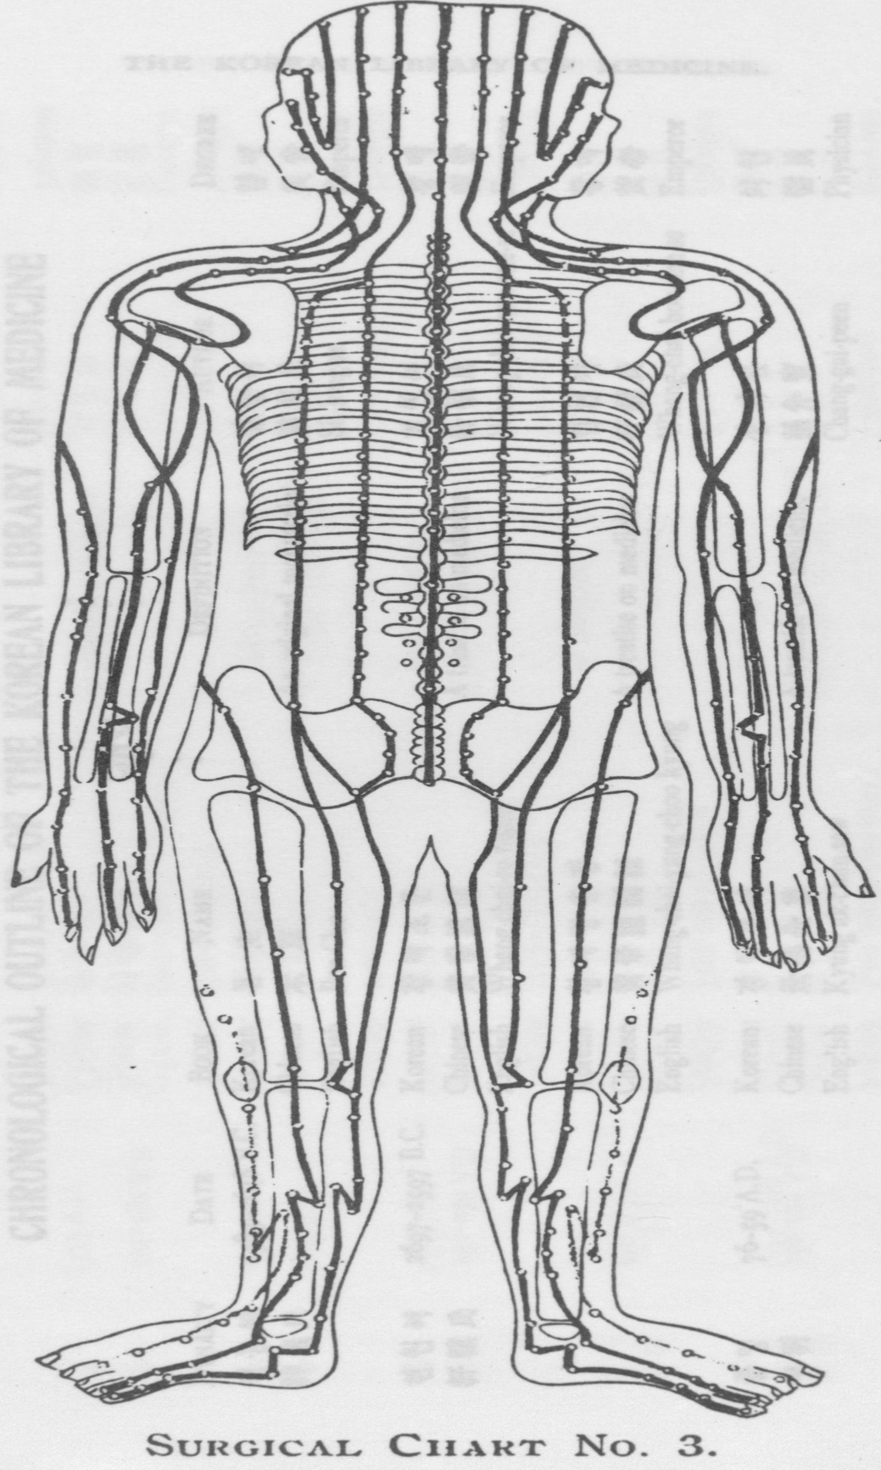

[page 31]

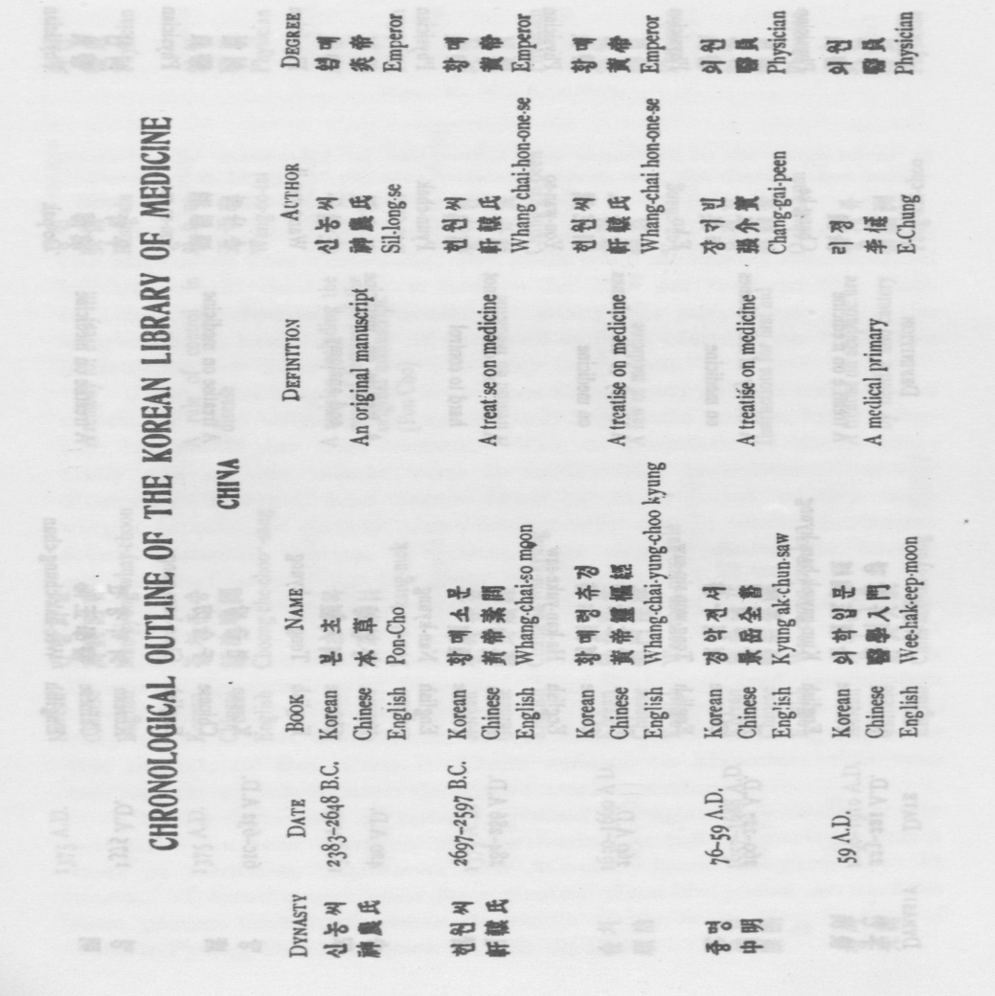

[page 32]

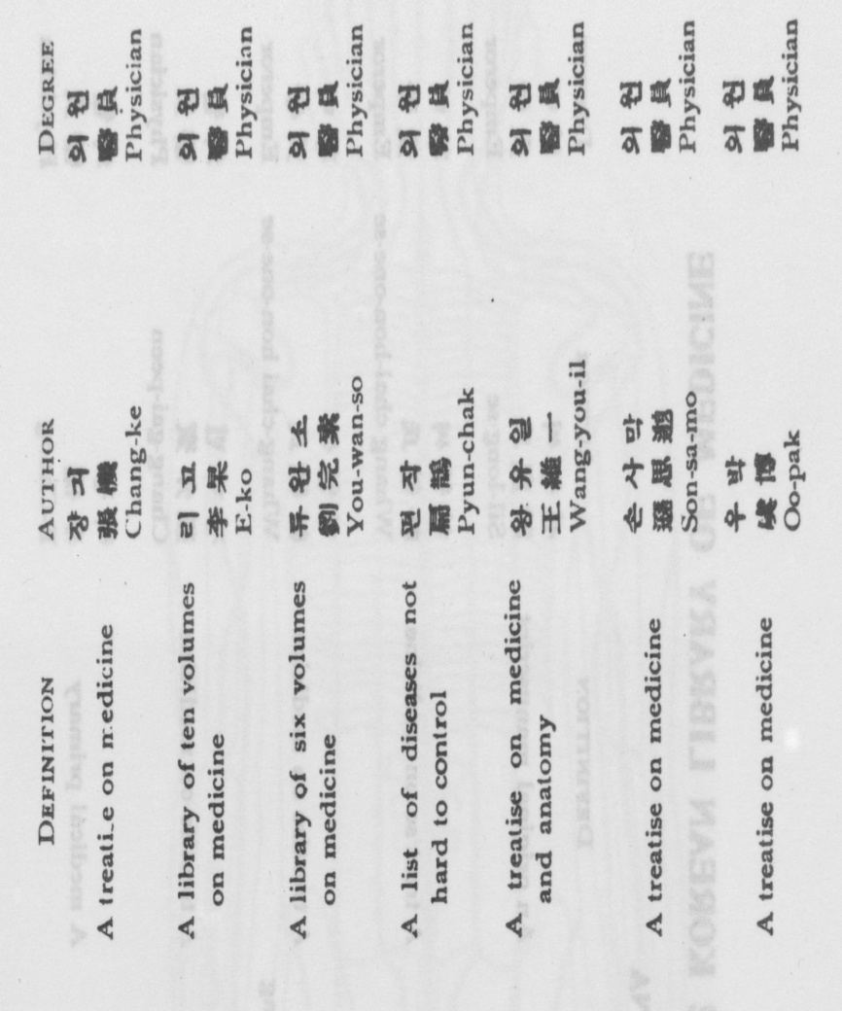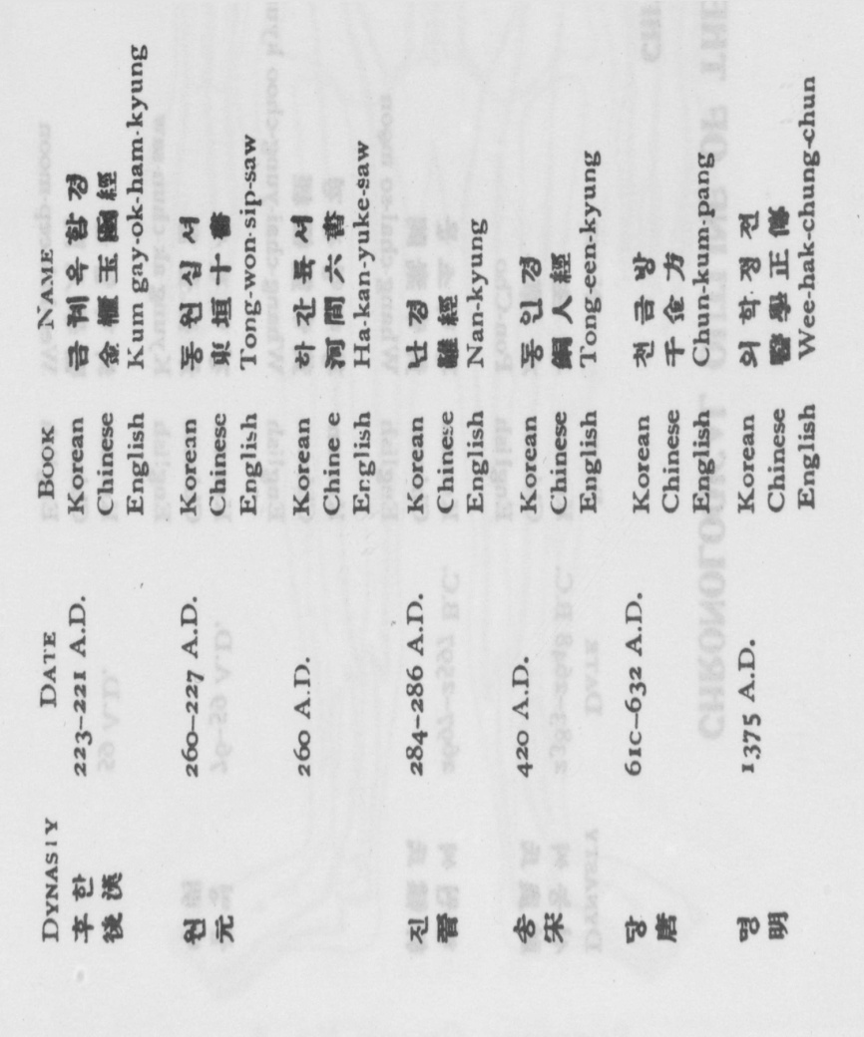

[page 33]

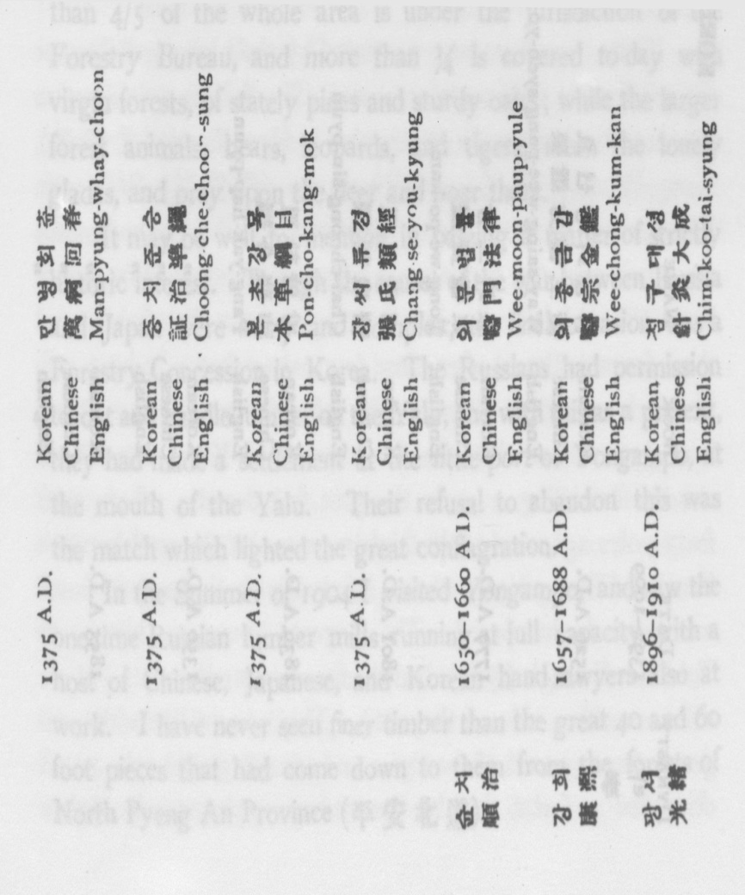

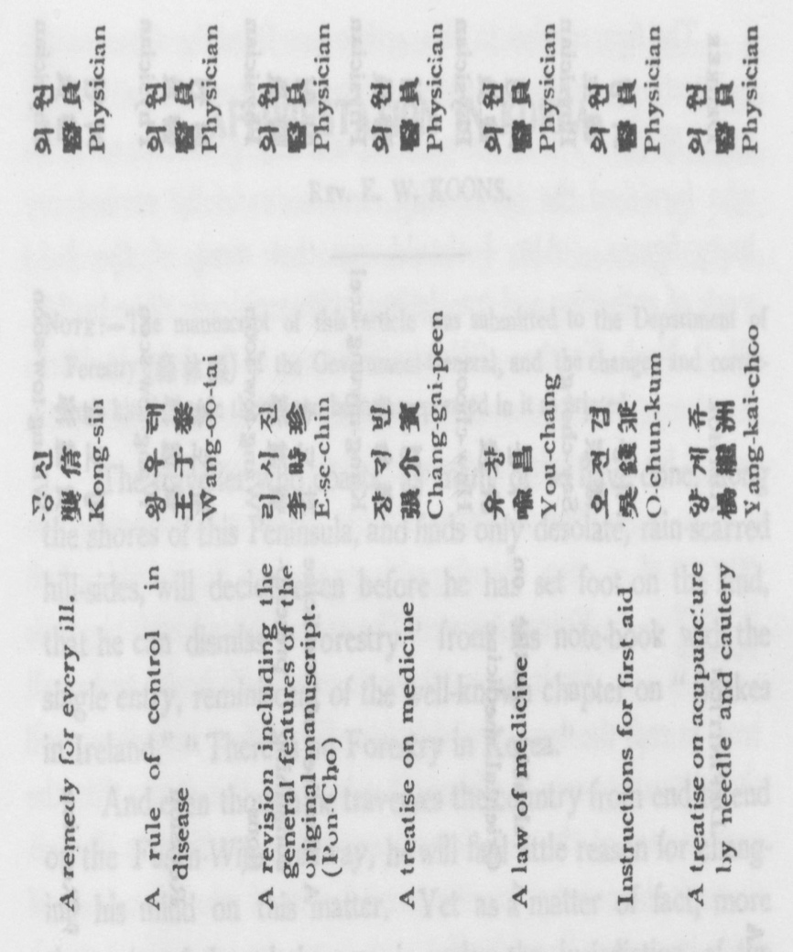

[page 34]

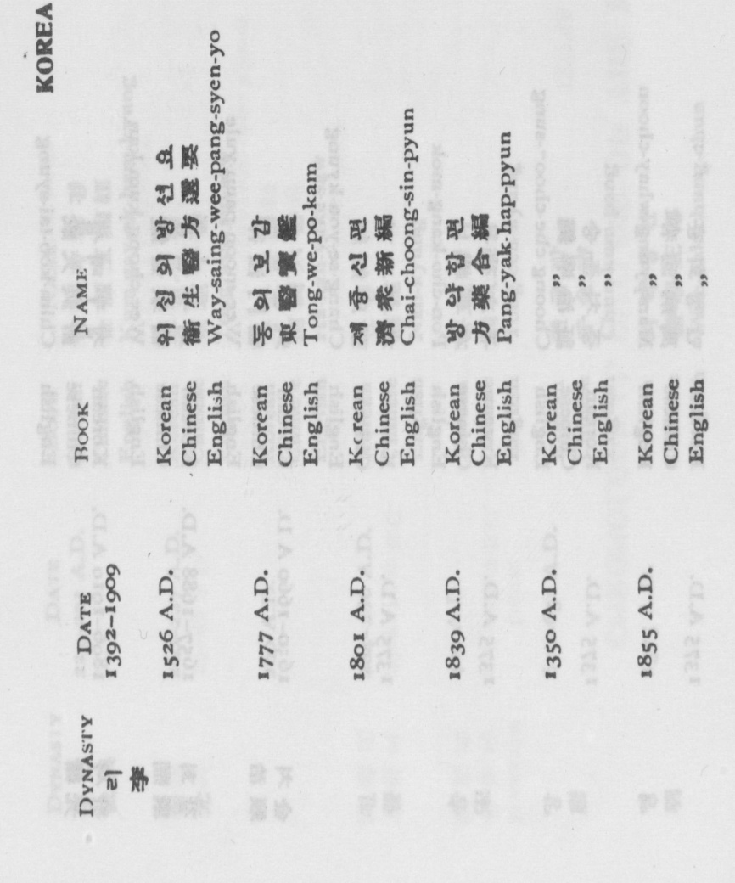

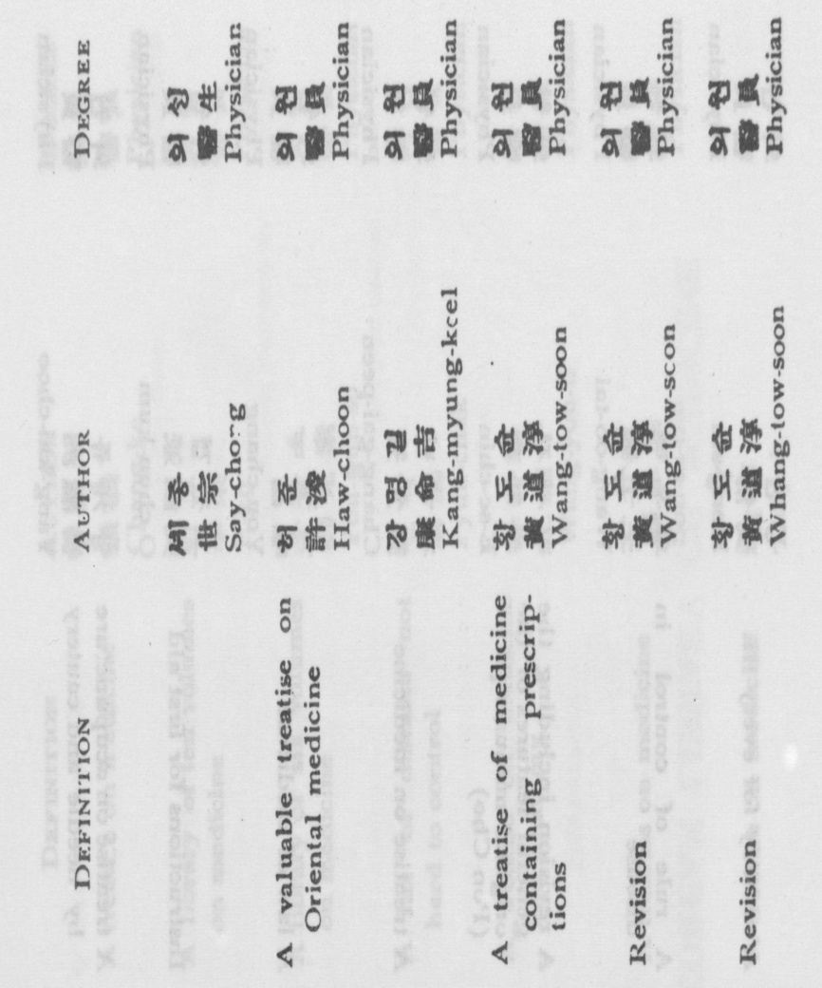

[page 35]

**AFFORESTATION IN KOREA**.

REV. E. W. KOONS.

NOTE :—The manuscript of this article was submitted to the Department of Forestry (森 林 課) of the Government-General, and the changes and corrections kindly made there have been incorporated in it as printed.

The traveller who coasts, as many of us have done, along the shores of this Peninsula, and finds only desolate, rain scarred hill-sides, will decide even before he has set foot on the land, that he can dismiss “Forestry” from his note-book with the single entry, reminiscent of the well-known chapter on “Snakes in Ireland,” “There is no Forestry in Korea.”

And even though he traverses the country from end to end on the Fusan Wiju Railway, he will find littie reason for changing his mind on this matter. Yet as a matter of fact, more than 4/5 of the whole area is under the jurisdiction of the Forestry Bureau, and more than 1/4 is covered today with virgin forests, of stately pines and sturdy oaks ; while the larger forest animals, bears, leopards, and tigers, roam the lonely glades, and prey upon the deer and boar there.

It may be well to mention in passing a matter of strictly historic interest. Though the causes of the war between Russia and Japan were many and complex, the final occasion was a Forestry Concession in Korea. The Russians had permission to cut and handle lumber on the Yalu, and with this as a pretext, they had made a settlement at the little port of Yongampo, at the mouth of the Yalu. Their refusal to abandon this was the match which lighted the great conflagration.

In the Summer of 1904 I visited Yongampo, and saw the one-time Russian lumber mills running at full capacity, with a host of Chinese, Japanese, and Korean hand- sawyers also at work. I have never seen finer timber than the great 40 and 60 foot pieces that hard come down to them from the forests of North Pyeng An Province (平安北道).  [page 36]

The figures used in this article are from the Government publications, chiefly the 1914 edition of “Latest Korea” (最近朝 鲜事情)—I wish here to express my gratitude to those who furnished the information, and so carefully revised my hasty figures. Also I should say that most of the hard work of gathering and translating the material was done by Mr. W. C. Narh, Teacher of Natural sciences in the John IX Wells Academy, who has made a specialty of Forestry, and kindly put all his knowledge of technicalities at my service.

History of Korean Forests

The Forestry Bureau issues a remarkably fine map, showing with great detail the location of all Forest Areas, The areas covered with big trees are in green, those covered with brush and small trees in red, the land available for afforestation in yellow, and the cultivated areas in white. A glance at this shows that the greater part of the real forests are in the far North. But all through the country are scattered forests of good size, some of them in or near Seoul itself.

These trees have been protected by their inaccessibility, or for religious or sentimental reasons. The former consideration accounts for the great forest stretches in Ham Kyung (咸 鏡 道), Kang Won (江 原 道) and Pyeng An (平 安 道) Provinces. The “sacred troves” surrounding temples, shrines, and tombs owe their existence to the second class of reasons. We cannot but be thankful for the instinct of reverence that has spared these fine woodlands, often close to good markets.

It is evident to anyone who takes the trouble to make a few observations, that the forest areas in Korea have been steadily dwindling, even in the past few decades. Less than forty years ago, one of the higher passes on the road between Seoul and Pyeng Yang was so infested with tigers that travel was seriously hampered. The Regent, known to history as Tai Wun Kun (大 院 君), had the forests cleared away for three miles on either side of the road This was in line with progress, for it got rid of the tigers and encouraged travel ; but it destroyed a forest that has never been replaced. Doubtless [page 37] this has been the history of many a forest. The growth of population has worked against the forests in two ways. It has increased the demand for building materials, while it also pushed the line of cultivation higher on the hills year by yean A few years ago it was common, in my old itinerating field in Whang Hai Province (黃 海 道), to find new clearings in the making, with the ground freshly burned over, and a few little fields wrested from the all too scanty forest lands.

Another factor is the export trade in lumber, railway sleepers, and charcoal. Leaving out the firewood that is smuggled out of the country, mostly by junks that cross the Yellow Sea and put in at some little creek, to return home a few weeks later loaded with bundles of wood, the Customs figures amount to ￥152,440 in 1910, and more in 1912.

The imports for the same years show clearly enough the need of afforestation. In 1910 they amounted to more than ten times the exports, and in 1912 to ￥2,263,982, or more than fourteen times the exports. It is interesting to know that the imports from the United States amounted in 1912 to ￥86,ooo, or more than half the whole amount of exports. An important part of this is veneer, used for finishing the railway cars, etc. This, as well as much of the building lumber imported from the United States is of a nature that will not be produced in this country for many years to come.

This importation of lumber illustrates only a part of Korea’s dire need of more forests, and better care for the trees already growing. We are all familiar with the gulliea hill-sides, and their corollary, the sand-choked water-courses, that wander sluggishly through the plains below, or, too often, turn aside from the shallow channels their own sediment has blocked, to devastate the fields, and cover them with a forbidding layer of sand and stones.

We know the furious floods of Summer, and the dreary drouths of Fall and Spring. Many a time I have come into Chairyung (載 寧 郡) late at night, and found a group of women patiently waiting at each of the little seep-holes (I  [page 38] cannot call them springs) where the water trickles out of the rocks. They would wait half the night, in the cold and darkness, for the sake of one more jar of water for use the next day. These are among the penalties a land pays when it has been stripped of its forests. Afforestation will mend these conditions ; it may even affect the climate and agricultural possibilities. We who live in Seoul cannot doubt that the bare hills encircling the City intensify the heat of Summer, as they reflect the sun’s rays from their bare slopes.

Still, I am not as extreme a believer in afforestation as the visitor who was taken to see Puk Han (北 漢). He took a good look at those granite peaks, rising sheer above the city walls, and finally said “They will be all right, when they are covered with pines.” Forestry has its limits, and we can all be glad that the prospect of seeing Puk Han turned into a forest is too far away to worry our generation.

Forest-Areas

The largest body of real forest, that is, of big trees (成林地), is in South Ham Kyung Province (咸羅鏡道), It covers 5,737 square miles. The smallest is in South Chulla (全羅南道) 333 miles. Kung Ki (京 畿 道) is 9th among the 13 Provinces, with 458 miles. This is a large area, when you consider Seoul’s constant demand for lumber and fuel. Most of it is in groves surrounding graves, either Royal or private.

The whole area of forests (of big trees), is about 20,000 square miles, almost 30 per cent of the whole country. Much of this is owned by the State, a large part of the remainder by Buddhist Monasteries, some by individuals or clans. Much of it has no legal owner, as titles to Forest Lands were not clear in the old days. It is only since 1910 that any concerted effort at delimitation has been made. It is reassuring to read, on Page 179 of the “Report of Progress” for 1912-13, that in the case of forests whose owners have failed to make the proper reports “they may be transferred to their bona fide owners”

The present Forestry law wisely provides that no trees [page 39] may be cut in these forests, whether owned by the State or privately, without permission from the Governor-General or the Provincial Governor, and it makes one of the conditions for this permission the planting of seedlings to replace the trees that are to be cut.

Next in importance to this 20,000 miles of big trees, is the more than 25,000 square miles of young trees, brush, etc., called 稚樹發生地. This is the basis of the native fuel supply. Much of the land is owned by individuals and clans, but more by the State. Most of it is cut over each year, the brush being cut short, and part of the branches taken from the trees. These cuttings come to us in the shape of the young mountains of brush for fuel that move majestically through the streets of every town or city in Korea.

The third area under the care of the Forestry Department is the waste land, not used for agriculture, and not furnishing a regular crop of marketable fuel, and so, as a rule, not claimed by any owner. There are 16,000 square miles of this, and it is all open for afforestation, except some comparatively small tracts already taken by individuals and firms.

The land under cultivation is 11,123 square miles. This makes the following proportions for the various kinds of land:

Cultivated fields 15.3%

Forests of Big Trees 27.4,,

Bushes and Small Trees 35.4 ,,

Open for Afforestation 21.9 ,,

As the Forestry Department has charge of all but the first, the rather startling statement at the beginning of this article is justified. As a basis of comparison, we may note that the area under cultivation in Japan Proper is 18.5 per cent, and in Germany (before the war) 93.6 per cent.

Character of the Korean Forests

In the Northern part of the country they are composed mostly of slender-leaved woods, and are enumerated as 19 varieties, pines greatly predominating. In the Southern part there are 116 varieties of forest trees, with 3 kinds of bamboo included. Here they are mostly broad-leaved, like the oak.  [page 40]

We should note that fruit trees are not included in this enumeration. Let those who are familiar with the chestnut and the persimmon (not the puckery little object that goes by that name in the United States, but the Persimmon Dc Luxe that we have here) judge the importance of this omission. I recall the occasion when I was making a long trip ill the country, and my supply of dried prunes, that stand-by of the itinerator, was running low. We came to a village where the “market” was being held, and I despatched my boy to get a supply of fruit. He came back empty-handed, for with three kinds of fruit for sale, he could not decide which would be best. Cross-questioning developed the fact that the three kinds of fruit were chestnuts, potatoes, and turnips !

Work of Afforestation

The Government made its beginning of this in 1907. Seedling stations were opened in 1908, and by 1913 these numbered 319. They are maintained by the Government-General, by Provincial and Prefectural authorities, and (a few only) private enterprise. The Imperial Grant made at the time of annexation is also used in supporting some of these stations, particularly for raising mulberry trees, for the sake of the silk-worm industry. One of these mulberry groves can be seen inside the Su Ku Mun (水口門) of Seoul, and one of the large seedling stations is outside the West Gate, directly between the proposed site of the Chosen Christian College and the City. It is worth a visit The Government Stations reported in 1912 almost 25 million plantlets, and the Government-General spent on this work over ¥166,000 that year. The rapid growth of Afforestation can be seen from this Table: It shows the principal agencies now doing this work, and dates when they began, as well as their relative results.

PLANTED BY YEAR TREES ACRES YEAR TREES ACRES

General Government. 1907 72,000 30 1913 1,015,000 276

Local And Provincial 1911 15,000 13 1913 836,000 518

Authorities

Private Enterprise. 1910 1,947,0001,243 1913 38,355,000 47 SQ. MI.

This “Private Enterprise” is principally the work of the [page 41] Mitsui Firm and the Oriental Development Company, both of which are planning to raise material for railway and other construction on a large scale.

The last figure will be better understood when one remembers that it means 3 little trees planted in one year for every man, woman, and child in this country, and yet that only one acre in 300 of those available for afforestation was planted.

An interesting part of this work is planting for Memorials (記念植樹). This is done by the people, along roads, on common village property, and in other similar locations. In 1913, 12,431,000 trees were planted in this way, almost one for each person in the country. Arbor Day is observed on April 3d, and the highest officials set the example of tree-planting on that day.

Assignment of Land for Afforestation

Seeds and seedlings from the Government Stations are distributed free to encourage afforestation. In 1913 over 14,885,000 trees (one for each person in the country) and 645 bushels of tree-seeds, were so distributed. The varieties so far cultivated are the Pine, Acacia, Poplar, Chestnut, and Wild Oak. The silk-worms that produce the thread used in making Pongee feed upon the leaves of the last-named. Two Experimental Farms are trying various kinds of trees, in the hope of finding those best adapted to local conditions.

Government land will be assigned to those who are fitted to carry out afforestation projects. This may be in the form of a lease, or a deed. Usually the former is given for a time, as an

experiment, and is followed by the latter, when the one in charge has proved his fitness. So far some 400 or 500 of the 16,000 square miles available has been so taken, but the amount is rapidly increasing year by year.

This assignment is made after an application has been filed with the Local Authorities. If it has their approval, it is transmitted to the Forestry Bureau, which takes action. The qualifications essential to an applicant are two, namely : Financial [page 42] ability to carry out the enterprise, and zeal for this sort of work.

If more than one person applies for the same piece of land,

and all have the above qualifications in equal measure, the preference is given to the one who shows the following :

1. Public Spirit.

2. Former Relation to the Land — See Government-General Regulations, 1912, Number 10, Paragraph I.

3. A Native of the District.

4. Immigrants (those who have come in a body).

5. A former claim upon the land.

The need of afforestation is evident to all. We who have made our homes in this land can congratulate ourselves, and the people of Korea may well be glad, in knowing that this great and pressing problem is so well met by the Government. We can also be glad that private enterprise is sharing the work, and hope that it will be so profitable that this will be greatly extended Most of all, we rejoice to know that the Government is showing the people how to do their part, and that they are taking advantage of its assistance.

Those 12 millions of Memorial trees are a hopeful sign for Korea.

[page 43]

**MINUTES OF THE ANNUAL MEETING OF THE KOREA BRANCH, ROYAL ASIATIC SOCIETY**.

Held in the Seoul Union, Friday, Feb. 5, 1915.

Dr. Mills presided, while Dr. Gale read a most interesting and instructive paper on the “Marble Pagoda” giving the true story of its origin. A unanimous vote of thanks was passed.

At 5 : 00 the Annual Business Meeting was called to order, with Dr. Mills in the chair. All the officers except Dr. Kruger were re-elected. In his place as Councilor Hon. R. S. Miller, U. S. Consul-General, was elected.

The members present at this meeting were : Bishop Harris, Mr. Bon wick, Dr. Gale, Mr. J. H. Morris, Mr. Hugh Miller, Mr. F. H. Smith, Mr. R. S. Miller, Mr. J. F. Genso, Dr. Ludlow, Mr. Snyder, Mr. Burdick, Mr. Cable, Dr. Mills, Dr. Noble, Mr. Bunker, Mr. Beck, Mr. Lay, Mrs. Gale, and Mr. Koons.

**REPORT OF THE COUNCIL**.

This has been a prosperous year for the Korea Branch of the Royal Asiatic Society. Council meetings have been held monthly except during the summer.

Nearly forty persons have been elected to membership during the year. The Treasurer reports dues received from 79 members. His balance sheet is as follows :

BALANCE SHEET R. A. S. ACCOUNT 1914.

DR.

DEPOSIT IN BANK

CASH ON HAND 1/1/14

DUES AND FEES

SALES BY CUSTODIAN

BANK INTEREST ¥703.79 116.12

I84.53

49.5° 1.50

￥1055.44

CASH FOR PRINTING

POSTAGE AND SUNDRIES ..............

CHAIRS (30) FOR SEOUL UNION DEPOSIT RECEIPT

Cash in Bank 12/1/14 ...

￥ 141.81

44.37

703.79 IO6.97 ￥1055.44

￥1055.44

[page 44]

The Librarian makes the following report :

LIBRARIAN’S REPORT.

The following Exchanges have been received during the

year :--

Geographical Journal of R. G. S. London.

Bulletin of the American Geographical Society.

Journal of the Royal Asiatic Society, London.

Transactions of Asiatic Society of Japan.

Transactions of Bombay Branch of R. A. S.

Annual Report of Smithsonian Inst 1911 and 1912.

Only six books have been loaned for reading during the year.

The following is the stock in hand at the present time : —

240 TRANSACTIONS VOL. I. PART 1. 1900 ⑪ 3.00

280 DO DO II. DO 1. 1901 ⑪ 2.50

321 DO DO II. do 2. 1902 ⑪ 3.00

274 DO DO III. DO 1. 1903 ⑪ 2.50

357 DO DO IV. DO 1. 1912 ⑪ 1.50

408 DO DO IV. DO 2. 1913 ⑪ 2.50

403 DO DO IV. DO 3. 1913 ⑪ 2.50

358 DO DO V. DO 1. 1914 ⑪ 2.50

We are now ready to send to the printers the manuscripts for Vol. VI, Part I, which will contain the paper on “Korean Medicine” by Dr. N. H. Bowman, and on “Afforestation” by Rev. E. W. Koons.

There is promise of a number of other papers for 1915, and we hope for a still larger membership during the year.

[page 45]

OFFICERS FOR 1915

President

REV. J. S. GALE, D. D.

VICE PRESIDENT

RALPH G. MILLS, M. D.

Corresponding Secretary

S. A. BECK.

Recording Secretary

E. W. KOONS.

TREASURER

D. A. BUNKER.

Librarian

GERALD BONWICK.

councillors

R. S. MILLER, (American Consul General) I. YAMAGATA, (Editor “Seoul Press”) A. H. LAY, (British Consul General)

[page 46]

**LIST OF MEMBERS, KOREA BRANCH, ROYAL**

**ASIATIC SOCIETY.**

HONORARY MEMBERS.

Alien, Hon. H. N., M. D. LL. D Toledo, Ohio, U. S. A.

Gubbins, J. H., C. M. G c/o Foreign Office, London.

Hulbert, H. B., Prof Springfield, Mass., U. S. A.

Jones, Geo. IL, D. D. 150 Fifth Avenue, New York.

Jordan, Sir John Peking, China.

Ross, Rev. John, D. D. Moukden, Manchuria.

ORDINARY MEMBERS.

Albertson, Miss M. M. Seoul.

Asami, R Judge of Supreme Court, Seoul.

Avison, Dr. O. R. Seoul.

Badcock, Rev. J. S Pai Rchun.

Beck, Rev. S. A Seoul.

Bolljahn, J Seoul.

Bonwick, Gerald Seoul.

Bowman, Dr. N. H Seoul.

Bridle, Rev. G. A Suwon.

Brinckmeier, R ........ Chemulpo.

Bunker, Rev. D. A Seoul.

Bunker, Mrs. D. A … Seoul.

Burdick, Rev. G. M Seoul.

Collyer, Rev. C. T … Wonsan.

Crispin, J. F London, England.

Cutler, Dr. M. M Pyeng Yang.

Elliot, Sir Charles University of Hongkong.

Forsyth, Miss Helen Seoul.

Gale, Rev. J. S., D. D. Seoul.

Genso. J. F Seoul.

Gillett, P. L Shanghai, China.

Greenfield, Rev. M. W Taiku.

Grifin, J. T Yokohama, Japan.

Grove, Rev. L Pyeng Yang.

Hall, Mrs. R. S., M. D. Pyeng Yang.

Harris, Bishop, M. C. Seoul.

Haven, Rev. Dr. W. I. Bible House, Astor Place, New York. [page 47]

Hoffman, Rev. C. S Kangkei.

Holdcroft, Rev. J. G., Pyeng Yang.

Hooker, J. T Spartanburg, S. C., U. S. A.

Irvin, Dr. C. H ............ Fusan.

Kanazawa, Dr. S ............ Imperial University, Tokyo, Japan.

Kavanaugh, J Shanghai, China.

Koons, Rev. E. W Seoul.

Kruger, Dr. F., Ph. D German Consul General, Seoul.

Lay, A. Hyde British Consul General, Seoul.

Leadingham, Dr. R. S Mokpo.

Ludlow, Dr. A. I. Seoul.

McEachern, Rev. John Kunsan.

McGary, E. ....................................................... Seoul.

Macrae, Rev. F. J. L Kuchang.

Miller, Hugh Seoul.

Mills, Edwin W. Tul Mi Chung Mine, Korea.

Mills, Dr. R. G Seoul.

Min Yung Chan Seoul.

Moffett, Dr. S. A. Pyeng Yang.

Moore, Rev. J. Z Pyeng Yang.

Moose, Rev. J. R. Seoul.

Morgan, Hon. E. V. Dept. of State, Washington, D. C.

Morris, Rev. C. D. Pyeng Yang.

Morris, J. H Seoul.

Niwa, S. Japanese Y. M. C. A., Seoul.

Pye, Miss Olive F Seoul.

Reiner, R. O. Taiku.

Rhee, Dr. S. M. Honolulu, Hawaii.

Rhodes, Rev. H. A Kangkei.

Richard, Rev. Dr. Timothy Shanghai.

Robbins, Miss H. P Pyeng Yang.

Scidmore, Hon. G. H American Consul General, Yokohama,

Japan.

Scranton, Dr. W. B. Chicksan.

Shidehara, Dr President Hiroshima Higher Normal

School, Japan.

Smith, Rev. F. H Seoul.

Smith, Dr. R. K. Andong.

Smith, Rev. W. K Pyeng Yang.

Snyder, L. H Seoul.

Starr, Prof. Frederick Chicago University, Chicago, Illinois.

Swearer, Rev. W. C Kongju.

Stillman, E. G, M. D. 83o Park Ave., New York.

Tate, Rev. L. B Chunju.

Taylor, W. W Seoul. [page 48]

Townsend, W. D Chemulpo.

Trollope, Rt. Rev. Bishop M. N Seoul.

Underwood, Rev. Dr. H. G Seoul.

Van Buskirk, Rev. Dr. J. 1… Seoul.

Wada, Dr. Y Directormeteorological Observatory, Chemulpo.

Welbon, Rev. A. G Andong.

Whittemore, Rev. N. C Syenchun.

Williams, Prof. F. W New Haven, Connecticut, U. S. A.

Yamagata, Mr. Isoh “Editor Seoul Fress,” Seoul. [page 49]

**CATALOGUE**

“TRANSACTIONS OF THE KOREA BRANCH OF THE ROYAL ASIATIC SOCIETY.”

VOLUME I. PART I ONLY. 1900.

Price Yen 3.00.

Contents : —

Influence of China upon Korea.

Korean Survivals.

Colossal Buddha at Eun-jin.

Minutes of General Meeting.

Appendix :—

Office Bearers.

List of Members.

Constitution and By-Laws.

VOLUME II. PART I. 1901.

Price Yen 2.50.

Contents

Kang-Wha.

The Spirit Worship of the Koreans.

VOLUME II. PART II. 1902.

Price Yen 3 00.

contents : —

Han-Yang (Seoul).

Korean Folk-Tales.

Minutes of General Meetings.

Report of the Council.

Appendix : —

Officers.

List of Members.

VOLUME III. PART I only. 1903.

Price Yen 2.50.

Contents ： 一

Ch’oe Ch’e-Wun : His Life and Times. [page 50]

The Culture and Preparation of Ginseng in Korea. Minutes of Annual Meetings. Report of the Council.

Appendix :—

Officers.

List of Members.

Catalogue of the Landes Library.

VOLUME IV. PART I. 1912.

Price Yen 1.50.

Contents :—

The Old People and the New Government.

The Korean Alphabet.

VOLUME IV. PART II. 1913.

Price Yen 2.50.

Contents :—

Japanese-Korean Relations after the Japanese invasion

of Korea in the 16th Century. The Village Gilds of Old Korea. Coinage of Old Korea.

Minutes of Important Meetings.

VOLUME IV. PART III. 1913.

Price Yen 2.50.

Contents :—

Marriage Customs of Korea.

Selection and Divorce.

The Celestial Planisphere of King Yi Tai-Jo.

VOLUME V. PART I only. 1914.

Price Yen 2.50.

Contents:—

Some Recent Discoveries in Korean Temples and

their Relationship to Early Eastern Christianity.

A Plea for the Investigation of Korean Myths and

Folklore. Catalogue.