REPORT ON INVESTIGATIONS

No.2-January,1924

DEVELOPMENT AND TREND OF THE AUTOMOTIVE TRANSPORTATION IN CHOSEN.

Reviewing the condition of the automotive transportation in Chosen, its development is still in its infancy and by no means to be compared with Europe and America, though, in consideration of the degree to which the railways are extended and the roads improved, it may be said to be comparatively speaking far better developed than in Japan or Taiwan. Especially in the past few years, this automotive transportation business has been markedly extended. At the end of

March 1922, there were in Japan 8,265 automobiles for passenger service and 1,383 for freight service, while in Chosen there were only 31 automobiles in 1913 but the number increased to 935 in 1922, its development during this period being greater than any of the land traffics. For the purpose of comparison the following statistics of the conveyances for the last 10 years will be reviewed :—

|  |  |  |  |  |  |  |
| --- | --- | --- | --- | --- | --- | --- |
| Year | Auto | Ricksha | Hand Cart | Bull Cart | Horse Cart | Horse Carriage |
| 1913 | 31 | 2,692 | 7,072 | 45,689 | 1,442 | 198 |
| 1914 | 43 | 3,167 | 9,355 | 78,244 | 1,642 | 228 |
| 1915 | 70 | 3,424 | 9,422 | 65,428 | 1,904 | 212 |
| 1916 | 79 | 4,133 | 11,778 | 68,658 | 2,269 | 199 |
| 1917 | 114 | 4,605 | 15,689 | 51,075 | 2,498 | 213 |
| 1918 | 212 | 4,811 | 18,236 | 63,294 | 2,614 | 231 |
| 1919 | 416 | 4,933 | 19,507 | 67,873 | 3,601 | 135 |
| 1920 | 679 | 4,950 | 21,658 | 66,071 | 4,500 | 84 |
| 1921 | 774 | 4,527 | 26,680 | 68,736 | 3,939 | 111 |
| 1922 | 935 | 4,494 | 29,196 | 89,425 | 4,343 | 102 |

Of course the condition of the traffic in Chosen, especially the traffic by carts and horses is necessarily different according to the geographical conditions. In western Chosen, where there are so many out-of-the-way places, and where the country is so intersected by high mountains, the traffic is, unlike[page 58] in South Chosen, very difficult in many places. On the other hand the traffic between important places in South Chosen is almost all opened for the horses and carts to travel very easily. Hence the recent rise of the prosperous automotive transportation with the tendency to increase still more.

According to the investigation instituted by the Police Affairs Bureau of the Government General comparing the condition of the recent development of the passenger automobile service with that of 1919, when the system was revised, the automobile line extended only 1,053 ri (1 ri二2.4403 miles), but at the end of January 1923 it increased to 2,565 ri. increasing about times in three years. At present the railway lines in Chosen, both state and private, extend 1,454 miles, and so the automobile lines extend more than four times those of the railways.

The following is a comparative table showing the increase of the automobile lines: -

(Investigated by Police Bureau).

|  |  |  |  |
| --- | --- | --- | --- |
| PROVINCE | Number of miles run  by 1919 (when the system  was revised) | automobiles  Jan. 31 19 3 | RATE OF  INCREASE |
| keiki . . | 74 ri 32 cho | 157 ri 4 cho | 2 10 times |
| North Chusei | 41 ri 27 cho | 135 ri 13 cho | 3.24 ,, |
| South Chusei | 112 ri 13 cho | 202 ri 14 cho | 1.80 ,, |
| North Zenra | 53 ri 22 cho | 142 ri 30 cho | 2.66 ,, |
| South Zenra | 54 ri 13 cho | 253 ri 20 cho | 4.66 ,, |
| North Keisho | 158 ri 14 cho | 293 ri 31 cho | 1.86 ,, |
| South Keisho | 72 ri 8 cho | 270 ri 2 cho | 3.74 ,, |
| Kokai . . | 98 ri 18 cho | 170 ri 27 cho | 1.73 ,, |
| South Heian | 70 ri 2 cho | 245 ri 11 cho |  |
| North Heian | **98 ri** 18 cho | 182 ri 32 cho | 1 86 ,, |
| Kogen . . | 140 ri 1 cho | 267 ri 14 cho | 1.91 ,, |
| South Kankyo | 59 ri 15 cho | 159 ri 26 cho | 2.69 ,, |
| North Hankyo | **19 ri** 16 cho | 84 ri 16 cho | 4.41 ,, |
| Total . | 1,053 ri 18 cho | 2,565 ri 24 cho | — |
| Average. . | . . . . . | . . . . . | 2.44 times |

[page 59]

Now we will review the number of persons engaged in automobile service. At the end of June 1923 persons engaged in passenger automobile service numbered 233, those in the automobile let out for hire 82, and those in the freight automobile service 25, showing that the last mentioned service was in the most unprosperous condition. Following is a table showing the condition of the automobile service since 1920:—

NUMBER OF PERSONS ENGAGED IN AUTOMOBILE SERVICE.

(Investigated by Police Bureau).

|  |  |  |
| --- | --- | --- |
| Date | Number of persons  engaged in  automobile service | Specification |
| December 31 1920 | 337 | Passenger Service 256   Letting out for hire 56  Freight Service 25 |
| December 31 1921 | 415 | Passenger Service 324  Letting out for hire 69  Freight Service 22 |
| December 31 1922 | 323 | Passenger Service 221 Letting out for hire 79 Freight Service 23 |
| June 30 1823 | 340 | Passenger Service 233  Letting out for hire 82  Freight Service 25 |

For the purpose of reviewing the extension of the automobile lines at present in Chosen, there is shown below the table of distances of the automobile lines in the provinces in March 1923，investigated by the Public Works Department of the Government General. In Chosen also, though on a small scale, some Railway Companies engage in Automobile Service. The Automobile service between Heiko and the Diamond Mountains, between Genzan and the Diamond Mountains, and between Seishin and Ranan by the South Manchuria Railway Company, and between Shojo, Keigen and Onjo by the Tomon Railway Company, and a few examples, and the connection of Railways and automobiles is recently greatly on the increase. The joint run by the Automobile Companies and the Railway Companies is also carried for the convenience of the passengers. [page 60]

TABLE OF DISTANCES OF AUTOMOBILE LINES IN THE

PROVINCES.

(Investigated by Public Works Dept.)

|  |  |  |
| --- | --- | --- |
| P**rovince** | Name of the P**oints** | D**istance** |
| Reiki | Hekirauto - Ryochoho | 10 ri 9 cho |
| **,,** | Kanjo - Saikato | 1 ri 18 cho |
| **,,** | Chota - Koroho | 4 ri 12 cho |
| **,,** | Seoul - Shotein | 19 ri |
| **,,** | Seoul -Koyo | 5 ri 23 cho |
| **,,** | Seoul - Kinho | 8 ri 1 cho |
| **,,** | Seoul - Kokei | 17 ri |
| **,,** | Seoul - Suigen | 28 ri 12 cho |
| **,,** | Tonori - Ryosinto | 3 ri |
| **,,** | Suigen - Gumpocho | 6 ri |
| **,,** | Suigen - Hatsuancho | 5 ri 28 cho |
| **,,** | Yosni -Hakuan | 5 ri |
| **,,** | Risan - Chokoin | 6 ri 31 cho |
| **,,** | Chokoin -Anjo | 8 ri 17 cho |
| **,,** | Anjo - Heitaku | 5 ri |
| **,,** | Chokoin - Chushu | 11 ri 18 cho |
| North Chusei | Chushu - Teisen | 12 ri 16 cho |
| **,,** | Teisen - Boundary line of |  |
| **,,** | the Province | 4 ri |
| **,,** | Teisen - Tanyo | 8ri |
| **,,** | Chushu - Boundary line of |  |
| **,,** | the Province | 9 ri 34 cho |
| **,,** | Taishoin - Seishu | 14 ri 25 cho |
| **,,** | Hautan - Kaisan | 4 ri 6 cho |
| **,,** | Seishu -Seisencho | 13 ri 29 cho |
| **,,** | Seishu - Eenki | 4 ri 24 cho |
| **,,** | Seishu - Chinsen | 6 ri 27 cho |
| **,,** | Ho-on - Totei | 7 ri 34 cho |
| **,,** | Seisan - Mushu | 11 ri 12 cho |
| South Chusei | Kaushin - Toshin | 4 ri 25 cho |
| **,,** | Toshin - Reisan | 12 ri |
| **,,** | Jesan -Tokusan | 13 ri |
| **,,** | Jasan - Taian | 4 ri |
| **,,** | Reisan - Koshu | 4 ri |
|  |  |  |
|  |  |  |
| **[page 61]** |  |  |
| Province | Name op the Points | Distance |
| South Chusei | Reisan - Jasan | 15 ri 15 cho |
| **,,** | Reisan - Koji | 8 ri 9 cho |
| **,,** | Koshu - Seiyo | 6ri |
| **,,** | Reisan - Kunsan | 27 ri 12 cho |
| **,,** | Seiyo - Taisen | 7 ri 2 cho |
| **,,** | Jasen - Kigan | 7 ri 32 cho |
| **,,** | Kigan - Ronsan | 6 ri 7 cho |
| **,,** | Kauhei - Kokei | 5 ri 29 cho |
| **,,** | Ronsan - Kokei | 2 ri 15 cho |
| **,,** | Koshu - Ronsan | 8 ri 28 cho |
| **,,** | Sashu - Jujocho | 10 ri |
| **,,** | Jujocho - Taiden | 2 ri 29 cho |
| **,,** | Taiden - Kinshu | 8 ri 13 cho |
| **,,** | Koshu -Eenki | 6 ri 20 cho |
| **,,** | Reisan -Tinsan | 10 ri |
| **,,** | Tenan - Chinsen | 9 ri 34 cho |
| **,,** | Hakusekiko - Tompo | 2 ri 28 cho |
| **,,** | Tompo - Seigan | 3ri |
| **,,** | Seigan - Ryotai | 2ri 8 cho |
| Kokai | Sinan - Joko | 12 ri 6 cho |
| **,,** | Koshu - Tokuyocho | 5 ri 3 cho |
| **,,** | Kyokusan - Nausenden | 17 ri 6 cho |
| **,,** | Nausenden - Onjoin | 9 ri 16 cho |
| **,,** | Shikeuri - Kin sen | 6 ri 7 cho |
| **,,** | Kaishu - Shariin | 18 ri 35 cho |
| **,,** | Hokuso - Sainei | 11 ri 34 cho |
| **,,** | Sainei - Shinsen | 3 ri 19 cho |
| **,,** | Angaku - Shinsen | 5 ri 33 cho |
| **,,** | Onjoto - Choren | 3 ri 15 cho |
| **,,** | Kaishu - Kinka | 23 ri 15 cho |
| **,,** | Kaishu - Mokinko | 33 ri 5 cho |
| **,,** | Kyotsito - Shosekishi | 2 ri 12 cho |
| North Keisho | Shuntai - Eisen | 9 ri 17 cho |
| **,,** | Nojo - Anto | 5 ri 14 cho |
| **,,** | Eisen - Reisen | 6 ri 3 cho |
| **,,** | Reisen - Keusho | 7 ri 8 cho |
|  |  |  |
| [page 62] |  |  |
| Province | Name of the Points | Distance |
| North Chusei | Nansho - Boundary of the | 7 ri 32 cho |
| Province |
| **,,** | Kansho - Shochu | 5 ri 22 cho |
| **,,** | Shosho - Kiosen | 9 ri 17 cho |
| **,,** | Kinsen - Boundary line of | 10 ri 12 cho |
| the Province |
| **,,** | Chosen - Shoshu | 14 ri 32 cho |
| **,,** | Kinsen - Zensan | 5 ri 34 cho |
| **,,** | Zensen - Kyubi | 3 ri 27 cho |
| **,,** | Jakusin - Toteido | 2 ri 1 cho |
| **,,** | Toteido - Jindo | 3 ri 26 cho |
| **,,** | Toteido - Seishu | 3 ri 9 cho |
| **,,** | Seishu - Sosen | 3 ri 23 cho |
| **,,** | Reian - An to | 5 ri 2 cho |
| **,,** | An to - Gijo | 8 ri 5 cho |
| **,,** | Gijo - Chosen | 11 ri 6 cho |
| North Keisho | Chosen - Taikyu | 7 ri 14 cho |
| **,,** | Taikyu - Kinko | 5 ri 31 cho |
| **,,** | Kinko - Korei | 3 ri 19 cho |
| **,,** | **Korei -** Kaiiyi | 3 ri 12 cho |
| **,,** | Kinyokudo - Seito | 4 ri 11 cho |
| **,,** | Kinko - Heisondo | 3 ri 31 cho |
| **,,** | Taikyu - Kayo | 8 ri 17 cho |
| **,,** | / Kayo - Eisen | 1 ri 25 cho |
| **,,** | Eisen - Keishu | 9 ri 18 cho |
| **,,** | Keishu - Hoko | 7 ri 33 cho |
| **,,** | Hoko - Kyurocho | 5 ri 30 cho |
| **,,** | Hoko - Ryotoku | 11 ri 4 cho |
| **,,** | Ryotoku - Shihin | 6 ri 12 cho |
| **,,** | Kayo - Shinnei | 4 ri 9 cho |
| **,,** | Kayo - Jijin | 3 ri 25 cho |
| South Keisho | Hogyoshin - Torai | 9 ri 31 cho |
| **,,** | Torai - Kaiuntai | 2 ri 15 cho |
| **,,** | Torai - Fusan | 3 ri 26 cho |
| **,,** | Fusan - Katau | 1 ri 10 cho |
| **,,** | Torai - Ryssan | 4 ri |
| **,,** | Ryssan - Mokkin | 34 cho |
|  |  |  |
| [page 63] |  |  |
| Province | Name of the Points | Distance |
| South Keisho | Ryssan - Genyo | 7 ri 19 cho |
| **,,** | Genyo - Utsusan | 5 ri |
| **,,** | Kiho - Shinei | 9 ri 5 cho |
| **,,** | Shogen - Chinkai | 5 ri 2 cho |
| **,,** | Mitsuyo - Reisan | 7 ri 29 cho |
| **,,** | Shonei - Sokai | 7 ri 34 cho |
| **,,** | Masan - Toei - | 16 ri 14 cho |
| **,,** | Masan - Heisondo | 12 ri 19 cho |
| **,,** | Kyosai - Gyokuko | 6 ri 28 cho |
| **,,** | Masan - Shinshu | 18 ri 3 cho |
| **,,** | Banjo - Chinto | 8 ri 12 cho |
| **,,** | Kojo - Shisen | 7 ri 6 cho |
| **,,** | Shinshu - Sansenko | 8 ri 24 cho |
| **,,** | Koto - Shinshu | 12 ri 15 cho |
| **,,** | Shinshu - Kyosen | 13 ri 6 cho |
| **,,** | Kyosen - Korei | 7 ri 17 cho |
| **,,** | Shinno - Sennei | 7 ri |
| **,,** | Sennei - Tankai | 5 ri |
| **,,** | Tokusan - Tan jo | 3 ri 8 cho |
| **,,** | Tanjo - Kyosho | 21 ri 34 cho |
| **,,** | Shakin - Kanjo | 2ri |
| **,,** | Kyosho - Boundary line of | 5 ri 10 cho |
| the Province |
| **,,** | Tanjo - Tankai | 4 ri |
| **,,** | Roryoshin - Kato | 5 ri 16 cho |
| **,,** | Kato - Kakaishin | 4 ri |
| North Zenra | Kokai - Eikaishin | 6 ri 18 cho |
| **,,** | Riri - Suisenri | 29 cho |
| **,,** | Suisenri - Zenshu | 6 ri 12 cho |
| **,,** | Mankei - Kintei | 2ri 2 cho |
| **,,** | Kintei - Kinko | 3 ri 22 cho |
| **,,** | Kinko - Choyu | 12 ri |
| **,,** | Choyu - Kosho | 6 ri 24 cho |
| **,,** | Choyu - Shutsuko | 5 ri 14 cho |
| **,,** | Shotsuko - Fuan | 4 ri 29 cho |
| **,,** | Fuan - Taijin | 4 ri 21 cho |
| **,,** | Hoseiho - Kosho | 7 ri 20 cho |
|  |  |  |
| [page 64] |  |  |
| Province | Name of the Points | Distance |
| **,,** | Zenshu - Chinan | 10 ri 8 cho |
| **,,** | Zenshu - Nangen | 15 ri 26 cho |
| **,,** | Nangen - Kyokujo | 4 ri 20 cho |
| **,,** | Chinan - Chokai | 3 ri 22 cho |
| **,,** | Chokai - Mushu | 4 ri 22 cho |
| **,,** | Mushu - Boundary line of | 1 ri 21 cho |
| the Province |
| **,,** | Kinsan - Ryutan | 5 ri 30 cho |
| **,,** | Shunsho - Tanyo | 4 ri 8 cho |
| South Zenra | Reiko - Kanhei | 6 ri 18 cho |
| **,,** | Kanhei - Mokuho (Mokpo) | 9 ri 28 cho |
| **,,** | Reiko - Koshu | 13 ri |
| **,,** | Chokai - Chosin | 4 ri 14 cho |
| **,,** | Nanhei - Rashu | 6 ri 20 cho |
| **,,** | Koshu - Nankei | 3 ri 25 cho |
| **,,** | Nanhei - Ryoshu | 3 ri 16 cho |
| **,,** | Wajun - Hojo | 11 ri 35 cho |
| **,,** | Eisanho - Kainan | 16 ri 13 cho |
| **,,** | Kainan - Nanso | 6 ri 14 cho |
| **,,** | Kainan - Kozei | 2 ri 25 cho |
| **,,** | Kainan - Choko | 9 ri 14 cho |
| South Zenra | Reigan - Choko | 7 ri 26 cho |
| **,,** | Choko - Batsukyo | 14 ri 5 cho |
| **,,** | Koshu - Kosen | 9 ri 13 cho |
| **,,** | Koshu - Kyokujo | 12 ri 19 cho |
| **,,** | Tanyo - Shunsho | 4 ri 8 cho |
| **,,** | Tanyo - Gorenn | 2 ri 30 cho |
| **,,** | Tanyo - Chojo | 6 ri 28 cho |
| **,,** | Batsukyo - Koyo | 9ri 6 cho |
| **,,** | Koyo - Honan | 3 ri 6 cho |
| **,,** | Honan - Hogan | 5 ri 25 cho |
| **,,** | Batsukyo - Junten | 6 ri 18 cho |
| **,,** | Junten - Reisui | 10 ri 2 cho |
| **,,** | Junten - Koyo | 3 ri 7 cho |
| **,,** | Koyo - Senkyou | 4 ri 21 cho |
| **,,** | Koyo - Raikori | 3 ri 26 cho |
| **,,** | Junten - Kosen | 12 ri 25 cho |
| [page 65] |  |  |
|  |  |  |
| Province | Name op the Points | Distance |
| South Zenra | Junten - Kyokujo | 15ri 19 cho |
| ,, | Kesen - Kyokujo | 7 ri 23 chc |
| **,,** | Inson - Kyurei | 3 ri 24 cho |
| ,, | Kyurei - Shoteiri | 4 ri 10 cho |
| North Kankyo | Shojo - Kindo | 11 ri 22 cho |
| ,, | Onjo - Hokusohei | 10 ri 34 cho |
| ,, | Shinansan - Keiko | 13 ri 1 cho |
| ,, | Musan - Muryutai | 14 ri 1 cho |
| ,, | Muryutai - Funei | 2 ri 22 cho |
| North Kankyo | Seishin - Ranan | 4 ri 12 cho |
| ,, | Seiotsuonjo - Seikirei | 2 ri 21 cho |
| „ | Kisshu - Joshin | 9 ri 31 cho |
| ,, | Tokei - Riuseneki | 2 ri 28 cho |
| „ | Shoko - Joshin | 1 ri 3 cho |
| ,, | Todori - Jokaishin | 1 ri 15 cho |
| South Kankyo | Jakaishin - Rentairi | 3 ri 20 cho |
| „ | Todori - Sotairi | 2 ri 10 chc |
| ,, | Kaisanchin - Hokusei | 51 ri |
| ,, | Hokusei - Todo | 4 ri 31 cho |
| ,, | Todo - Shinsho | 1 ri 4 chc |
| ,, | Hokusei - Shinsho | 7 ri 34 ch( |
| **,,** | Shinho - Kogen | 4 ri 10 chc |
| **,,** | Kogen - Kanko | 14 ri *18* chc |
| ,, | Kyushin - Saiin | 9 ri 18 chc |
| „ | Shinkori - Kanko | 10 ri |
| ,, | Teikei - Boundary line of |  |
|  | the Province | 32 cho |
| **,,** | Gensan - Boundary line of |  |
|  | the Province | 15 ri 8 cho |
| ,, | Gensan - Anben Station | 2 ri 13 cho |
| ,, | Anben Station - Nansan | 4 ri 8 cho |
| ,, | Nansan - Shakuoji | 1 ri 20 cho |
| ,, | Gensan - Boundary line of |  |
|  | the Province | 3 ri 7 cho |
| North Heian | Kokai - Manchinho | 14 ri 3 cho |
| „ | Kokai - Kisen | 37 ri |
| **,,** | Kisen - Shinkou | 18 ri |
| [page 66] |  |  |
| Province | Name op the Points | Distance |
| North Heian | Shinkou - Genguri | 17 ri 30 cho |
| ,, | Gunguri - *heinen* | 4 ri |
| North Heian | Hokutetsu - Ouseiri | 3 ri 30 cho |
| ,, | Ouseiri - Unsan | 6 ri 36 cho |
| ,, | Unsan - Hakusen | 11 ri 30 cho |
| ,, | Hakusen - Mochuri | 2 ri 30 cho |
| „ | Shojo - Gishu | 24 ri 8 cho |
| ,, | Sakushu-Kijo | 16 ri 20 cho |
| ,, | Kijo - Kasan | 13 ri 34 cho |
| ,, | Kijo - Teishu | 10 ri 3 cho |
| **,,** | Geshu - Shingishu | 4 ri 35 cho |
| ,, | Shingishu - Ryuganho | 6 ri 7 cho |
| **,,** | Ryuganho - Nanshi | 6 ri 3 cho |
| ,, | Shaenkan - Tetsusan | 3 ri 18 cho |
| South Heian | Shinanshu - Anshu | 1 ri 22 cho |
| „ | Shinkori - Ginsan | 33 ri 4 cho |
| ,, | Ginsan - Jinsen | 5 ri 18 cho |
| **,,** | Jinsen - Jisan | 2 ri 6 cho |
| „ | Pyengyang - Ginsan | 13 ri 18 cho |
| ,, | Ginsan - Ryoha | 5 ri 29 cho |
| ,, | Jinsen - Shukusen | 8 ri 12 cho |
| **,,** | Gyoha - Eiju | 1 ri 22 cho |
| **,,** | Eiju - Kansen | 5 ri 17 cho |
| „ | Kansen - Sosan | 4 ri 13 cho |
| „ | Sosan - Onseiri | 12 ri 22 cho |
| ,, | Onseiri - Chinampo | 6 ri 30 cho |
| ,, | Kansen • Pyengyang | 13 ri 12 cho |
| ,, | Sosan - Kiyo | 9 ri 6 cho |
| ,, | Onseiri - Shinchido | 6 ri |
| South Heian | Chinampo - Pyengyang | 22 ri 20 cho |
| ,, | Pyengyang - Boundary line |  |
|  | of the Province | 37 ri 25 cho |
| ,, | Pyengyang - Shogen | 10 ri 21 cho |
| **,,** | Shogen - Suiqren | 10 ri 33 cho |
| ,, | Shogen - Chuwa | 7 ri |
| ,, | Sekiyo - Chuwa | 3 ri 16 cho |
| ,, | Chuwa - Kanto | 6 ri 4 cho |

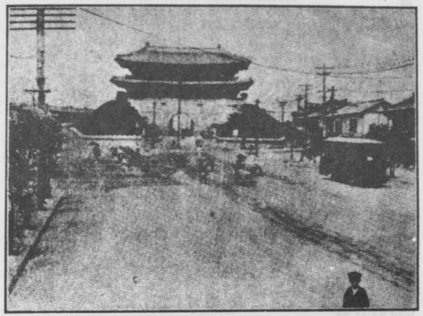

STREET IMPROVEMENT, SEOUL (Showing South Gate)

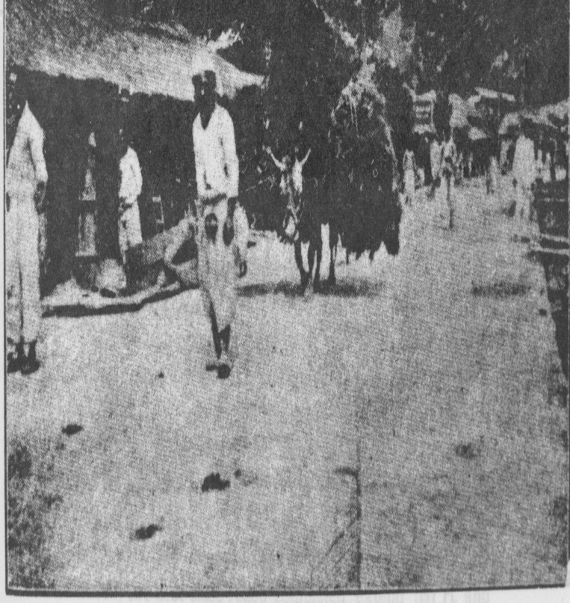

TRANSPORTING FIREWOOD[page 67]

|  |  |  |
| --- | --- | --- |
| Province | Name of the Points | Distance |
| Kogen | Kojo - Boundary line of | 28 ri 2 cho |
| the Province |
| **,,** | Shoto - Kinkoa | 19 ri 9 cho |
| **,,** | Heiko - Isen | 12 ri 8 cho |
| **,,** | Heiko - Shunsen | 25 ri 19 cho |
| **,,** | Ankyo - Tetsugen | 7 ri 30 cho |
| **,,** | Tetsugen - Taikou | 28 cho |
| **,,** | Shunsen - Kakei | 6ri 9 cho |
| **,,** | Shunsen - Kosen | 10 ri 9 cho |
| **,,** | Kosen - Genshu | 13 ri 4 cho |
| **,,** | Genshu - Boundary line of |  |
| the Province | 6ri |
| **,,** | Genshu - Koryo | 36 ri 13 cho |
| **,,** | Koryu - Chumonshin | 5 ri 3 cho |
| **,,** | Haisho - Teisen | 19 ri 10 cho |

THE FUTURE OF THE AUTOMOTIVE TRANSPORTATION.

That which has the greatest relation to the development of automotive transportation is the extension of railways and the improvement of roads. In Chosen, where the extension of railways is not developed, there is big room for automotive transportation to be developed along with the improvement of roads being effected. It is needless to say that the automobiles are economical and convenient in transporting passengers and freight; but especially so are they when the extension of railways is made impossible on account of shortness of funds. The automobiles then serve as an auxiliary or substitute for the railways in the transportation business.

The first thing to do to facilitate the development of the automotive transportation is to render the network of roads to perfection and to keep them in good repair, then the result will be to facilitate the general communication and traffic, as well as to help to bring about in a great measure the local industrial development and progress.

To review the present condition of the network of roads in Chosen: the first class roads completed extend 597 ri, and incompleted 196 ri ; second class roads completed extend 1,476 [page 98] ri and uncompleted 917 ri ; and third class roads completed 1,762 ri and uncompleted 1,078 ri. When the uncompleted road lines are wholly opened to traffic, the network of roads in Chosen may be said to be fairly well extended. If this network of roads is kept in good repair, the distance for running the antomobiles will be greatly increased.

At present the automotive transportation in Chosen is mainly for passenger service, but it is believed that when the tractors are more and more putin use for transporting freight, conveying local products to cities or railway stations and vice versa and for farming purposes, this automobile service will greatly help to effect the industrial development of Chosen and to advance the welfare of the people.

In Europe and America the automotive transportation is developed to such a degree that it proves a menace to the railway service, but in Chosen there is no immediate fear for the competition between these two factors of transportation. Such a time is still far distant, and nobody can foretell when it will come. It is to be hoped that for the extention of culture and the development or industries the railways and the automobiles are both develope, the one for transporting great quantities for long distances, and the other for transporting small quantities for short distances, or to the interior, and in concert bring about good results in the transportation business.

MOTORING.

My experience dates back to 1911-1912 when Korea’s cars could be counted on the fingers of one hand. The first motor car, if same could be called such, was a one lunger affair of French design and doubtful vintage imported by Mr. Lefre, a Frenchman. The first motor cycle to my knowledge was also imported by a French citizen and I surely was greatly thrilled as the girl said, when I took my first voyage down Cabinet Street—the one existing street of any width at that time. In 1910 2 Paige Cars were imported by a Korean who knew nothing of the running of same, and it was with these that my actual experience with an old type motor car commenced. Many were the times we pushed or pulled

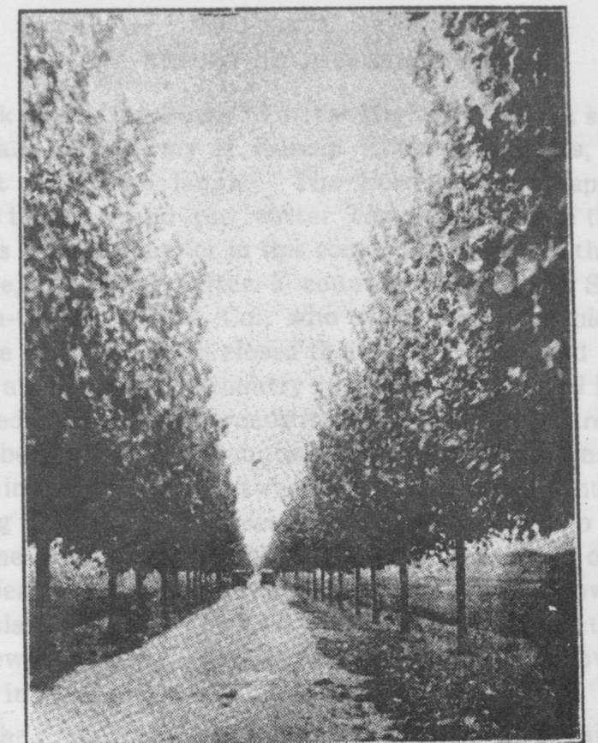

FIRST CLASS ROAD CONSTRUCTED SEVERAL YEARS AGO.

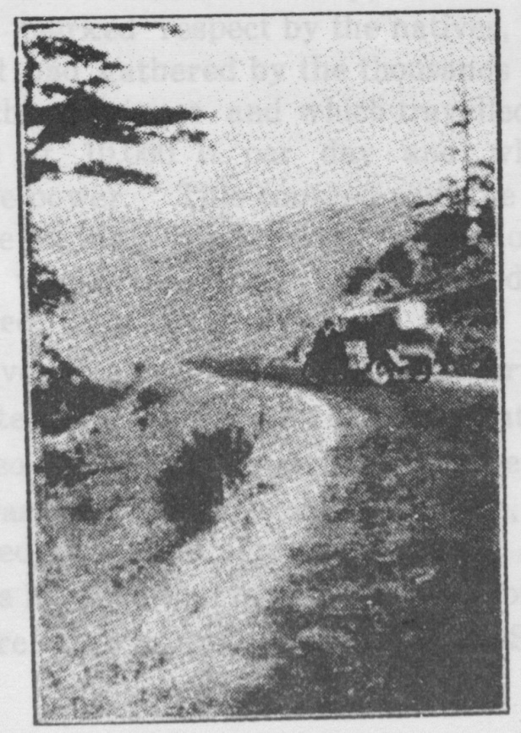

OUR “LIZZIE” [page 69]

it back from the Kings’ Tombs Highway with a string of bulls and a vast army of Korean Kookung Sarems, handing us out the Horse laugh. The Ford made its appearance about this time and the writer commenced to see the possi-bilities with the motor in this country and started the second garage, and shortly after a country run between Seoul and Choon-Chun. Ori & Co., who were really the pioneers in garage business, soon closed their Seoul Office, and confined their attention to the country runs of which several had been granted to them. The roads in these days were hard travelling, being green and unballasted, and many a night was spent in a Korean inn between here and Choon-Chun, after having torn Lizzie to pieces in trying to get her to pull out of some particularly bad spot During these years of garage experience, the writer was called on often by the Government Officials to drive for them on their tours of inspection over the newly opened up roads, which openings followed each other in rapid succession.

The first long trip was to the Diamond Mountains, driving in to Choanji from Heiku Station on the Gensan-Seoul Railroad. The writer’s car being the first that had ever been driven over this road and country, he was held in awe and treated with marked respect by the natives, who on our return trip out had gathered by the thousands to see this new invention of the foreigner and which travelled according to their figures at 10,000 li per day and which seemingly had no motive power This coupled with the fact that I was treated as one of the official party, tended to make the trip through the wonderful country we travelled in one long to be remembered.

Tables given in a previous part of this article will give the person interested information of roads that are accessible to motoring, so I will not describe in detail other than the long

trip which was the inspiration of this article, and to which I have referred in the first part of my paper. Before passing on to this I would like to mention a few of the beautiful roads that are open to traffic in and around Seoul. [page 70]

Seoul to Chemulpo

Seoul to Kang Wha Island, via Yeitoho Seoul to the Rin-Shin River

Seoul to Gisei, from which point the road branches, one following the Genzan Railroad line, the other to the East.

Seoul to Shunsen, following the River Han for the greater part of the distance, and passing what is known as the “Nine Kings Tombs” and the tombs of the late Emperor and Queen Min.

This trip can be made circular by striking south from Shun-Sen to Genshu and thence to Seoul, passing through Reishu and Reisen. This is about two days motoring over wonderful roads and through beautiful country.

Probably one of the most pleasant one day circular trips out of Seoul is to Suigen—Reisen —Kwoshu. crossing the river at Kwang Nari about eight miles out of Seoul.

Another very interesting one day trip is to the Chicksan Mines and return, but of this I speak in the description I give of one of my longer jaunts.

One trip that I must mention and which I can strongly urge any one to make, is the trip from Seoul to Koryo, due east of Seoul on the east coast of Korea. This takes one through the cities of Risen, — Reishu —Genshu, and many towns of less importance, but none the less interesting from a historical point. Some time in a future article I hope to be able to describe to you the wonders of this trip, both historical and scenic, but with the amount of space that I have already taken I shall have to leave it for a future date, as this article gives you merely an outline.

In closing my article which I trust will be the means of creating an interest in motoring and its possibilities both from a pleasure as well as a business point, I will describe my longest trip made in Korea, a total distance of over 2,000 miles. I attach hereto a table of distances between the main points on the main roads, but which does not cover any of the numerous side trips over smaller roads into the interior that I made, and which kept me from Seoul close on to 2[page 71] months, during which time I lived entirely off the country with the exception of the few meals furnished me by my kind-hearted missionary friends.

The trip was undertaken primarily for business reasons, but I know that it was the love of motoring and a thorough first hand investigation of roads that made it attractive enough for me to make.

My objective in this trip was as follows, starting from Seoul to strike due south-west to the West coast following same to Mokpo, thence along the South Coast of Korea to Fusan and return to Seoul along the route followed by the Fasan-Seoul Railroad. This was accomplished, but a trip with variations and much zig-zagging was necessary, as you will see by looking at the map and the enclosed table, which gives towns passed and distances travelled.

The discription of this trip as written at the time for the Japan Advertiser will, I think, give you a very good idea of the country passed through, along with some of the trials and tribulations connected therewith :—

“Leaving Seoul for the south, the motorist has the choice of two routes, one following the railroad line passing through the old walled city of Suigen, Tenan, etc. and the other which I think the most attractive as far as scenic beauty is concerned, crosses the Han River about 12 miles from Seoul, a crossing which we were able to make over the ice, and thence to Koshu, Risen, Chokoin, Anjo and the Chiksan Mines. Arriving at the mines, we put up, at the home of Mr. and Mrs. Wilson, where a hearty welcome and a large dinner awaited us.

This part of the trip I have made many times before, but always in the spring or the fall. The beauty of the country covered with snow as far as the eye can see gives one an idea of what the splendor of the Yosemite in winter must be.

The best part of this road is a well travelled jitney service country, and at Risen and Chokoin the Standard Oil Company has service stations In this section we passed 20 cars. The road as far as Chokoin is called a First Class Highway and is worthy of the name. Some of the wooden[page 72] bridges along the road have been washed out, and they are being replaced as fast as possible by permanent structures of concrete.

This is the route by which Hideoshi’s armies entered Seoul, and the road’s historical interest is equalled by its scenic beauty, for in several places high passes are crossed, from which there is an extensive view of the surrounding country.

From Chokoin we took the third class road running due west from the city. This road is in a poor condition due to the thaw, but cannot be considered dangerous or especially disagreeable. We reached the Chiksan Mine at 7 o’clock in the evening, having left Seoul at 10 o’clock in the morning and stopped one hour for lunch, and also made several stops en route at different points to transact business. Thus our actual running time did not exceed 7 hours.

Leaving Chiksan at 10 o’clock the next morning, we took the road that passes through Seikwan Station, passing the scene of the first battle fought between the Chinese and the Japanese daring the Sino-Japanese War. From Seikwan to Tenan the road is rough, due to the red clay which last fall was used as surfacing material during the army manoeuveres. When the spring rains arrive I am afraid that this road will become considerably worse. There is only about eight miles of this, however, before one reaches Tenan, a prosperous and growing town on the Seouk-Fusan railroad. Tenan is the terminus for the light railroad which has been completed as far as Reisan, which is being pushed on to the West Coast through a fertile and productive country. The motor road follows the route of this light railroad, passing through the Onyo Hot Springs.

This country reminds one of the American West, with its new towns springing up as the railroad advances. Great credit should be given the Japanese for their spirit of enterprise and initiative in opening up this section with a system of

highways and railroads—a part of Korea which has lain dormant for centuries. [page 73]

Passing from time to time monuments, pagodas, and cere-monial tablets, which mark the sites of the strongholds of Buddhism, which has held sway here for so many centuries, we came at last to the walled city of Hojo. On the highest and most inaccessible peaks one sees the old fortress walls, reminders of a time when Korea was a country of many warring tribes.

Stopping an hour for lunch at Reisan, and several times to shoot, we reached Hirokawa in the early afternoon. Stories of good shooting had been so persistant that we decided to stay throughout the night. Our bag consisted of four Mallard ducks and five pheasants. The day’s run was 62 miles, making a total of 194 miles from Seoul in two days.

We retraced our road to Reisan, instead of taking the coast route to Kunsan, 40 miles from here. At Reisan my companions returned to Seoul and I went on alone.

From February 9th to February 17th, the date of my arrival at Mokpo, seems a long time to take in covering 326 miles, and without a few words of explanation the reader may form a wrong impression. In the first place it must be remembered that this was about the worst time of the year for undertaking a journey in this part of the country. Early spring rains and thaws have combined to make the new roads, some of which have not yet been regularly thrown open to traffic, about as bad as could be imagined. Again, I have taken a good deal of time in visiting the various missions along the route. Thirdly, from Kunsan south to Mokpo, practically the entire distance was made over a road which is very seldom used, and, which I believe, has never been used, by motorists. On this part a good deal of road and bridge building was necessary, which took time .

Many of the difficulties encountered could have been avoided had I gone on from Kunsan and Zenshu over the main highway through Central Korea, instead of keeping to the west of the railroad line in quest of untravelled roads. This main highway leads through Winjitsu, Mangen—Ryurri, Junten, and over one of the finest pieces of road engineering I have seen, to Koshu and Mokpo. Motorists in this section[page 74] will have little trouble if they stick to the main routes, which are perhaps not so direct as some of the other roads, but are at least Well-surfaced. The main highway mentioned above is in splendid condition, and recently a missionary moved his family of five and all the household furniture—with the exception of the piano—from Junten to Zenshu on a Ford, with bird cages and dog kennels tied to the hood for warmth.

Beautiful Scenery Passed.

But to return to the point where I left off in my previous article. From Riesan, the end of the light railway to Koshu is a distance of 35 miles over one of the finest roads I have ever travelled over. We covered the stretch in the dark, crossing two rivers by ferry and climbing over one very high pass, which was snow covered. It was a beautifully clear evening and the view from the summit of the pass with the road winding down for miles along the river below, is one which I shall not soon forget. This road is built in many places along the side of a steep cliff that rises sheer up from the river bed, and the scenery reminds one of some of the more beautiful parts of Japan. Azalea bushes grow to a man’s height here, and there are many other blooms which we never see around Seoul I shall revisit this spot again at the earliest opportunity.

At the last river crossing before entering Koshu, I saw a sight which reminded me strongly of the cormorant fishers in southern Japan. As I drove down the steep bank to the river’s edge, a weird noise burst on my ears. The whole river was lighted up from the open fires which were burning in the sterns of innumerable small fishing boats which were being carried down stream swiftly in the fast moving current. As the boats rushed on, the fishermen threw nets from the bows, while the musicians standing up in the boats beat a rapid tattoo on heavy hard wood sticks. The effect resembled the music from a xylophone. It was an impressive sight and made a fitting greeting to Koshu.

Koshu, with its ancient gate, pavilions and tablet houses, seems the same as in the old days when we used to enter it

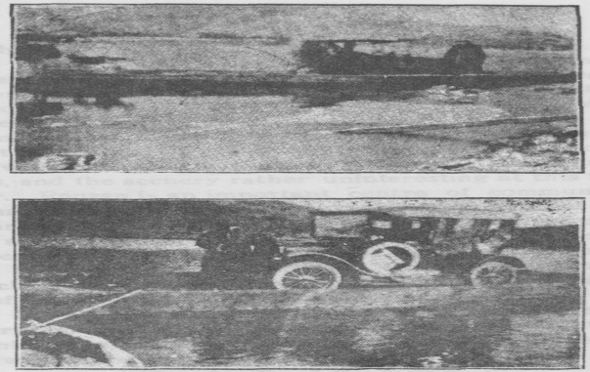

CONDITIONS STILL MET WITH

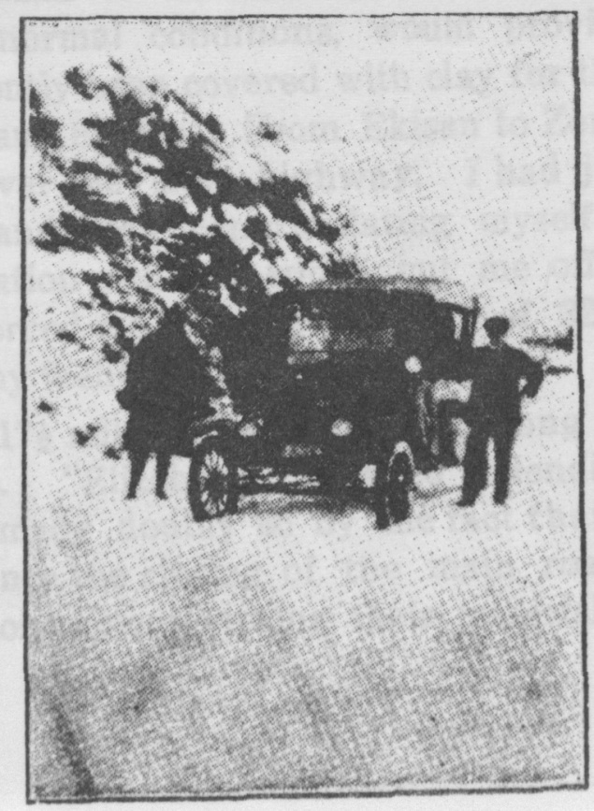 [page 75]

on the back of a Korean pony, averaging 30 miles a day. Many of the streets have been widened and several fine new buildings have been erected, and before long a light railway will enter the city, but, with all these improvements, there is still much to remind the tourist of the vanished glories of Old Korea.

From Koshu to Ronzan there is a first class highway in excellent condition, suffering only from having been recently treated with an overdose of gravel dressing. The distance is 20 miles, and the scenery rather uninteresting at this time of the year. Ronzan is an important centre of communication with many of the roads leading from it. The motorist should make careful inquiries before leaving the city, for the country natives are far from well posted, and the best information I have received has come from resident Japanese. Ronzan has little of interest to the traveller, but the district surrounding it is rich in historical interest Preeminent is the Great Image of Onshin two and a half miles out of Ronzan. It was erected by a Buddhist Priest, and last year received some necessary repairs. I arrived at Onshin just at twilight, when the monks were chanting their evening prayers : the whole setting was impressive, a side trip well worth while.

Clay for Road Surfacing.

From Ronzan to Zenshu there is a first class highway which, under normal conditions, would provide fine going, but it has recently been covered with clay for the 16 miles between Rozan and Ekisan. From Ekisan to Zenshu there is a direct route over the main highway. I had just gotten out of red clay and was congratulating myself, when I ran into an irrigation scheme which cut me off entirely from Zenshu and forced me to make a detour of 32½ miles. You can imagine my feelings.

The first 17½ miles I made running along the paddy field embankments. “Elizabeth” behaved splendidly, but it was hard going, made doubly so by the fact that I know it was unncessary since the closing of the main road was entirely due to the contractors storing their material on it, for a [page 76] distance of a mile only. Finally I got out on the main road at Ri Ri. Motor fans will appreciate my feelings on hearing the motor purring along on the good level road after miles of low gear work. I didn’t try to hold “Elizabeth” back.

This whole southern country is rich in ancient landmarks and historical interest, and I think it will be of interest to mention a few of the more interesting that lie within a radius of 50 miles from Zenshu.

Fuyo, once the proud capital of the Paikche Kingdom, lives now in the glory of the past. It was twice occupied as a capital, the last time for 120 years. with six kings, but was finally overcome by invaders from Sinla Kingdom in 662 A. D. Near Fuyo is a large rock, the scene of a tragedy in the olden times. When the invaders entered the city and overthrew the Paikche King, the court ladies, rather than fall captive to the enemy warriors, threw themselves from the high rock into the stream below.

Old Monastries Add Charm.

The Royal Pagoda at Ri-Ri is worth a visit, and the monastries which nestle in the quiet and secluded, but now easily approachable, ravines, lend added charm to the district I am glad to say that the Japanese authorities are looking after these old buildings, a striking contrast to their evident lack of interest in anything of Old Korea in Seoul and the surrounding district

From Zenshu to Kunsan is but 27½ miles over a fine road. Here, as in Zenshu and other cities in the south, the Presbyterian South Mission have their stations, carrying on their work ably and unostentationsly.

Kunsan is a seaport town, important commercially, just like hundreds of similar towns in Japan, but entirely lacking in anything to attract the tourist I soon returned to Zenshu, and from there made several short trips to points of interest in the neighbourhood, visiting districts with fantastic shaped mountains, like those we so often see portrayed in Oriental art, and which we foreigners are inclined to think imaginary.

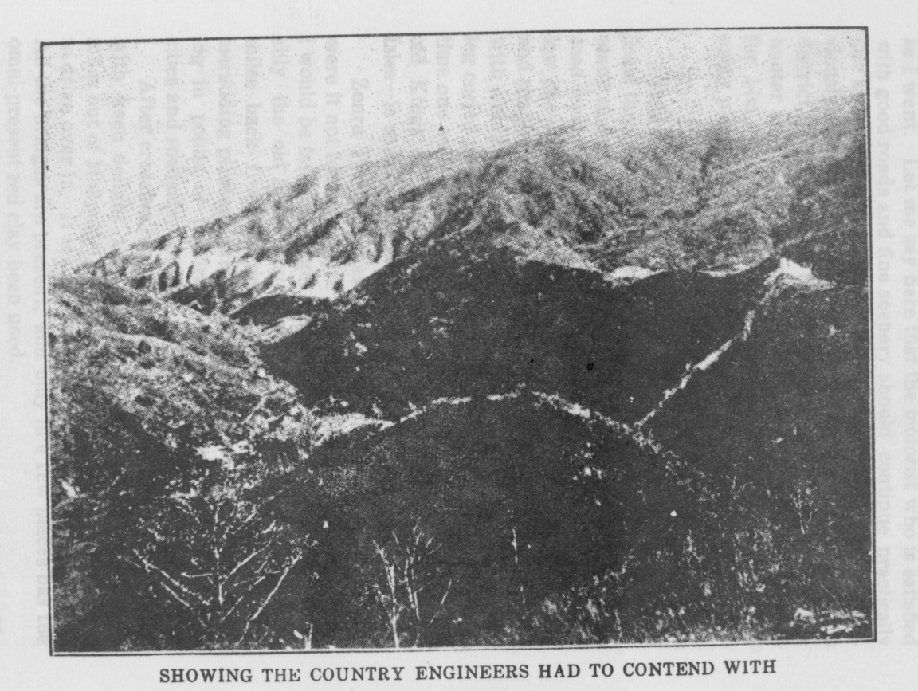[page 77]Sight seeing again, several days behind my schedule. For three days I travelled south, building bridges and roads as I went. Let me say here that the motorist who is satisfied with good roads and fine scenery should continue practically due south through the town and the district mentioned previously. For the benefit of the nimrod I will add that this district, which I have mentioned is a paradise for the relic hunter and those interested in Ola Korea, is equally paradise for him. I saw dozens of pheasants along the road and every place except in the trees.

Wild Game Abundant.

This stretch, a total of 118 miles, passing along the west coast through seaport towns and fishing villages, also affords many opportunities for a shot at water fowl and geese. The road winds through many low mountain passes, and often below one sees narrow shallow inlets, dotted with little islands. and simply covered with myriads of ducks and swans, always with a solitary gander mounting guard on the bank, with one leg curled under him and one eye wide open. From time to time one sees the sea, studded with islands, and the title the old Kings of Korea assumed—King of Tai Han and 10,000 Isles—is easy to understand.

Zenra Province has a superabundance of red clay, and, were it not for my desire to try out the untravelled roads, I would be tempted to get back on the main highways. Probably the old Korean custom of denuding the country for miles back from the sea in order to offer no attraction to marauding pirates, is the reason why this route is so lacking in points of historical interest, except for a few walled cities and roadside tombs.

After crossing high passes, mostly in driving rain, it was with keen delight that I came out on the main highway 29 miles out of Mokpo. This is a good road and it is a pleasure to drive over it. It is not used much, hut is in fine condition. All the bridges are present, and only in a few places has the omni-present red clay been used.

This side of the ocean coast has one of the biggest tide[page 78] movements in the world, but fortunately the tide was in and we made Mokpo in good time, ending several days hardgoing.

Mokpo is in many points similar to Kunsan. It has little of historical value.

Much has transpired since my last description from Mokpo. The weather man seemed to pursue me with bad weather—rain and sleet alternating with snow storms, and cold weather, which the local residents assured me was very unusual for that time of which was never before experienced in the memory of man, etc. However, enough about weather, what the motor fans want to hear about is roads.

Having heard much about the quarries from which the Koreans obtain the stone for making numerous articles, and being assured that the road to them was good, I decided to take a run down to the Kainan District, which is on the extreme southern point of the Korean Peninsula. The road as far as Fashu - over which we had travelled when entering Mokpo from the north—is a second class road in excellent condition. From Kashu I took a third class road south the Kunsan. This road is as usual with third class roads in this country, very narrow, but except for the downpour which accompanied me, I believe it would make excellent going.

Plenty of Wild Game.

This is a great country for game, but cannot be commended to the motor fan otherwise. One day in the district was sufficient, and I motored back to Rashu, from which town I turned west to Koshu, going over a beautiful stretch of road which allowed fast driving even after dark. From Mokpo to Kunsan is 96 miles and from Kunsan to Koshu 77 miles.

Koshu or Kwangju, as it is called by the Koreans, is one of the most important cities of southern Korea, and has a population of about 12,000. It is the seat of the Governor of South Zenra Province and within the next two years it will be connected with Masan and Shinshu by rail. There is also a branch line connecting Koshu with the Taiden-Mokpo Line,

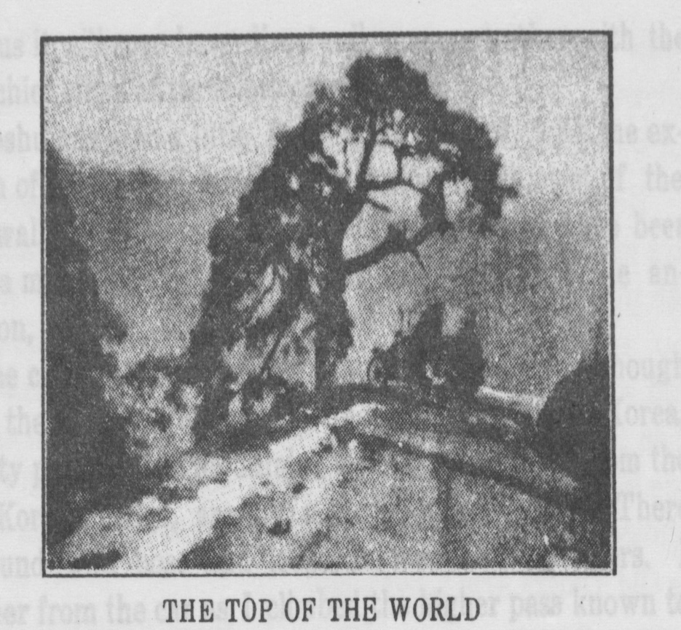

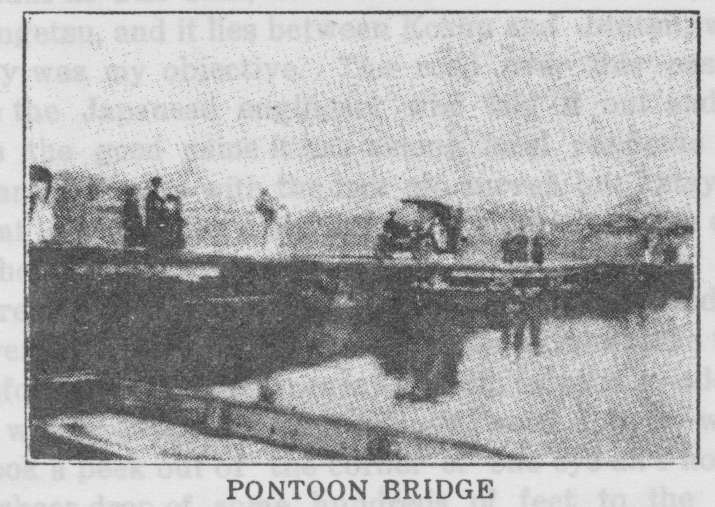

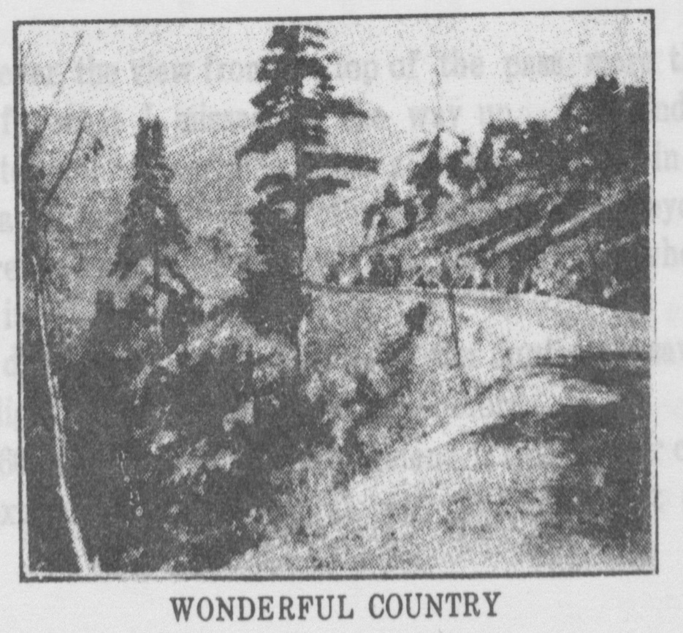

and thus it will soon have direct rail communication with the three chief cities of three provinces.

Koshu has seen a little fighting in the past, with the exception of the tong-hak rebellion, during which most of the city’s walls were destroyed. Those that remained have been put to a more practical use by the japanese since the annexation,

The city is surrounded by beautiful country. Although it is in the centre of one of the finest rice districts of Korea, the lofty peaks of the mountains which form a spur from the main Korean range, are but a short distance away. There are found wild boar and leopards, and some say tigers. I saw deer from the car as i climbed the higher pass known to the koreans as uno chai, or anxious pass. The Japanese call it ungetsu, and it lies between Koshu and Junten, which latter city was my objective. The road over this pass is a credit to the Japanese engineers who laid it out and well deserves the good name it has among local residents both foreign and Japanese with the hair pin curves, but i stayed in low for at least half the distance, and consequently the climb took an hour.

There are plenty of thrills in climbing this pass, and, as i went over it both ways, i got enough to last me some time. I am informed that the scenery on both sides is wonderful, and feel willing to take my informant’s word for it—whenever i took a peek out of the corner of one eye all I noticed was the sheer drop of some hundreds of feet to the river below.

However, the view from the top of the pass more than made up for what I missed on the way up. The winding road stretches for many miles, with a snake like river in the distance and range after range of lofty mountains far beyond. The impression is as clear now while I am writing as when I first saw it.

Two days later, on my way back from junten, I saw it by moonlight, more beautiful even than before.

It is 60 miles from Koshu to Junten: it is the latter city, in the extreme southern central part of Korea, that one [page 80] would reach if the main road, mentioned previously, were followed. From Junten, good roads branch out to the east and west also.

Here I am going to leave you and I trust that others who have the opportunity of trying some newly opened road will take the trouble of telling us about it and its delights. Whenever you are inclined to criticise harshly some bad bit of road where you have found heavy going, remember the days when there were no roads, no motor cars, and what can be done in an hour now took a hard ten hours day actual travel besides the hours required to feed and load the ponies. Ask the Old Timers Arm Chair Club.

NAMES OF CITY TO JAP. RI MILES

Seoul to Risen 17 41

Risen to Chokoyen 7 17

Chokoyen to Shoksan 14 34

Shoksan to Anjo 4 10

Anjo to Heitaku 5 13

Heikatu to Seikwan 3 7

Seikwan to Shoksan 1 2

Shoksan to Reisan 12 29

Reisan to Hirogawa 9 22

Hirogawa to Reisan 9 22

Reisan to Koshu 13 32

Koshu to Ronsan 9 22

Ronsan to Sanrei 10 24

Sanrei to Riri 3 7

Riri to Zenshu 6 15

Zenshu to Kunsan 12 29

Kunsan to Zenshu 12 29

Zenshu to Chinan 9 22

Chinan to Zenshu 9 22

Zenshu to Seiyu 7 17

Seiyu to Tsurupo 5 12

Tsurupo to Kosho 4 10

Kosho to Moppo 4 10

Moppo to Reiko 3 7[page 81]

NAMES OF CITY TO JAP. RI MILES

Reiko to Kambei 6 15

Kambei to Moppo 11 27

Moppo to Rashu 15 37

Rashu to Yesampo 2 5

Yesampo to Koshin 12 29

Koshin to Kainan 4 10

Kainan to Koshin 4 10

Koshin to Choko 2 5

Choko to Koshu 22 54

Koshu to Tofuku 10 24

Tofuku to Hirogawa 4 10

Hirogawa to Junten 11 27

Junten to Bakyo 7 17

Bakyo to Junten 7 17

Junten to Koyo 3 7

Koyo to Junten 3 7

Junten to Koshu 24 59

Koshu to Tanyo 5 12

Tanyo to Junsho 5 12

Junsho to Tanyo 5 12

Tanyo to Kokujo 9 22

Kokujo to Nanken 4 10

Nanken to Kokujo 4 10

Kokujo to Kurei 7 17

Kurei to Kado 9 22

Kado to Shinshu 13 32

Shinshu to Sansen po 8 19

Sansenpo to Sisen 5 12

Sisen to Kojo 7 17

415 1012

Kojo to Toyei 6 15

Toyei to Kojo 6 15

Kojo to Masan 11 27

Masan to Reisan 10 24

Reisan to Mitsuyo 7 17

Mitsuyo to Reisan 7 17

Reisan to Shonei 3 7[page 82]

Names of city vo jap. Ri mimes

Shonei to Taikyu 13 32

Taikyu to Keishu 17 41

Keishu to Woorusan 6 15

Woorusan to Fusan 15 37

Taikyu to Seishu 9 22

Seishu to Kinsen 10 24

Kinsen to Seishu 10 24

Seishu to Bunkei 32 78

Bunkei to Chushu 12 29

Chushu to Risen 28 68

Risen to Keijo 17 41

634 1545

