[page 1]

**The Anglican Cathedral Seoul 1926-1986**

J. E. HOARE

May 1986 marked the sixtieth aniversary of the consecration of the Anglican pro-cathedral of St. Mary and St. Nicholas, the central church of the Anglican community in Korea. This great church is situated on the edge of Seoul’s old foreign quarter, Chong-dong, and is an imposing brick and granite building. Once it stood out clear from its surroundings, but today it is in among the high-rise hotels and the tall office blocks which are so characteristic of modern Seoul.

It is not a well-known landmark. Many of Seoul’s citizens whether Christians or not are familiar with the Roman Catholic cathedral in Myong-dong, and also with the newer churches south of the Han River, but very few are even aware of the Anglican cathedral’s existence and even fewer know how to find it. Crowds of people visit sights such as the National Museum or Toksu Palace every day, but in 1983, an official of the Anglican cathedral noted that only about fifteen visitors came to the cathedral each day. Yet on Sundays and festivals, several hundred Koreans come to worship. There is also a small but devoted group of foreign Anglicans (or Episcopalians as they are generally known in the United States) who attend the Sunday mass in the cathedral crypt.1

The general lack of knowledge about the cathedral is reflected in guide-books and other tourist aids. Indeed, few guide books mention the cathedral at all, and those that do are frequently not very informative or sometimes wrong. Even Seoul city authorities, who have designated the cathedral as “Local Tangible Property No. 35,” have erected an incorrect notice outside the building.

This neglect is a pity. The cathedral has long been regarded as one of the most attractive western-style buildings in East Asia. The story of how it came to be built, and its survival during the troubled times of the past sixty years is an interesting one both in itself and as part of the wider history of the Anglican church in Korea. Together with the nineteenth-century buildings of the nearby British Embassy compound and Toksu Palace, the cathedral forms part of an older Seoul that has almost vanished.

[page 2]

The Anglican church began to take an interest in Korea from 1880, and the Korean Anglican mission dates from the appointment of Charles John Corfe, a former British naval chaplain, as bishop of Korea (or Corea as he and most of his contemporaries spelt it) by the archbishop of Canterbury in 1889. The decision to make such an appointment arose from a visit to Korea in 1887 by the Anglican bishops of Tokyo and North China. It was perhaps the confidence of nineteenth-century Anglican missionaries which led one of the visitors, Bishop Bickersteth of Tokyo, to foresee a future Anglican church established in Korea with its own cathedral in Seoul before an Anglican mission had begun to function there.2

The reality was that Corfe’s fledgling church was in no position to support a cathedral during his episcopacy or for many years afterwards. His policy for himself and his missionary colleagues was to concentrate their energies on learning the Korean language before beginning the task of making converts. Even when the work of conversion began, Corfe emphasized the need for a well-trained few rather than large numbers who might only half understand what they were supposed to believe. These few and the small number of foreign Anglicans could worship adequately in the small churches erected in Seoul, Chemulpo (now Inch’on) and Kanghwa island.

This small Anglican community expanded during the episcopacy of Corfe’s successor, Bishop Turner. Both men believed that the Anglicans in Korea should minister to all people there. The Anglican church therefore came to be almost alone in having Korean, Japanese and western congregations. Although they were all Anglicans, however, they did not generally worship together. By 1910, Turner and his colleagues believed that the Anglican community was able to support the erection and upkeep of a large central church, where the various nationalities could all meet together under one roof on at least some occasions. Thus in August of that year, the *Korean Mission Field* reported that the Anglican mission intended to erect a cathedral and commented that “with the usual good taste of their denomination in matters of architecture and art, [they] will follow the general lines of Korean architecture in the structure....”3 In the event, both predictions proved incorrect. Bishop Turner died before he could put his plans into action. His death led to the postponement of the cathedral project for the time being. When it was revived under his successor some years later, any idea of a building based on traditional Korean architecture had been abandoned.

Turner’s successor was Mark Trollope, one of the first Anglicans to join Corfe in Korea. During his years with the Korean mission, he had acquired a reputation for getting things done. He had also been responsible [page 3] for building what was and is one of the most attractive churches in Korea, the church of St. Peter and St. Paul in Kanghwa town. This church completed in 1900, was an imaginative blend of traditional Korean temple and palace style of construction and layout with the needs of a Christian place of worship. With a reputation as a builder of churches already established, it was natural that Trollope should take on the cathedral project. There was now an added incentive, in the fund collected to erect a memorial to Bishop Turner. It was this fund which was to become the basis of the cathedral construction fund.

The outbreak of the first world war in 1914 effectively postponed the project for several years. But Trollope did not lose sight of it. In August 1915, he spelt out his thoughts on the subject in his “Charge” or instruction to his clergy. These now included Koreans and Trollope took account of their susceptibilities. He disclaimed any intention of fixing finally where the central church of the Korean Anglican community should be. That was for the Koreans themselves to decide when in due course they took over the complete running of the church. In the meantime, there should be a temporary central church in Seoul, which would be a “pro-Cathedral.”4 This term was to be a source of some confusion in subsequent years, and Trollope on one occasion felt the need to explain that it stood for “pro- temporary Cathedral,” not as some apparently claimed, “Protestant Cathedral.”5

In July 1918, as the war in Europe showed signs of ending, Trollope again turned his attention to the question of the cathedral. Space was available at the mission’s site in Chong-dong, following the reconstruction of a boys’ home run by the mission. Although the mission possessed other possible sites in Seoul, this was the best, “adjoining the Bishop’s residence on the great high road through Seoul from the railway station to the Governor- General’s official residence.” There was already a small church on the site, the “Church of the Advent.” used particularly by the foreign community.6

In order to begin raising additional funds, Trollope consulted an old acquaintance, the architect Arthur S. Dixon, on his proposed church. They had met when Trollope had been the priest in charge of the church of St. Alban the Martyr in Birmingham while Dixon was establishing a reputation as a church architect in and around that city. They seem to have got on well, for Dixon drew up the plans for the Seoul cathedral without charge and also made two trips to Korea at his own expense to supervise the work once it started.7 It was Dixon’s drawings which formed the basis for Trollope’s appeal for funds for the great undertaking. From the very beginning, [page 4] Trollope decided not to build in Korean style. Without specifying what the problems were, he told the supporters of the Korean mission in Britain that “The difficulties in the way of adopting the indigenous architecture of these lands—a task we have essayed with some small measure of success in Kangwha—are possibly well-nigh insuperable....” Instead Trollope, who had a great nostalgia for the undivided church, decided that what was needed was a building which would in some way reflect universal Christian values of beauty and art. He also hoped that his church would become a model for all Korean church building. At the same time, the new cathedral must fit into the modern city which Seoul was rapidly becoming under Japanese influence. He therefore decided to build in the “Romanesque, Lombardic or ‘Norman’ style....”8

That decision taken, money was the next problem. In 1918, the memorial fund for Bishop Turner stood at some £5000 (US$20,000 at the then rate of exchange), but that would not go very far. Prices in Korea as elsewhere had increased dramatically as a result of the war. The British Embassy in Tokyo reported in December 1919, for example, that differences in exchange rates alone compared to pre-war days meant about a twenty-four percent decrease in the value of British currency, even before local inflation was taken into account.9 Dixon’s plans would cost about £50,000 if executed in their entirety. This was too much. But even the modified version with which Trollope proposed to begin would take some £18,000 to £20,000. These were large sums, and there was no possibility that the small Korean church could raise them. Trollope therefore saw no choice but to appeal outside Korea.10

Undaunted by the problems of fund-raising, Trollope announced that work would start on the crypt which would form the memorial to Bishop Turner. It could also serve as a place of worship until the whole church was completed. Trollope pointed to the tradition of the great medieval churches, some of which had taken centuries to complete, and to the more recent example of Lancing College in Sussex, the school founded in 1848 which both Corfe ana he had attended, and where the chapel had taken forty years to finish.

The appeal for outside funds met with success from three main sources. The Anglo-Catholic conference of 1920 responded with a donation of £5000. To this was added a further £5000 from the Wills, Bequest, a fund set up under the will of H. W. Wills, a member of a prominent British tobacco company. Money also came from the Marriott Bequest, established in 1896, one of whose purposes was to provide funds for church building [page 5] overseas. And always, in addition to these large amounts, there was a steady trickle of private donations. Although the money from these various sources was to come in sporadic bursts, with the result that much of the bishop’s correspondence from 1921 to 1926 was taken up with chasing funds or bemoaning their non-arrival, Trollope could see his way forward. Work therefore commenced.11

By September 1922, the foundations of the crypt were finished and the walls had begun to rise. Work was much slowed up by the rains in July and August, and Trollope at one time thought that it would not be sufficently advanced to hold the planned ceremony of laying the foundation stone on 24 September. But, rain or no rain, the work kept up, and what had been planned as a simple ceremony for the Anglican faithful grew into something much grander. The Anglican bishops from Peking and Shantung were joined by the bishop of Osaka. There were American priests from Japan, a Chinese priest who had also come from Shantung, plus the Korean, British and Japanese clergy of the Korean mission itself. The ceremony was also attended by the Japanese governor general, Baron Saito, the governor of the province, the mayor of Seoul, the British consul-general, and other consular representatives. Though rain fell at one point, the ceremony was a great success, as were a series of celebratory tea-parties and “at homes” held to mark the event.12

After the excitements of that day, the more humdrum task of building continued. By mid-summer 1923, the outline of the main church was taking shape; the roof went on that autumn. For Trollope, it was all something of a strain. To his constant worries about money were added concern over the laborers and the primitive conditions in which they worked. As with most other major building projects in Korea at that time, the actual construction work was in the hands of a Chinese contractor, who managed a mixed Chinese and Korean workforce. Supervising the contractor was a young British architect, Leslie C. Brooke, who, understandably, knew neither Korean nor Chinese. He was aided by the bishop and the other Anglican priests, but it was a difficult task, not helped by the contractor’s equally understandable unfamiliarity with either the construction or the purpose of cathedrals.13

Yet by July 1924, the crypt was finished and the main shell of the cathedral proper was almost ready. At this stage, Trollope’s concern shifted somewhat, for he began to fear that he would be left with nothing but a shell. Funds to finish and furnish the building were now needed, and seemed unlikely to be forthcoming. Yet these problems too were[page 6] overcome. The trickle of donations continued; amongst them were funds for the high altar, which came from fourteen of the bishops and archbishops of England and Scotland.14

On 3 May 1926, the new cathedral was consecrated. The day chosen was Holy Cross Day, which Bishop Corfe had selected in 1889 as the festival day of the Korean mission. The dedication of the new cathedral was to Mary, the mother of Jesus—perhaps again a sign of Trollope’s concern with the traditions and beliefs of an undivided and universal church—and St. Nicholas, who as patron saint of sailors and children, had been a particular favorite of Bishop Corfe. It was no coincidence that Lancing College chapel was similarly dedicated. This ceremony was a far more modest affair than that of 1922. Only members of the Anglican community were invited. Trollope explained that this “semi-privacy” was decided upon for a number of reasons. One member of the mission, Fr. Hodges, had died a week or so earlier. The last Korean emperor had also died in April and his death had led to an upsurge of patriotic feeling among Koreans; clearly this was no time to bring Koreans and Japanese officials together. The disturbed state of China made it difficult for visitors to come from there. Trollope also wrote that his own health was poor, and that he did not wish to receive large numbers of visitors. So it was a quiet, domestic ceremony, with only the bishop of Kobe representing the outside world.15

The new building was much admired. Soon after its consecration, one British resident wrote:

“The Cathedral itselr is a handsome granite building, Byzantine in style... it stands up resolute and serene against the blue Korean sky. The choir is faced with Irish marble, and the alcove behind the altar has recently been inlaid with mosic. Its mere size is significant when you consider that its congregation consists of little more than the thirty boys from the hostel and perhaps as many girls from the convent.”

The writer, a teacher named H. B. Drake, somewhat played down the size of the congregation; though small, it was still larger than his account implied. From the earliest days, the main church was used for Korean services, while the much smaller Japanese and western congregations used the crypt. Together these amounted to more than the handful described by Drake.16

The cathedral was now in use, and Trollope went home on leave, exhausted by his recent labors. But though his great church was functioning, it remained incomplete. The nave was only half the projected length, and [page 7] the cathedral lacked its planned transepts. Furnishing and decorating too were not easy tasks; the mosaics mentioned by Drake, which were carried out by a British craftsman, were not cheap. Other minor but expensive problems included a fire early in 1930 which destroyed much of the altar linen. Sister Mary Clare, one of the Anglican sisters, whose convent then and now adjoins the cathedral, managed to raise the not inconsiderable sum of £120 for replacements. More important, perhaps, in marking the coming of age of the Anglican church in Korea, was the visit of the bishop of London late in 1926. He took high mass in the nave and evensong in the crypt. He also complained about the cold of the new cathedral; he got little sympathy from the western clergy, who felt that a Korean winter could hardly be said to have begun in December!17

Bishop Trollope died in November 1930. He had gone to London for the Lambeth Conference, since 1867 the regular forum of all bishops of the Anglican communion. On his way back to Korea, the ship on which he was travelling was in a collision at Kobe in Japan and Trollope suffered a fatal heart attack. His remains were brought back to Seoul and laid in state in the cathedral he had built. In keeping with a long established Christian tradition that a bishop who builds a cathedral is buried in it, permission was sought to inter the body in the crypt. This was granted, and so took place the only known burial inside Seoul’s ancient city walls since the founding of the city in 1392. Again in keeping with tradition, Trollope’s tomb is marked by a fine ornamental brass, which depicts him in his robes, holding the cathedral in one hand and his crozier, symbol of his office, in the other.18

The following years were peaceful, with no changes to the cathedral. Then in late 1940, as tensions grew in East Asia, all western missionaries including the Anglicans withdrew from Korea under growing Japanese harrassment, leaving their local congregations to manage as best they could. Despite the wartime pressures on Christians, the Anglicans of Seoul, both Korean and Japanese, still managed to use the cathedral for worship, and the building was generally left alone by the Japanese authorities. Like the rest of the city, it suffered from nelect and a general lack of maintenance.

During the war no news of the Anglican community nor of the cathedral reached the outside world. But soon after Japan’s defeat, a letter arrived in London, addressed to the archbishop of Canterbury, from Sgt. J. G. Mills, a member of the United States’ forces which had landed in Korea in September 1945. Soon after reaching Seoul, Sgt. Mills [page 8] had come upon the cathedral by chance. He had found a Korean priest, a Japanese priest and the Japanese bishop who had been left in charge in 1940. From them he learned that throughout the war, some hundred Koreans had continued to worship at the cathedral, while about ten Japanese had braved government opposition to attend services. Mills added that the cathedral itself was “in excellent condition...” as was the bishop’s house. Other buildings, however, were in a poor state.19 A month after Sgt. Mills, report, a solemn Eucharist of Thanksgiving was held in the cathedral, with five American generals among the congregation.20

With the end of the war, the Japanese congregation disappeared. There were at first few Westerners to replace them, and the cathedral was mainly used by Koreans. But by the time the first foreign clergy were able to return to Korea in the autumn of 1946, the position had begun to change. It was not long therefore before Bishop Cooper and Fr. Hunt were again using the crypt for non-Korean services.21

Then came the Korean war in June 1950. Bishop Cooper, Fr. Hunt and Sister Mary Clare were captured by the North Koreans. All three were taken on the “Death March” into North Korea. Only Cooper survived. Other Anglicans, both Korean and Western, disappeared without trace.

The cathedral survived. After Seoul fell in the panic of June-July 1950, the North Koreans used the building as a storehouse for the large quantity of Western furniture which they collected from all over the city. Much of this may have been destined to go north, together with the collection of the National Museum, then in nearby Toksu Palace, which with other art treasures was found boxed ready for departure when Seoul was retaken by U.N. forces in September. The collected furniture was then distributed, on the basis of need rather than ownership, to the small band of diplomats and others who returned to the city. During the January 1951 evacuation of Seoul, and again when it was retaken by the U.N. forces, the cathedral served as a refuge for those seeking shelter from the fighting.22

The war dispersed the Anglican faithful and clergy from Seoul. Bishop Chadwell, deputizing for Bishop Cooper, was in Pusan with most of the clergy until 1953. But a form of worship continued in the cathedral all through the war. Even during periods of North Korean occupation, the churchwarden Yi Zacharias and his wife Elizabeth stayed put. They lived in the crypt, where they said matins and evensong whenever possible. More surprisingly, they were often able to ring the bells for the [page 9] Angelus.23

Bishop Chadwell returned to Seoul in March 1953, in advance of most of the Korean government and the diplomatic corps. He found the cathedral still structurally sound, but in need of much repair. By the end of the year, however, Chadwell reported that the roof was “reasonably watertight, all the outside cement work and drainage... renewed...” The processional cross had been rediscovered and was once again in use. Services too were also back to normal. Though at first the congregations had been so small that all services were held in the crypt, by mid-summer 1953, the nave was again in use.24

Bishop Cooper, along with a number of others taken in 1950, was released in April 1953, and in November of that year he returned to his diocese. But captivity had taken its toll, and he resigned a year later. He retired to England, where he died in 1960. Under his successors, who are now Korean, the Anglican church has continued to grow and expand, though perhaps not as spectacularly as some other denominations.

The cathedral shows few outward signs of the Korean war, apart from a few bullet marks. The main reminder of the conflict is a number of war memorials. One British regiment is commemorated by a plaque in the crypt, while near the high altar is a series of simple photographs of those priests and nuns who died or disappeared in the war. The most notable monument is a stained glass window over the nave. It is to the memory of those who fell from the British Commonwealth Division, and shows St. George and the Dragon. It was made by a British craftsman, and unveiled by the then President of the Republic of Korea, Yun Po-sun, on 3 September 1961, the thirty-fifth anniversary of the cathedral’s consecration.25

Another addition to the cathedral, of more recent vintage, was a pipe organ. Built in Britain especially for the cathedral and installed in 1985, the organ, which replaced various earlier, inadequate models, was built by Harrison and Harrison Ltd. of Durham in the north of England, a company with a long tradition in this field, who have also in the past built organs for the Shanghai Anglican cathedral in 1925 and that in Tokyo in 1980. The new organ, delivered in October 1985, was dedicated by the bishop of Seoul on 21 December 1985.26

The cathedral has not become the model for other church building as Trollope had hoped; the limitations of the model for Korean churches at a time of great poverty were recognized almost as soon as the [page 9] cathedral was erected.27 Today, when there is much more money available, most Korean churches, of whatever denomination, remain architecturally nondescript. Neither has the cathedral ever been finished. Although still holding the original plans, the Anglican church in Korea has never had the funds to complete the building. While the full effect of Trollope’s great church may never now be achieved, because of the tall buildings all around, there can be no doubt that its completion would add to the attraction of central Seoul. Perhaps now, over sixty years after the consecration, the project might be set in hand.

**NOTES**

While living in Seoul from 1981 to 1985, I became interested in the history of the Anglican cathedral, whose outline greeted me every morning as I drove to work, and which stood like a sentry on the lane outside the British embassy compound. In August 1984, I gave a talk on the history of the British embassy compound and the cathedral to a group from the RAS, who then accompanied me on a tour of these two areas which have played such an important role in the history of the British community, and indeed the wider foreign community in Korea. It is from that occasion that the present paper developed. I am most gratful to the Right Reverend Bishop Richard Rutt, formerly of Taejon and now Bishop of Leicester, and to Dr. Horace Underwood of Yonsei University for their comments on earlier drafts, and for advice about additional information. I am also grateful to Miss A. J. Roberts, MBE, formerly of the Anglican mission in Korea,whose interest and enthusiasm for the byways of history was infectious. Any faults or errors of interpretation are mine.

1. ‘‘Cultural Asset: Anglican Cathedral,” Korea Nemreview, 2 April, 1983.

2. Bickersteth, S. Life and Letters of Edward Bickersteth, Bishop of South Tokyo, (London, 1901),p. 162. The diocese of South Tokyo had not been created in 1887. For the tradition of Anglican missionary cathedrals, see Clarke, Basi. Anglican Cathedrals outside the British Isles, (London, 1958),p. 8.

3. Korean Mission Field, Vol. VII,No. 8,1 Aug. 1910. See also Trollope, Constance, Mark Napier Trollope: Bishop in Korea, 1911-1930, (London, 1936),pp. 60-61.

4. United Society for the Propagation of the Gospel (USPG) Archives, Trollope Papers X620, Box 1, Charge to the Clergy 3 Aug. 19815. Trollope also mentioned the need for a cathedral in his history of the mission,published that same year: Trollope, M. The Church in Corea, (London, 1915), pp. 39-40.

5. Corean Leaflet Letter, No. 51, Sept. 1918.

6. Corean Leaflet Letter, No. 51, Sept. 1918; Trollope, Mark Napier Trollope, p. 65.

7. Clarke, Anglican Cathedrals, p. 120; Trollope, Mark Napier Trollope, p. 63. For an appraisal of Dixon’s work in Britain, see Pevsner, N. and Wedgewood, A. The Buildings of England: Warwickshire, (Harmondsworth, 1966, reprinted 1981), pp. 131 and 186.

8. Corean Leaflet Letter, No. 62,March 1921. For some of the influences on church building in Britain at this time, see Service, A. Edwardian Architecture, (London, 1977), pp. 80-83 and Clifton-Taylor, A. The Cathedrals of England, (London, 1967), Chapter 10.

[page 11] 9. Foreign Office Archives, F0369/1172/K3027, Tokyo telegram to the Foreign Office, No. 477, 4 Dec. 1919.

10. Corean Leaflet Letter, No. 62, March 1921.

11. Trollope Papers X620,Box 2, letters to his family,23 July,19 Aug. and 15 Nov. 1923, 13 Jan. and 29 June 1924. See also ‘‘The Corean Mission and the Monetary Crisis,” The Morning Calm, Oct. 1933.

12. The Morning Calm, Jan. 1923.

13. Trollope Papers X620, Trollope to his sister Lily, 29 June 1924. For another account of the primitive work conditions,see Drake, H. B. Korea of the Japanese, (London and New York, 1930), p. 115. Mr. Brooke, the junior architect, did work for other missions: Korean Mission Field Vol. XX,No. 2,Feb. 1924. I know nothing of his subsequent career.

14. See the account of some of the gifts in The Morning Calm, July 1926.

15.USPG Archives Africa,India, the Far East,E. 1926,English Church Mission in Corea,Report for 1926; D1926,the Far East; and The Morning Calm, July 1926.

16. Drake, Korea of the Japanese, pp. 193-84. Mrs. Winifred Bland, daughter of H. W. Davidson,for many years the treasurer of the Anglican church in Korea,also remembers small Korean congregations; interview, 2 November 1983, Mrs. Bland was also married in the cathedral in 193b.

17. USPG Archives, Africa, India, the Far East, E 1926,English Church Mission in Corea, Report for 1926; Trollope Papers X620,Trollope to his sister Constance, 16 May 1930.

18. The only biography of Trollope is that written by his sister in the 1930’s. He deserves more, not only because his sister glossed over many aspects of a complex personality but also because of his record as both a missionary bishop and a scholar.

19. USPG Archives, D 1945,Copy of Sgt. J. G. Mills to the archbishop of Canterbury, 21 Sept. 1945.

20. Thompson,H. P. Into All Lands: The History of the Society for the Propagation of the Gospel in Foreign Parts, 1701-1950, (London, 1951),p. 708.

21. Marrison, D. The English Church, 1890-1954, pp. 12-14.

22. Conversation with Mr. A. Adams, CMG,CBE,British charge d’affaires in Korea 1950-52, 23 Aug. 1985.

23. Morrison,English Church, p. 17.

24. USPG Archives, D 1954,Korea: Report on 1953 by Bishop Chadwell,20 January 1954. 」

25. Letter from the Right Reverend C. R. Rutt, CBE, MA, Bishop of Leicester, 24 Dec. 1985.

26. Press release and pamphlet issued by Harrison and Harrison Ltd., December 1985. I am grateful to Mr. C. T. L. Harrison for permission to make use of his company’s material.

27. Missionary Council of the Church Assembly, The Call from the Far East, (Westminster, 1926), p. 134.

[page 12]

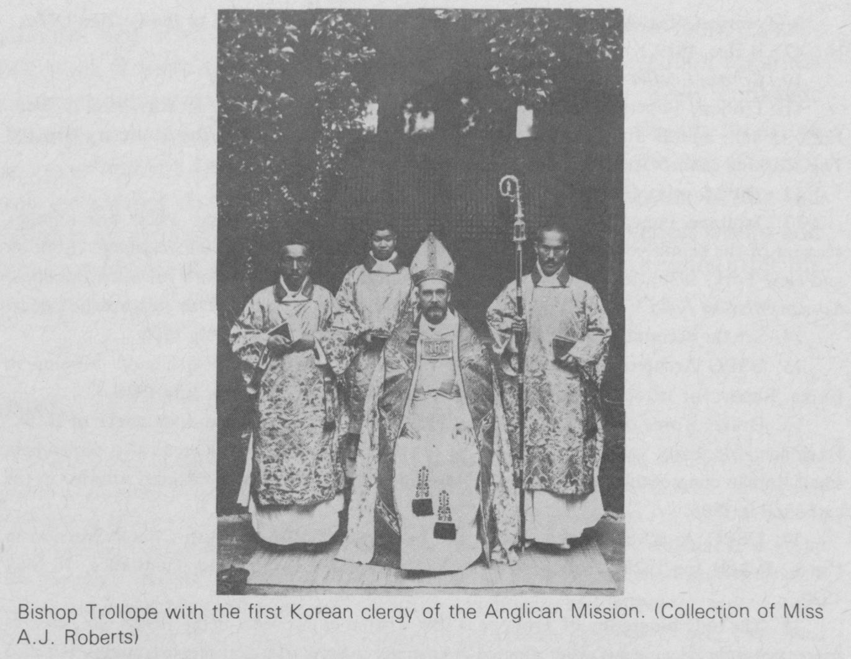

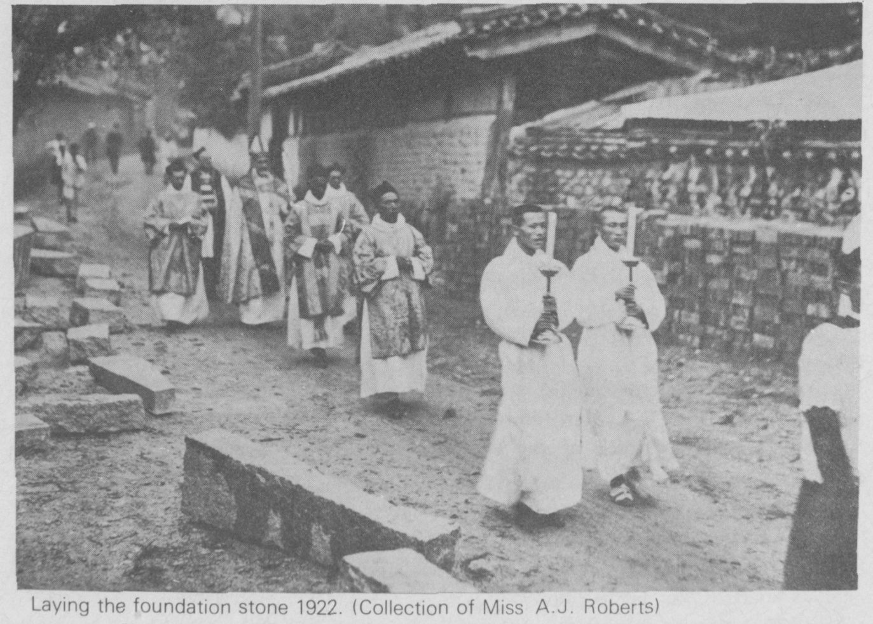

[page 13]

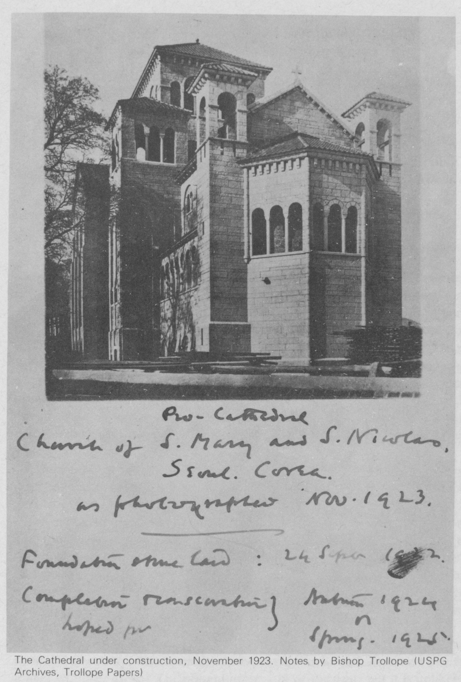

[page 14]

